2SAS 2 Step Authentication Login Procedure prototype

..,

··

-'

...

""'

.

.__ .. .,

.

Contents

Copyright  About This Book

Audience and Candidates Prerequisites

Disclaimer Virtual Machines

Preparing Virtual Machines

Task 1: Installing VMware Workstation on the Host Machine Task 2: Installing and Configuring the DC1 Virtual Machine

Task 2.1: Configuring the DC1 Virtual Machine

Task 2.2: Promoting the DC1 Virtual Machine as a Domain Controller Task 3: Installing and Configuring the SERVER1 Virtual Machine Task 4: Installing and Configuring the CLIENT1 Virtual Machine Task 5: Installing and Configuring the ROUTER Virtual Machine Task 6: Creating and Configuring the SERVER2 Virtual Machine

Task 7: Creating Snapshots of Virtual Machines

Task 8: Working with the Windows Server 2016 Desktop Experience

Exercise 1: Installing and Configuring Windows Server 2012 R2 Core Machine

Task 1: Installing Windows Server 2012 R2 Core Machine. Task 2: Configuring the Windows Server 2016 Core Machine.

Task 3: Adding CORE1 to Domain Exercise 2: Managing Servers Remotely

Task 1: Creating and Managing the Server Group Task 2: Deploying Roles and Features on CORE1 Machine

Task 3: Managing Services on the CORE1 Machine Exercise 3: Using Windows PowerShell to Manage Servers

Task 1: Using the Windows PowerShell to Connect Remotely to Servers and View Information

Task 2: Using Windows PowerShell to Manage Roles and Features Remotely

Exercise 04: Installing and Configuring Domain Controllers Task 1: Adding the AD DS Role on a Member Server

Task 2: Configuring SERVER1 Server as a Domain Controller Task 3: Configuring SERVER1 as a Global Catalog Server Exercise 5: Installing a Domain Controller by Using IFM

Task 1: Generating a IFM Data File

Task 2: Adding the AD DS Role to the Member Server

Task 3: Configuring SERVER1 as a New Domain Controller Using the IFM Data File

Exercise 6: Managing Organizational Units and Groups in AD DS Task 1: Managing Organizational Units and Groups

Task 2: Delegating the Permissions

Task 3: Configuring Home Folders for User Accounts Task 4: Testing and Verifying the Home Folders and Delegated

Permissions

Task 5: Resetting the Computer Accounts

Task 6: Examining the Behavior when a User Logins on Client.

Task 7: Rejoining the Domain to Reconnect the Computer Account Exercise 7: Using Windows PowerShell to Create User Accounts and Groups

Task 1: Creating a User Account Using Windows PowerShell Task 2: Creating Groups Using Windows PowerShell Task 3: Exporting User Accounts Using the ldifde Tool

Exercise 8: Installing and Configuring the DHCP Server Role Task 1: Installing the DHCP Server Role

Task 2: Configuring the DHCP Scope Task 3: Configuring DHCP Client Task 4: Configuring DHCP Reservation

Exercise 9: Installing and Configuring DNS

Task 1: Configuring SERVER1 as a Domain Controller without Installing the DNS Server Role

Task 2: Creating and Configuring the Myzone.local Zone on DC1 Task 3: Adding the DNS Server Role on the SERVER1 Task 4: Verifying Replication of the mcsalab.local Zone

Task 5: Configuring DNS Forwarder Task 6: Managing the DNS Cache 10: Implementing LAN Routing

Task 1: Installing the LAN Routing Feature on ROUTER Task 2: Configuring the LAN Routing Service on ROUTER

Task 3: Testing the Connectivity between DC1 and SERVER2 Servers Exercise 11: Configuring IPv6 Addressing

Task 1: Disabling IPv6 Address on DC1 Task 2: Disabling IPv4 Address on SERVER2

Task 3: Configuring an IPv6 Network on ROUTER Task 4: Verifying IPv6 Address on SERVER2

Exercise 12: Installing and Configuring Disk Storage Task 1: Adding New Virtual Disks to DC1

Task 2: Initializing the Added Disks

Task 3: Creating and Formatting Simple Volumes Task 4: Shrinking the Volumes

Task 5: Extending the Volumes Exercise 13: Configuring a Redundant Storage Space

Task 1: Creating a Storage Pool Task 2: Creating a Mirrored Virtual Disk

Task 3: Creating a File in to Mirrored Volume1 Task 4: Removing a Physical Drive

Task 5: Verifying the File Availability Exercise 14: Implementing File Sharing

Task 1: Creating the Folder Structure for the New Share

Task 2: Configuring NTFS Permissions on the Folder Structure Task 3: Sharing the Folder

Task 4: Accessing the Shared Folder Task 5: Enabling Access-based Enumeration

Task 6: Testing the Access-based Enumeration Configuration Exercise 15: Implementing Shadow Copies

Task 1: Configuring Shadow Copies

Task 2: Recovering a Deleted File Using Shadow Copy Exercise 16: Implementing Network Printing

Task 1: Installing the Print and Document Services Server Role Task 2: Installing a New Printer

Task 3: Configuring Printer Pooling Task 4: Connecting a Printer on a Client

Exercise 17: Implementing Group Policy Objects Task 1: Creating a New GPO

Task 2: Configuring the Internet Explorer GPO Task 3: Creating a Domain User to Test the GPO Task 4: Testing the Internet Explorer GPO

Task 5: Configuring Security Filtering to Exempt a User from the Internet Explorer GPO

Task 6: Testing the Internet Explorer GPO

Exercise 18: Implementing AppLocker and Firewall Using Group Policy Task 1: Restricting an Application Using AppLocker

Task 2: Configuring Windows Firewall Rules Using Group Policy

**Copyright**

The author holds all the rights of publishing and reproducing to this book. The content of this book cannot be reproduced or copied in any form or by any means or reproduced without the prior written permission of the author.

**About This Book**

This book contains the virtual lab setup guide and the lab exercises for installing and configuring Windows Server 2016. You can create the virtual lab infrastructure on your own system and you can easily perform all the lab exercises mentioned in this book. Candidate having the basic knowledge of Windows operating systems and networking fundamentals can perform all the lab exercises without (or least) the need of a trainer or faculty. This book mainly covers the initial implementation and configuration of core services, such as AD DS, networking services.

**Audience and Candidates Prerequisites**

This book is intended for the candidates who have basic operating system knowledge, and want to gain the hands-on practice skills and knowledge necessary to implement the core infrastructure services. In addition, this book is also helpful for the candidate who are looking for certification in the Windows Server 2016 platform.

The candidates should have the basic knowledge of the networking fundamentals, Windows-based operating systems, and virtualization platforms to perform the hands-on practices.

**Disclaimer**

We made almost every effort to avoid errors or omissions in this guide.

However, errors may slink in. Any mistake, error or discrepancy noted by the readers are requested to share with us, which will be highly appreciable. The contents and images in this guide could include technical inaccuracies or typographical errors. Author(s) or publisher makes no representations about the accuracy of the information contained in the guide.

**Virtual Machines**

The virtual machines that will be used throughout this book are listed in the following table.

|  |  |  |
| --- | --- | --- |
| ***S. No.*** | ***VM Name*** | ***Operating System*** |
| *1* | *DC1* | *Windows Server 2016* |
| *2* | *SERVER1* | *Windows Server 2016* |
| *3* | *CLIENT1* | *Windows 8.1/10* |
| *4* | *ROUTER* | *Windows Server 2016* |
| *5* | *SERVER2* | *Windows Server 2016* |

To prepare the virtual machines mentioned in the preceding table, you need ISO images. You can download the evaluation ISO images (Windows Server 2016 (Technical Preview) and Windows 8.1/10) from the Microsoft download center.

To perform the step by step lab exercises, download the ISO images and place them under the D:\ISOs folder on the host machine. You can setup the virtual lab infrastructure on the VMware or Hyper-V platform.

Each virtual machine will act as a separate machine with the unique GUID, SID, and IP address. The following table lists the IP addresses and roles of the respective VMs.

|  |  |  |  |
| --- | --- | --- | --- |
| ***S.***  ***No.*** | ***VM***  ***Name*** | ***IP Address*** | ***Role*** |
| *1* | *DC1* | *10.0.0.100* | *Domain controller of the mcsalab.local domain.* |
| *2* | *SERVER1* | *10.0.0.101* | *Member server of the mcsalab.local domain.* |
| *3* | *CLIENT1* | *10.0.0.102* | *Client machine of* |

|  |  |  |  |
| --- | --- | --- | --- |
|  |  |  | *the mcsalab.local domain.* |
| *4* | *ROUTER* | *Internal Subnet: 10.0.0.1*  *External Subnet: 192.168.0.1* | *Router server to perform the LAN routing.* |
| *5* | *SERVER2* | *192.168.0.2* | *Workgroup server in the external subnet.* |

**Preparing Virtual Machines**

To create the virtual machines, you need to perform the following tasks on the host machine:

* + 1. Install VMware Workstation or Player.
    2. Install and configure the DC1 virtual machine
    3. Install and configure the SERVER1 virtual machine
    4. Install and configure the CLIENT1 virtual machine
    5. Install and configure the ROUTER virtual machine
    6. Install and configure the SERVER2 virtual machine

# Task 1: Installing VMware Workstation on the Host Machine

To Install VMware Workstation or VMware Player, first you need to download it. Once it is downloaded, just double-click the setup file, and follow the simple steps to complete the installation process.

# Task 2: Installing and Configuring the DC1 Virtual Machine

To install and configure the DC1 virtual machine, you need to perform the following steps:

1. Make sure that the **VMware** console is active.
2. Select **File** and then select **New Virtual Machine**.
3. On the **New Virtual Machine Wizard**, click **Next**.

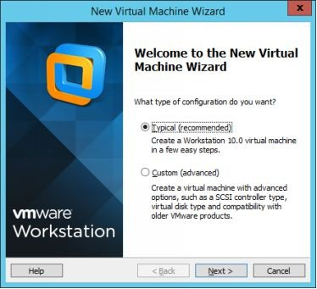

1. On the **Guest Operating System Installation** page, select the

**Installer disc image file (iso):** radio button, browse the location of the Server 2016 ISO image file, and then click **Next**.

5.

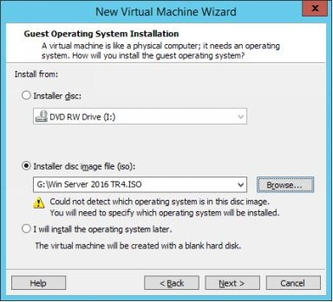

***Note:*** *If you use the VMware platform that automatically detects the version of the Windows server, you may asked to set the following settings:*

*Product key Operating system edition Administrator password*







*Otherwise, you may skip it.*

1. On the **Select a Guest Operating System** page, select the highest supported version of Windows server (in this case Windows Server 2012 but it will still support Windows Server 2016), and then click

## Next.

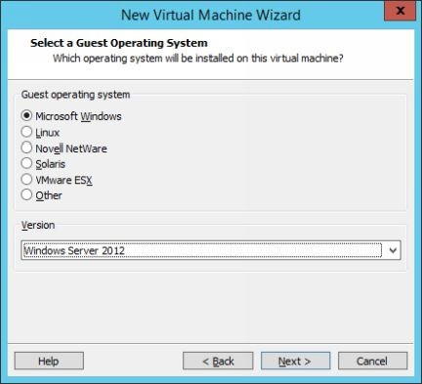

1. On the **Name and Virtual Machine** page, type **DC1** in the **Virtual**

**machine name** field.

1. In the **Location** field, navigate the location where you want to save the virtual machine, such as **H:\VMs\2k16\DC1**, and then click

## Next.

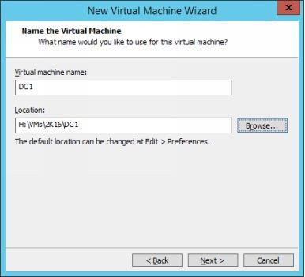

1. On the **Specify Disk Capacity** page, select **Store virtual disk as a single file**, optionally you can also set the disk size as well, and then

click **Next**.

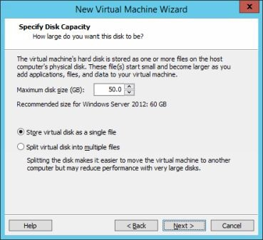

1. On the **Ready to Create Virtual Machine** page, click **Customize**

## Hardware.

1. On the **Hardware** window, select **Network Adapter** in the left

pane. Select the **Host only** radio button, and then click **Close**.

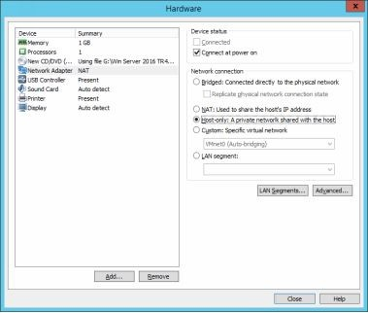

1. Click **Finish**.
2. On the **VMware** console, power on the **DC1** virtual machine.
3. On the **Windows Setup** page, click **Next**, and then click **Install**

**Now**.

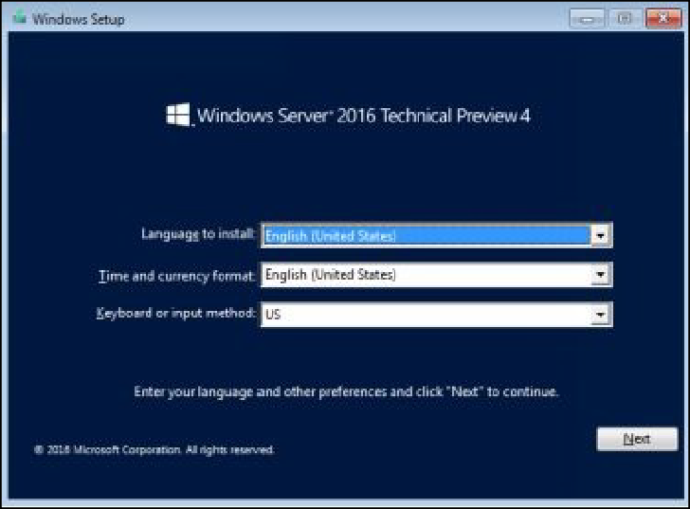

1. On the **Select the operating system you want to install** page, select the **Windows Server 2016 Desktop Experience**, and then

click **Next**.

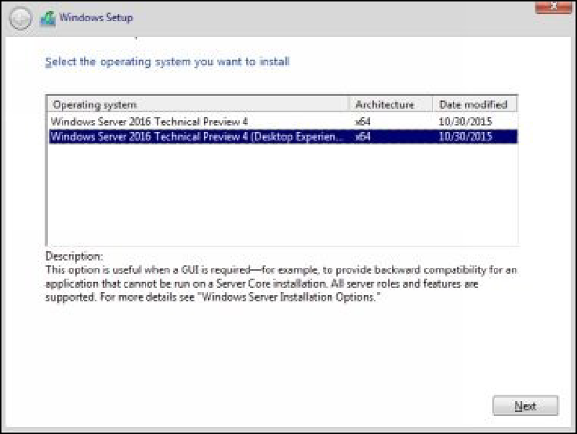

1. On the **License terms** page, select the **I accept the license terms**

check box, and then click **Next**.

1. On the **Which type of installation do you want page**, select the

**Custom** option, and then click **Next**.

1. On the **Where do you want to install Windows** page, click **Next**.

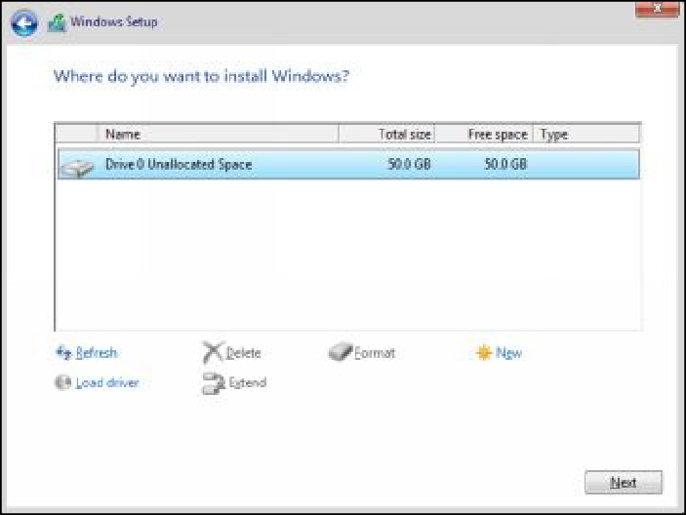

1. The Installation process will begin, after 10-15 minutes the

**Customize settings** screen will display.

1. Set Administrator password as **Password@123**.

# Task 2.1: Configuring the DC1 Virtual Machine

1. Sign in to **DC1** with the **Administrator** account.
2. Open the **System Properties** (sysdm.cpl) and set the computer

name as **DC1**.

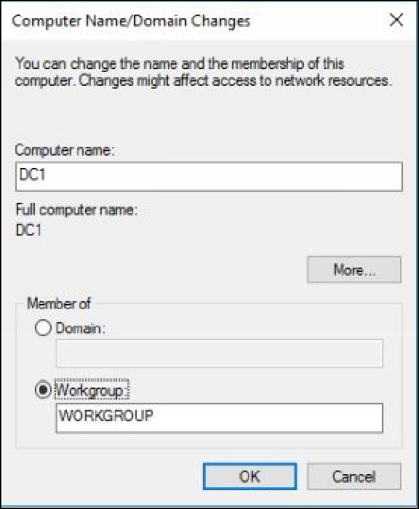

1. Restart and sign in to the system with the **Administrator** account. After some time, the **Server Manager** console will display.
2. Open the **Run** dialog box, type **ncpa.cpl**, and then press **Enter**.
3. Select and right-click the active network adapter, and then select

## Properties.

1. Set the following TCP/IP settings: IP address: **10.0.0.100**. Subnet mask: **255.0.0.0**. Default gateway: **10.0.0.1**.







Preferred DNS server: **10.0.0.100**.



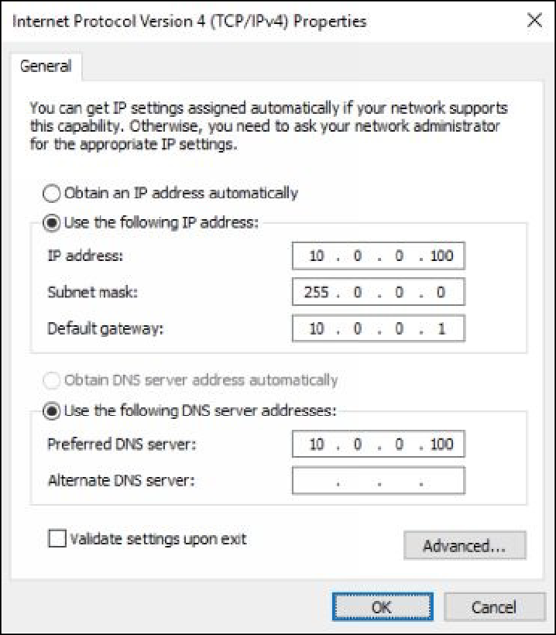

1. Close the **Network Connections** console.

# Task 2.2: Promoting the DC1 Virtual Machine as a Domain Controller

To promote the DC1 virtual machine as a domain controller, you need to perform the following steps:

1. Open the **Server Manager** console.
2. Click the **Add roles and features** link.
3. On the **Before you begin** page, click **Next**.
4. On the **Select installation type** page, click **Next**.
5. On the **Select destination server** page, click **Next**.
6. On the **Select server roles** page, select the **Active Directory Domain Services** check box, as shown in the following figure.

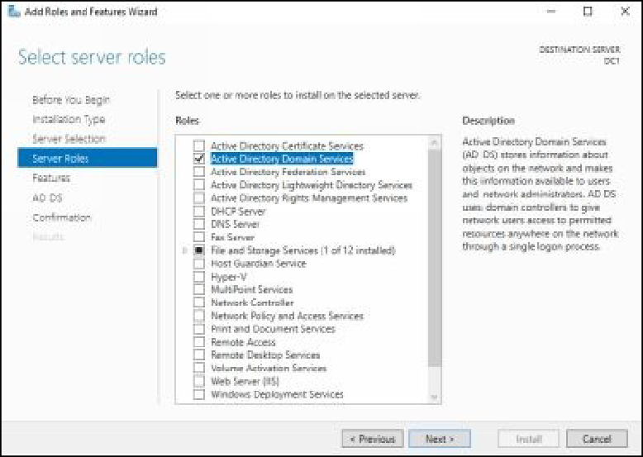

1. Accept the default selections through rest of the wizard and

complete the installation process.

1. Click **Close**, once the installation succeeds on **DC1**.
2. On the **Server Manager** console, click the **Notifications** icon.
3. Click the **Promote this server to a domain controller** link, as

shown in the following figure.

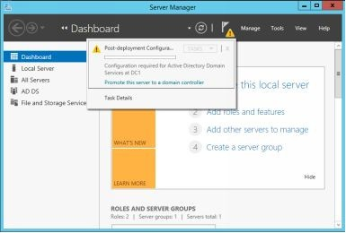

1. On the **Deployment Configuration** page, select the **Add a new**

**forest** radio button.

1. In the **Root domain name** text box, type **mcsalab.local,** as shown in the following figure, and then click **Next**.

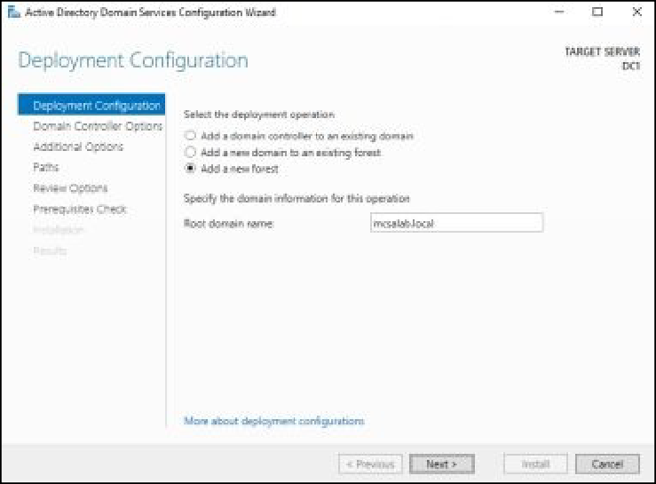

1. On the **Domain Controller Options** page, make sure that the

**Domain Name System (DNS) server** check box is selected, as shown in the following figure.

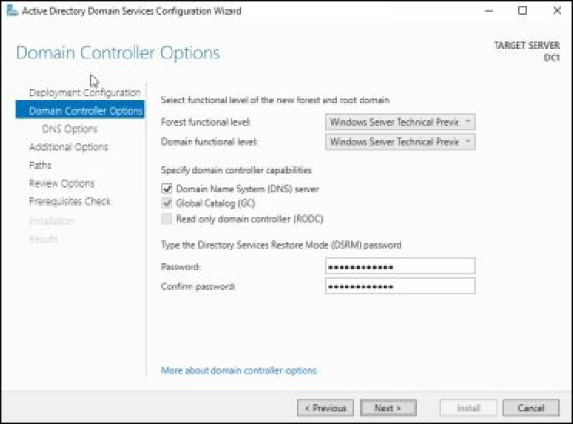

1. In the **Password** and **Confirm password** text boxes, type the

**Password@123**, and then click **Next**.

1. On the **DNS Options** page and then click **Next**.
2. On the **Additional Options** page, click **Next**.
3. On the **Paths** page, as shown in the following figure, review the default location for the AD DS database file, and then click **Next**.

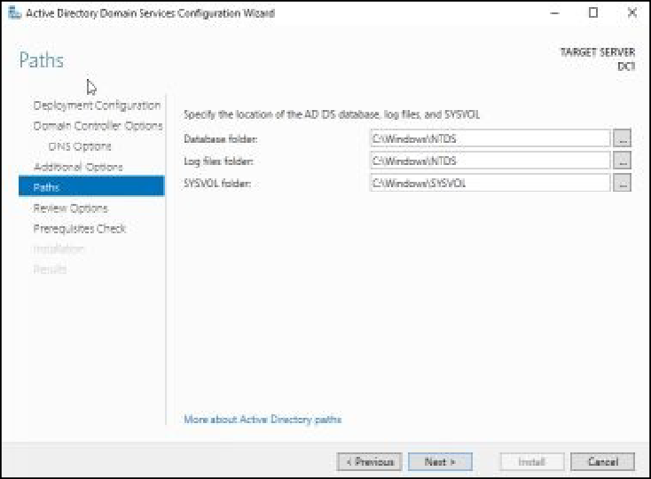

1. On the **Review Options** page, click **Next**.
2. On the **Prerequisites Check** page, as shown in the following figure, review the prerequisites, and then click **Install**.

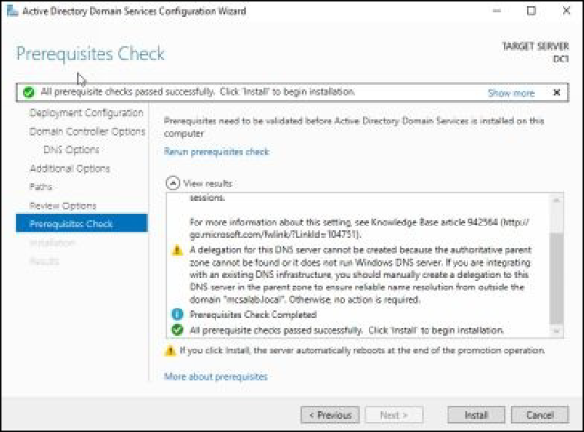

1. After some time, the system will restart automatically, sign in to

**DC1** with the **MCSALAB\Administrator** account.

1. Do not shut down the **DC1** virtual machine.

# Task 3: Installing and Configuring the SERVER1 Virtual Machine

To install and configure the **SERVER1** virtual machine, you can follow the simple steps as you used to install and configure the **DC1** virtual machine.

1. During the installing **SERVER1** virtual machine, make sure that you use the following settings and options:

Virtual machine name: **SERVER1**.



Operating system version: **Windows Server 2016**.



Memory: **2048 MB**



Hard disk size: **50 GB**



Network Adapter: **Host only** (click Customize Hardware before clicking the Finish button.)



Password: **Password@123**



1. Once you installed the **SERVER1** virtual machine with the preceding settings, configure the following TCP/IP settings:

IP address: **10.0.0.101**



Subnet mask: **255.0.0.0**



Default gateway: **10.0.0.1**



Preferred DNS server: **10.0.0.100**



1. Once you configured the preceding TCP/IP settings, open the

**System Properties** dialog box and click **Change**.

1. On the **Computer Name/Domain Changes** dialog box, in the

**Computer name** text box, type **SERVER1**.

1. Select the **Domain** radio button, in the **Member of** section, and then type **mcsalab.local**, and then click **OK**.
2. On the **Windows Security** dialog box, provide the credentials of the **DC1** server, and restart the **SERVER1** virtual machine.
3. Sign in to **SERVER1** with the Administrator account.
4. Shut down the **SERVER1** virtual machine.

# Task 4: Installing and Configuring the CLIENT1 Virtual Machine

To install and configure the **CLIENT1** virtual machine, you can follow the

simple steps as you used to install and configure the **DC1** virtual machine.

1. During the installing **CLIENT1** virtual machine, make sure that you use the following settings and options:

Virtual machine name: **CLIENT1**.



Operating system version: **Windows 8.1/10**.



Memory: **1024 MB**



Hard disk size: **50 GB**



Network Adapter: **Host only** (click Customize Hardware before clicking the Finish button.)



Password: **Password@123**



1. Once you installed the **CLIENT1** virtual machine with the preceding settings, configure the following TCP/IP settings:

IP address: **10.0.0.102**



Subnet mask: **255.0.0.0**



Default gateway: **10.0.0.1**



Preferred DNS server: **10.0.0.100**



1. Once you configured the preceding TCP/IP settings, open the

**System Properties** dialog box, and click **Change**.

1. On the **Computer Name/Domain Changes** dialog box, in the

**Computer name** text box, type **CLIENT1**.

1. Select the **Domain** radio button in the **Member of** section, type

**mcsalab.local**, and then click **OK**.

1. On the **Windows Security** dialog box, provide the credentials of the **DC1** server, and restart the **CLIENT1** virtual machine.
2. Sign in to **CLIENT1** with the Administrator account.
3. Shut down the **CLIENT1** virtual machine.

# Task 5: Installing and Configuring the ROUTER Virtual Machine

To install and configure the **ROUTER** virtual machine, you can follow the simple steps as you used to install and configure the **DC1** virtual machine.

1. During the creating **ROUTER** virtual machine, make sure that you use the following settings and options:

Virtual machine name: **ROUTER**. Operating system version: **Windows Server 2016**.





Memory: **1024 MB**



Hard disk size: **50 GB**



Network Adapter: **Host only**



1. Once you created the **ROUTER** virtual machine with the preceding settings, select the **ROUTER** virtual machine, click **Edit virtual**

**machine settings**, as shown in the following figure.

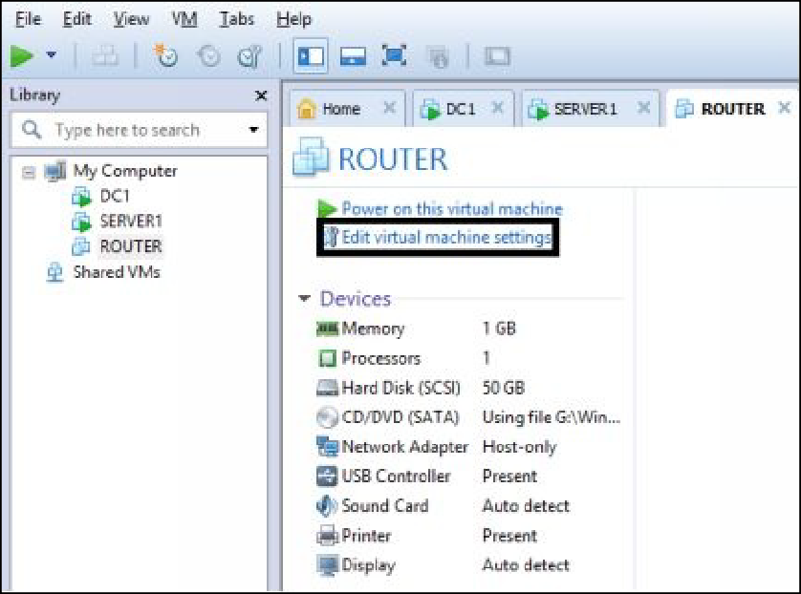

1. On the **Virtual Machine Settings** dialog box, click **Add**.
2. On the **Add Hardware Wizard**, select **Network Adapter**, and then

click **Next**.

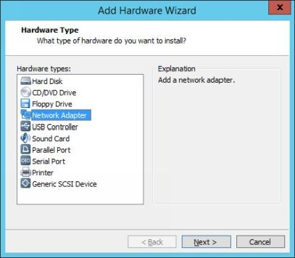

1. On the **Network Adapter Type** page, select **VMnet2** under the

**Custom** option.

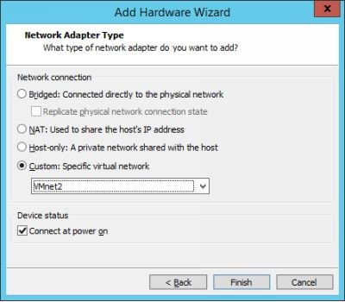

1. Click **Finish** and then click **OK** button.
2. Power on the **ROUTER** virtual machine.
3. Follow the simple steps to install the **ROUTER** virtul machine. Use

**Password@123** as Administrator password.

1. Once you installed the **ROUTER** virtual machine with the preceding settings, configure the following TCP/IP settings on the

first network adapter (connected to the **Host only** network):

IP address: **10.0.0.1**



Subnet mask: **255.0.0.0**



Preferred DNS server: **10.0.0.100**



1. Configure the following TCP/IP settings on the second network adapter (connected to the **VMnet2** network):

IP address: **192.168.0.1**



Subnet mask: **255.255.255.0**



1. Once you configured the preceding TCP/IP settings, open the

**System Properties** dialog box, set the computer name as

**ROUTER**, and restart the **ROUTER** virtual machine.

1. Open the **Command Prompt** window, type **ping 10.0.0.100**, and

then press **Enter**.

1. You should be able to communicate (ping) with the **DC1** server.

***Note****: If you are unable to communicate with the DC1 server, you may need to interchange the TCP/IP settings of the network adapters.*

1. Do not shut down the **ROUTER** virtual machine.

# Task 6: Creating and Configuring the SERVER2 Virtual Machine

To install and configure the **SERVER2** virtual machine, you can follow the simple steps as you used to install and configure the **DC1** virtual machine.

1. During the installing **SERVER2** virtual machine, make sure that you use the following settings and options:

Virtual machine name: **SERVER2**.



Operating system version: **Windows Server 2016**.



Memory: **1024 MB**



Hard disk size: **50 GB** Network Adapter: **VMnet2** Password: **Password@123**







1. Once you installed the **SERVER2** virtual machine with the preceding settings, configure the following TCP/IP settings:

IP address: **192.168.0.2**



Subnet mask: **255.255.255.0**



Default gateway: **192.168.0.1**



Preferred DNS server: **10.0.0.100**



1. Once you configured the preceding TCP/IP settings, open the **System Properties** dialog box, set the computer name as **SERVER2**, and restart the **SERVER2** virtual machine.
2. Sign in to **SERVER2** with the Administrator account.
3. Shut down the **SERVER2** virtual machine.

1. Shut down the **DC1** virtual machine.

# Task 7: Creating Snapshots of Virtual Machines

Once you installed and configured all the virtual machines, you need to create the snapshots/checkpoints for each virtual machine. Snapshot will help you to revert a virtual machine to its previously used state (at the point when you had created it).

To create a snapshot, you need to perform the following tasks:

1. Make sure that the all virtual machines are turned off.
2. Select and right-click any virtual machine, select **Snapshot**, and then select **Take snapshot**. After few seconds, the snapshot will be

created.

1. Using the preceding method, create snapshots of all the virtual

machines.

# Task 8: Working with Windows Server 2016 Desktop Experience

GUI interface of Windows Server 2016 is almost has similar functions as used in windows Server 2012 R2. However, there are some new feature have been added to make the user experience more interesting. Some of the basic GUI features are:

Start button Task Manager Task View







# Start button

1. Sign in to **DC1** and click the **Start** button. It will show you the various options, such as **Server Manager**, **Settings**, **PowerShell**,

and **Calculator** that can be accessed directly.

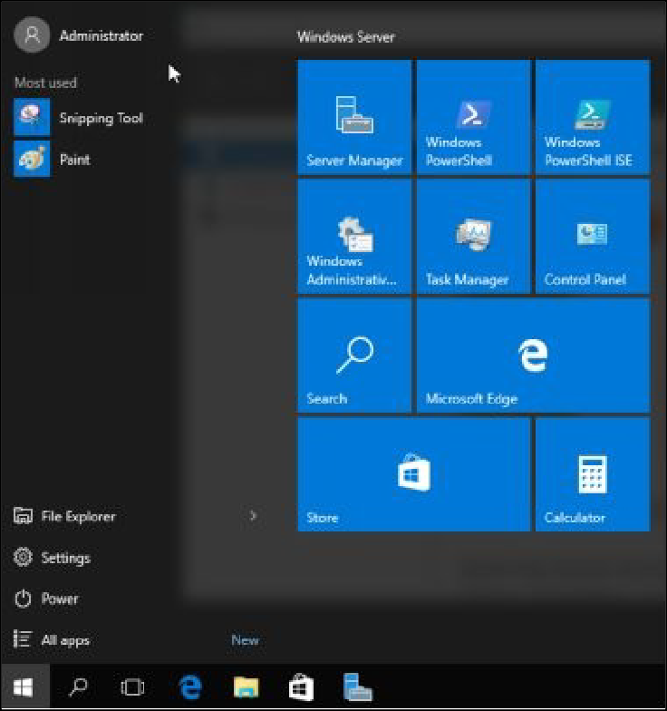

1. If you right-click the **Start** button, it will show you few more options, as shown in the following figure.

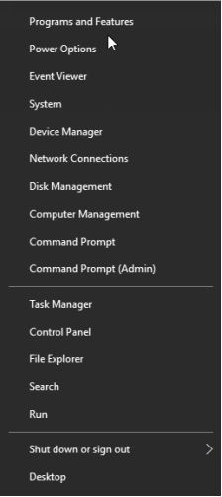

# Task Manager

The Task Manager in Windows Server 2016 is much similar to the Task Manager that has been used in Windows Server 2012 R2.

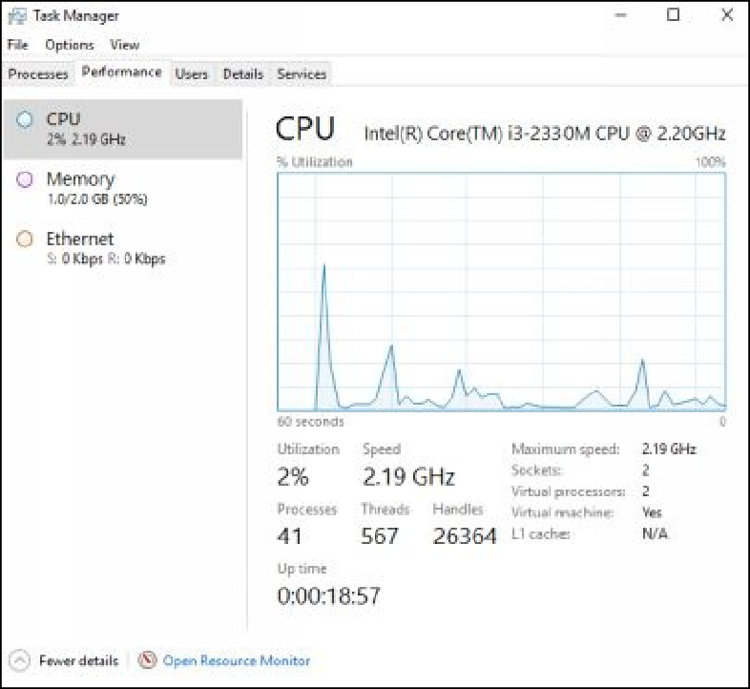

# Task View

Task View allows you to view and switch between different active windows.

This feature was not available in Windows Server 2012 R2.

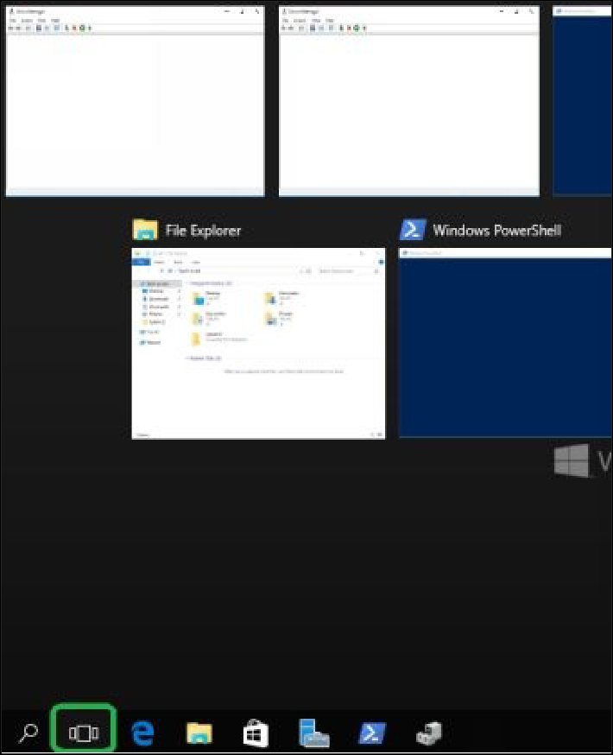

# Task 9: What’s New in Windows Server 2016?

In Windows Server 2016, there are many new roles and features have been added. Some of the major new roles and features are:

Host Guardian Service Multipoint Services





Windows Server Essentials Experience Setup and Boot Event Collections SMB Bandwidth Limit







Windows Biometric Framework BitLocker Network Unlock





# Host Guardian Service

The Host Guardian Service (HGS) is a server role introduced in Windows Server 2016. It provides the Attestation and Key Protection services that allow Guarded Hosts to run shielded virtual machines. The Attestation service validates guarded host identity and configuration. The Key Protection service allows transport keys to enable guarded hosts to unlock and run shielded virtual machines.

# Multipoint Services

It allows multiple users to simultaneously share one computer and each user has their own independent and familiar Windows experience.

# Windows Server Essentials Experience

This is a role service that sets up the IT infrastructure and offers powerful functions, such as “PC backups” that helps organizations’ to protect data, and “Remote Web Access” that helps access business information from anywhere, virtually. It also helps you to simply and rapidly connect to cloud-based applications and services to extend the functionality of the servers.

# Setup and Boot Event Collections

It is a feature that enables the collection and logging of setup and boot events from other computers on the network.

# SMB Bandwidth Limit

This feature provides a mechanism to track SMB traffic per category and allows

you to limit the amount of traffic allowed for a given category. It is commonly used to limit the bandwidth used by live migration over SMB.

# Windows Biometric Framework

This feature allows fingerprint devices to be used to identify and verify identities and to sign in to Windows.

# BitLocker Network Unlock

This feature enables a network-based key protector to be used to automatically unlock BitLocker-protected operating system drives in domain-joined computers, when the computer is restarted.

# Exercise 1: Installing and Configuring Windows Server 2012 R2 Core Machine

In this exercise, you will install and configure a Windows Server 2012 R2 core machine. The installation process for the server core option and full GUI option is almost identical. However, server core option requires less hardware resources and it is more secure than the full GUI option. In this exercise, you will use the following virtual machines:

DC1 CORE1





To install and configure the Windows Server 2012 R2 core machine, you need to perform the following tasks:

# Task 1: Installing Windows Server 2012 R2 Core Machine.

1. Create a virtual machine with the following settings:
2. During the creating the virtual machine, make sure that you use the

following settings and options: Virtual machine name: **CORE1**.



Operating system version: **Windows Server 2016**.



Memory: **512 MB**



Hard disk size: **20 GB** Network Adapter: **Host only** Password: **Password@123**







1. Once the virtual machine is created, power on the CORE1 virtual

machine.

1. After some time, the **Windows Setup** screen will display.
2. Click **Next** and then click **Install now**.
3. If the Activate Windows screen is displayed, click I don’t have a

product key link.

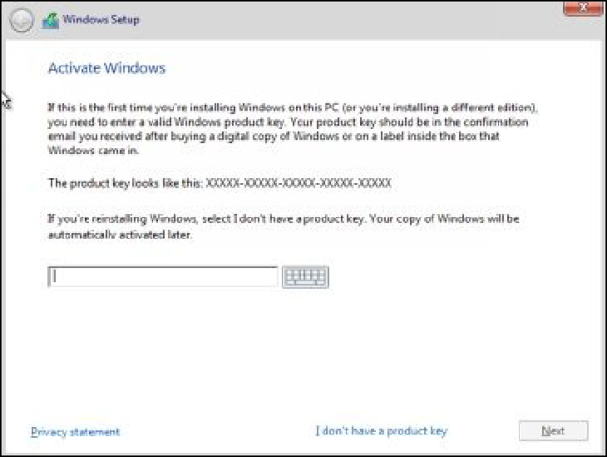

1. On the **Select the operating system you want to install** page, select **Windows Server 2016 Technical Preview 4,** and then click

## Next.

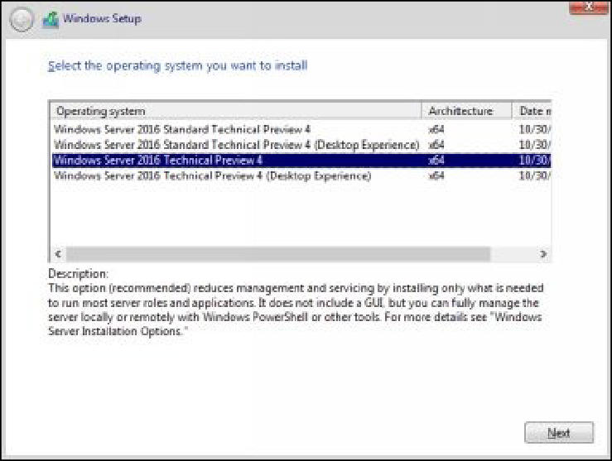

1. On the **License terms** page, select the **I accept the license terms**

check box, and then click **Next**.

1. On the **Which type of installation do you want?** page, click

**Custom: Install Windows only (advanced)**, as shown in the following figure.

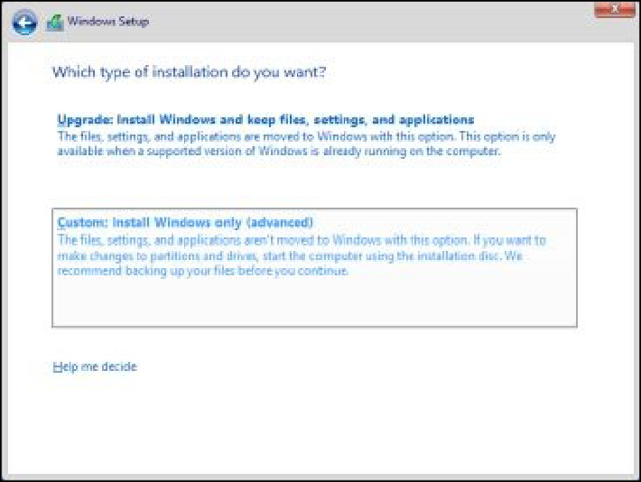

1. On the **Where do you want to install Windows?** page, click **Next**.
2. The installation process will start.
3. After some time, the sign in screen will display, and you will be asked to change the Administrator password.

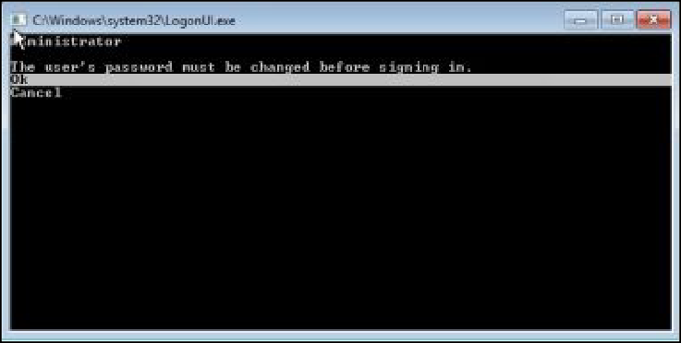

1. Set the Administrator password as **Password@123**.

# Task 2: Configuring the Windows Server 2016 Core Machine.

To configure the Windows Server 2016 core machine, you need to perform the following steps:

1. Sign in to **CORE1** with the Administrator account.
2. On the **Command Prompt** window, type **sconfig.cmd**, and then press **Enter**. The **Server Configuration** options will display, as

shown in the following figure.

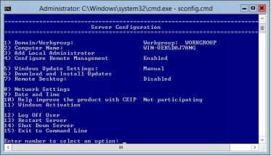

1. To change the system **Date and Time**, type **9**, and then press

## Enter.

1. On the **Date and Time** dialog box, as shown in the following

figure, click **Change time zone**.

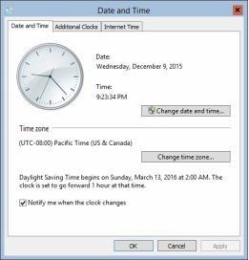

1. Select the desired time zone, and then click **OK**.
2. In the **Date and Time** dialog box, click **Change Date and Time**, and verify the date and time, and then click **OK**.
3. On the **Command Prompt** window, type **8**, and then press **Enter**

## to configure Network Settings.

1. Type the index number (in our example it is 10) of the network adapter, as shown in the following figure, and then press **Enter**.

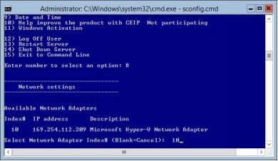

1. On the **Network Adapter Settings** page, type **1**, to set the **Network Adapter Address**, as shown in the following figure, and then press

## Enter.

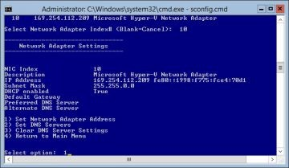

1. To set static IP address, type **S**, as shown in the following figure,

and then press **Enter**.

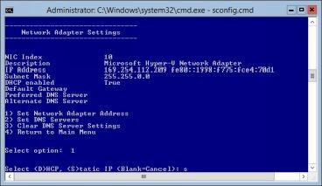

1. At the **Enter static IP address**: prompt, type **10.0.0.103**, and then

press **Enter**.

1. At the **Enter subnet mask**: prompt, accept the default value, and

then press **Enter**.

1. At the **Enter default gateway**: prompt, type **10.0.0.1**, and then press **Enter**, as shown in the following figure.

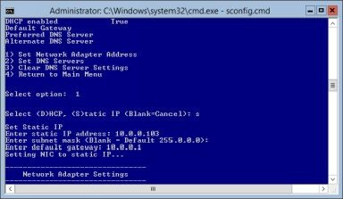

1. On the **Network Adapter Settings** option, type **2**, to configure the DNS server address, and then press **Enter**.
2. At the **Enter new preferred DNS server** prompt, type **10.0.0.100**,

and then press **Enter**.

1. On the **Network Settings** message box, as shown in the following

figure, click **OK**.

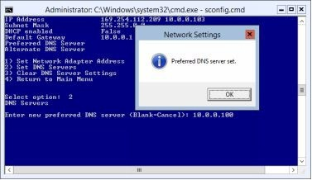

1. Press **Enter** to not configure an alternate DNS server address.
2. At the **Select option**: prompt, type **4**, and then press **Enter** to return

to the main menu.

1. At the **Enter number to select an option**: prompt, type **15**, and then press **Enter** to exit the **sconfig.cmd** utility.
2. On the **Command Prompt** window, type ping **dc1.mcsalab.local**

to verify the connectivity between **DC1** and **CORE1**.

# Task 3: Adding CORE1 to Domain

1. On the **Command Prompt** window, type **sconfig.cmd**, and then

press **Enter**.

1. At the **Enter number to select an option**: prompt, type **2**, and then

press **Enter**.

1. At the **Enter a new computer name**: prompt, type **CORE1**, and

then press **Enter**.

1. On the **Restart** dialog box, click **Yes**.

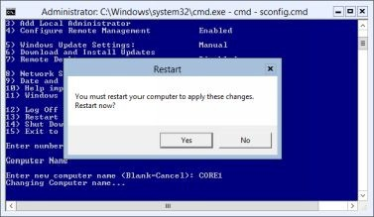

1. The system will restart and after some time the **Sign in** screen will

display.

1. Sign in to **CORE1** with the Administrator account.
2. On the **Command Prompt** window, type **hostname**, and then press

**Enter** to verify the computer’s name.

1. On the **Command Prompt** window, type **sconfig.cmd**, and then

press **Enter**.

1. Type **1** to change the **Domain/Workgroup** settings, and then press

## Enter.

1. Type **D** to join a domain, and then press **Enter**.
2. At the **Name of domain to join** prompt, type **mcsalab.local**, and

then press **Enter**.

1. At the **Specify an authorized domain\user** prompt, type

**Administrator**, and then press **Enter**.

## At the Type the password associated with the domain user

prompt, type **Password@123**, and then press **Enter**.

1. At the **Change Computer Name** message box, as shown in the

following figure, click **No**.

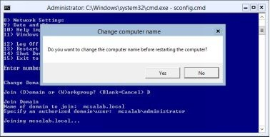

1. On the **Restart** dialog box, click **Yes**. The system will restart. After some time, the sign in screen will display.
2. Sign in to **CORE1** with the MCSALAB\Administrator account.

***Results****: After completing this exercise, you will have configured a Windows Server 2016 server core machine.*

Do not turn off or shut down the DC1 and/or CORE1 virtual machine(s) as these virtual machines will be required to perform the next exercise.

# Exercise 2: Managing Servers Remotely

In this exercise, you will manage the server core machine from the remote location. In addition, you will also deploy roles and features on the server core machine. Further, you will manage the services on the server core machine.

Before starting to perform this exercise, make sure that the DC1 and CORE1 virtual machines are running, and you have not reverted them in the previous exercise.

# Task 1: Creating and Managing the Server Group

1. Sign in to **DC1** with the MCSALAB\Administrator account.
2. On the **Server Manager** console, make sure that **Dashboard** is selected in the left pane, and then click **Create a server group**.
3. On the **Create Server Group** dialog box, click the **Active Directory** tab, and then click **Find Now**.
4. In the **Server group** name text box, select the **CORE1** and

**SERVER1** servers, and then add **CORE1** and **SERVER1** to the server group.

1. In the **Server group** name text box, type **ServerGroup1**, as shown

in the following figure.

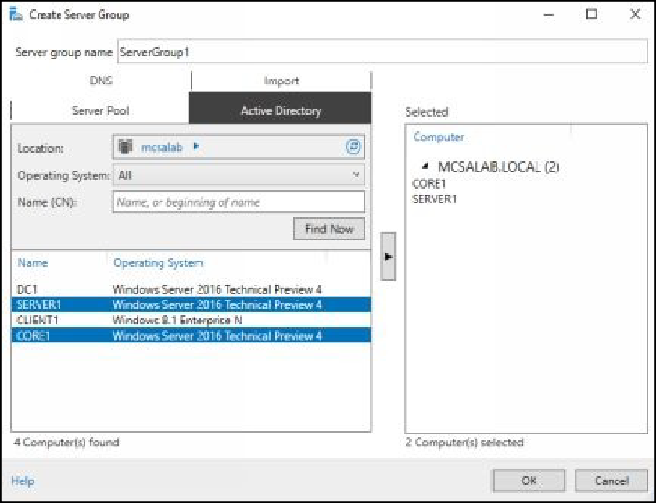

1. Click **OK** to close the **Create Server Group** dialog box.
2. On the **Server Manager** console, select **ServerGroup1** in the left pane. Verify that the both servers are listed in the **Servers** pane, as

shown in the following figure.

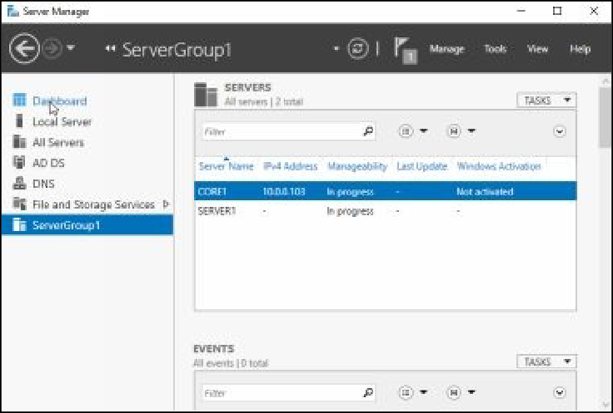

# Task 2: Deploying Roles and Features on CORE1 Machine

1. Sign in to **DC1** with the MCSALAB\Administrator account.
2. On the **Server Manager** console, click **ServerGroup1** in the left

pane.

1. Scroll to the top of the pane, select and right-click **CORE1**, and then select **Add Roles and Features**, as shown in the following

figure.

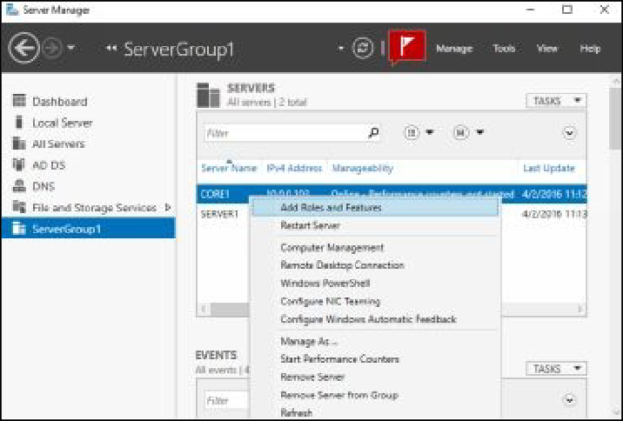

1. On the **Add Roles and Features Wizard**, click **Next**.
2. On the **Select installation type** page, click **Next**.
3. On the **Select destination server** page, make sure that

**CORE1.mcsalab.local** is selected, as shown in the following figure, and then click **Next**.

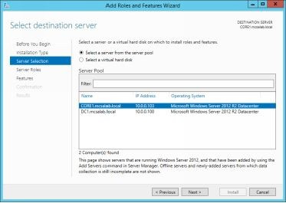

1. On the **Select server roles** page, select the **DHCP Server** check box, as shown in the following figure, and then click **Next**.

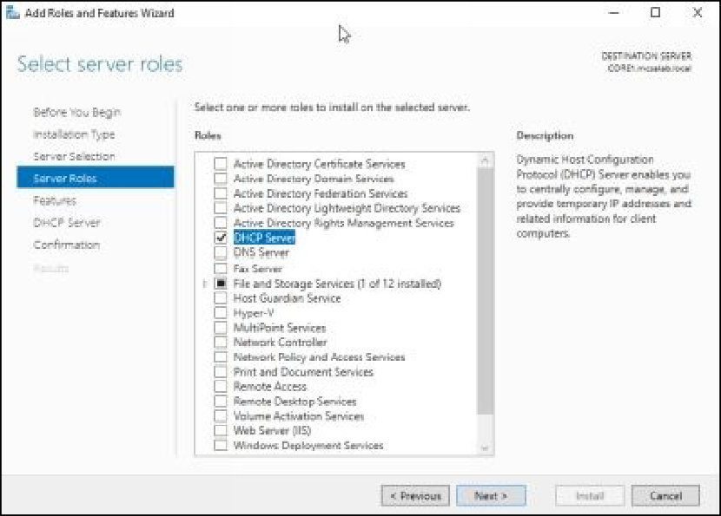

1. On the **Add Roles and Features** dialog box, click **Next**.
2. Click **Next**, until the **Confirm install selections** page is displayed.
3. On the **Confirm installation selections** page, select the **Restart the destination server automatically if required** check box, as

shown in the following figure, and then click **Install**.

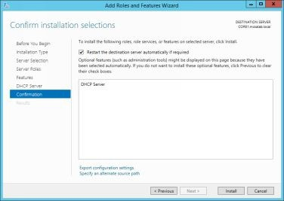

1. Click **Close** to close the **Add Roles and Features Wizard**, once

the installation is completed.

# Task 3: Managing Services on the CORE1 Machine

1. Switch to as **Other user** and sign in to **CORE1** with the

MCSALAB\Administrator account.

1. On the **Command Prompt** window, type the following command, and then press **Enter**, as shown in the following figure.

## netsh.exe firewall set service remoteadmin enable ALL

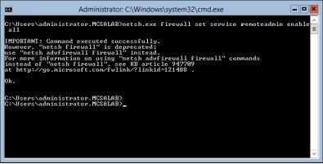

1. Switch back and sign in to **DC1** with the MCSALAB\Administrator

account.

1. On the **Server Manager** console, select **ServerGroup1**.
2. Select and right-click **CORE1**, and then click **Computer**

## Management.

1. On the **Computer Management** console, expand the **Services and Applications** node, and then select **Services**.
2. Select and right-click the **DHCP Server** service, and then click

**Properties**, as shown in the following figure.

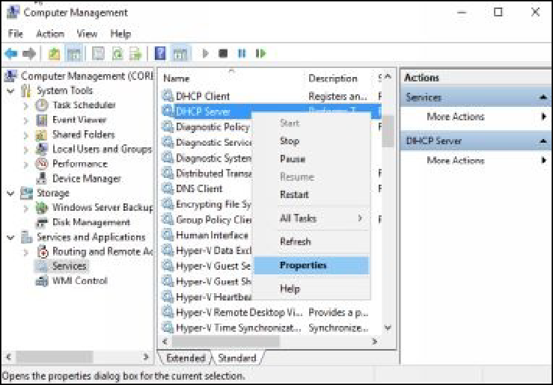

1. On the **Properties** dialog box, on the **General** tab, make sure that the **Startup type** is set to **Automatic**.
2. Select the **Recovery** tab, configure the following settings, as shown

in the following figure.

First failure: **Restart the Service**



Second failure: **Restart the Service** Subsequent failures: **Restart the Computer** Reset fail count after: **1 days**







Restart service after: **1 minute**



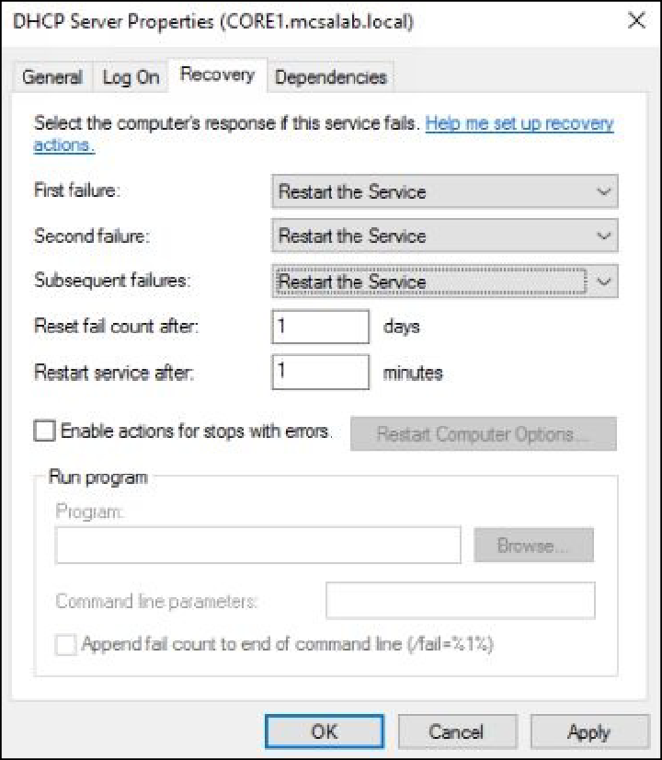

1. On the **Properties** dialog box, click **Restart Computer Options**.
2. On the **Restart Computer Options** dialog box, in the **Restart computer after** box, type **2**, and then click **OK**.
3. Click **OK** to close the **Properties** dialog box.
4. Close the **Computer Management** console.

***Results****: After completing this exercise, you have created a server group, deployed roles and features, and managed a service remotely.*

Shut down and revert the DC1 and CORE1 virtual machines to prepare for the next exercise.

# Exercise 3: Using Windows PowerShell to Manage Servers

In this exercise, you will use the Windows PowerShell to manage the Window Server 2016. Windows PowerShell is a command-line interface that is similar to command prompt. It is designed to execute the scripts similar to UNIX/Linux operating systems.

Start the DC1 virtual machine to perform this exercise.

# Task 1: Using the Windows PowerShell to Connect Remotely to Servers and View Information

1. Sign in to **DC1** with the MCSALAB\Administrator account.
2. On the **Server Manager** console, select **ServerGroup1**.
3. Select and right-click **CORE1**, and then select **Windows**

## PowerShell.

1. At the **Windows PowerShell** prompt, type **cd\** and then press

## Enter.

1. Type **Import-Module ServerManager**, and then press **Enter**.
2. Type **Get-WindowsFeature** and then press **Enter** to view the installed roles and features on **CORE1**, as shown in the following

figure.

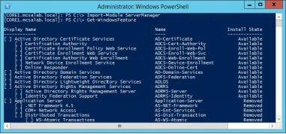

1. Type the following command to view the running services on

**CORE1** and then press **Enter**, as shown in the following figure.

## Get-service | where-object {$_.status -eq “Running”}

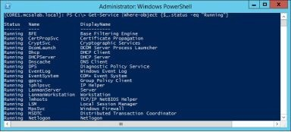

1. Type the following command and then press **Enter** to view a list of processes on **CORE1**, as shown in the following figure.

## Get-Process

1. Type the following command to view the IP addresses of the

**CORE1** machine, and then press **Enter**, as shown in the following figure.

## Get-NetIPAddress | Format-table

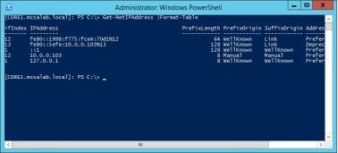

1. Type the following command to view the most recent **5** security logs, and then press **Enter**, as shown in the following figure.

## Get-EventLog Security -Newest 5

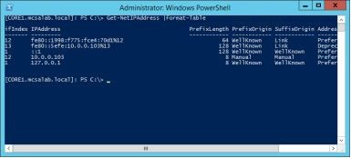

1. Close **Windows PowerShell**.

# Task 2: Using Windows PowerShell to Manage Roles and Features Remotely

1. On **DC1**, on the taskbar, click the **Windows PowerShell ** icon.
2. At the **Windows PowerShell** prompt, type the following command,

and then press **Enter**.

## Import-Module ServerManager

1. To verify that the **WINS Server** feature is not installed on **CORE1**, type the following command, and then press **Enter**, as shown in the

following figure.

## Get-WindowsFeature -ComputerName CORE1

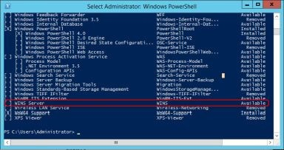

1. To install the **WINS Server** feature on **CORE1**, type the following command, and then press **Enter**, as shown in the following figure.

## Install-WindowsFeature WINS -ComputerName CORE1

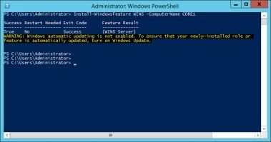

1. Verify that the **Exit Code** status displays as the success text.

***Results****: After completing this exercise, you have managed the servers using Windows PowerShell.*

Shut down and revert the DC1 and CORE1 virtual machines.

# Exercise 04: Installing and Configuring Domain Controllers

The system that holds the Active Directory Domain Services role acts as a domain controller. A domain controller is a server that is used to manage and control the clients on a network.

In this exercise, you will learn how to configure a domain controller on Windows Serve 2016. In addition, you will also learn how to configure a server as a Global Catalog server.

Start the DC1 and SERVER1 virtual machines to perform this exercise.

# Task 1: Adding the AD DS Role on a Member Server

1. Sign in to **DC1** with the MCSA\Administrator account.
2. On the **Server Manager** console, in the left pane, select and right- click **All Servers**, and then select **Add Servers**.
3. On the **Add Servers** dialog box, in the **Name (CN)** text box, type

**SERVER1**, and then click **Find Now**.

1. In the name list area, select **SERVER1**, and then click the arrow to add the server to the **Selected** column, as shown in the following

figure.

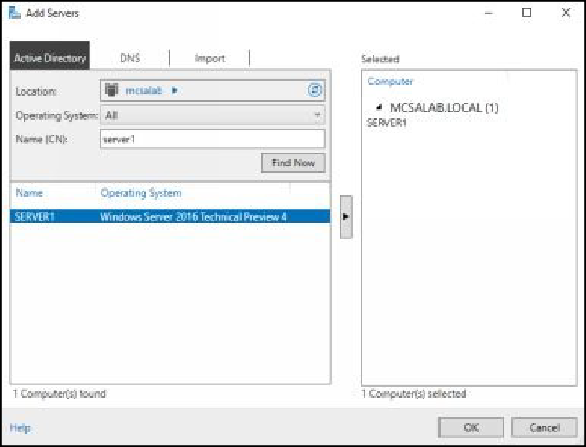

1. Click **OK** to close the **Add Servers** dialog box.
2. On the **Server Manager** console, in the **Servers** pane, wait until the

**Manageability** status displays as **Online – Performance counters not started**, as shown in the following figure.

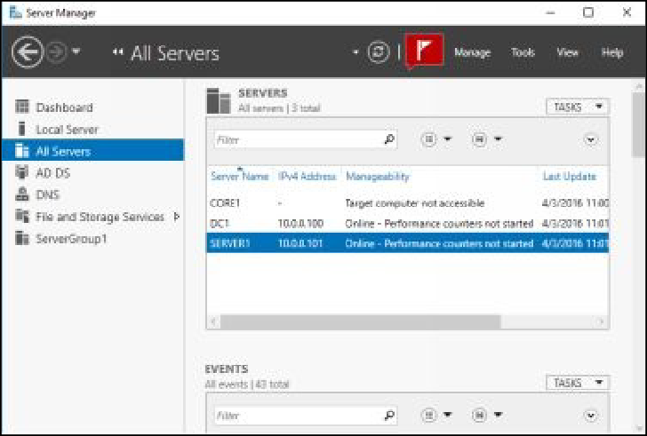

1. Select and right-click **SERVER1**, and then select **Add Roles and**

## Features.

1. On the **Add Roles and Features Wizard**, click **Next**.
2. On the **Select installation type** page, click **Next**.
3. On the **Select destination server** page, make sure that the **Select a server from the server pool** radio button is selected.
4. In the **Server Pool** area, make sure that **SERVER1.mcsalab.local**

is selected, as shown in the following figure, and then click **Next**.

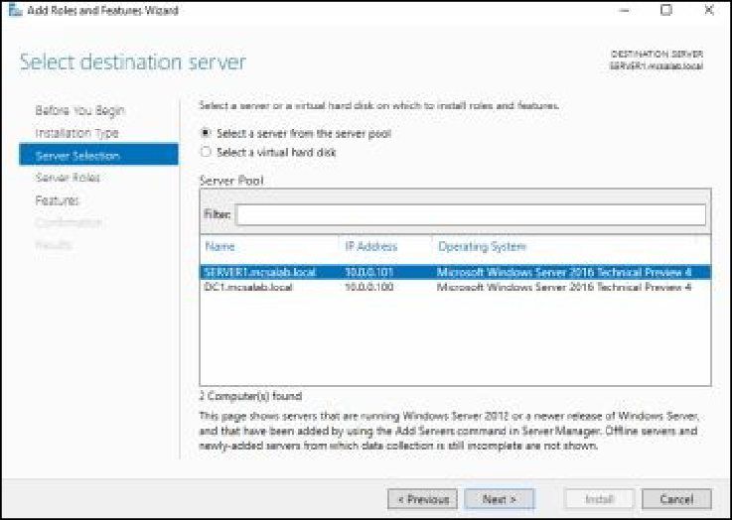

1. On the **Select server** roles page, select the **Active Directory**

**Domain Services** check box.

1. On the **Add Roles and Features** dialog box, click **Add Features**,

and then click **Next**.

1. The **Select server roles** page is returned, make sure that the **Active Directory Domain Services** check box is selected, as shown in the

following figure, and then click **Next**.

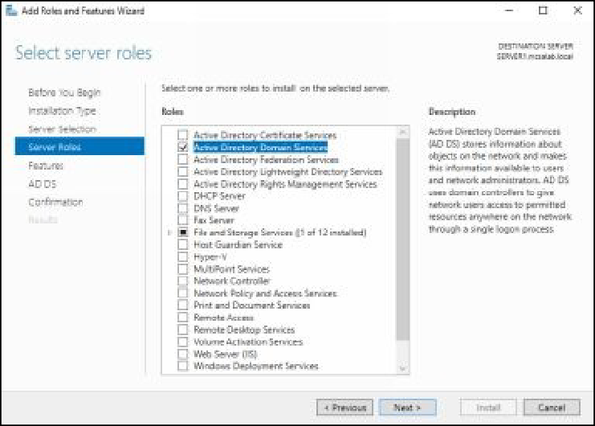

1. Click **Next**, until the **Confirm installation selections** page is

displayed.

1. On the **Confirm installation selections** page, select the **Restart the destination server automatically if required** check box, and

then click **Install**.

1. The installation process will start. Click **Close** to close the **Add Roles and Features Wizard**, once the installation is completed.

# Task 2: Configuring SERVER1 Server as a Domain Controller

1. On **DC1**, on the **Server Manager** console, click the **Notifications**

button.

1. On the **Post-deployment Configuration** box, click the **Promote this server to a domain controller** link, as shown in the following

figure.

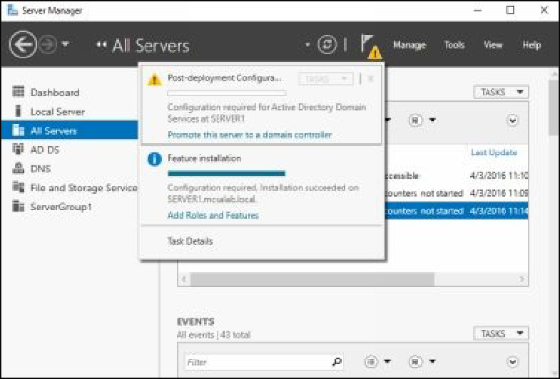

1. On the **Deployment Configuration** page, of the **Active Directory Domain Services Configuration Wizard**, make sure that the **Add**

**a domain controller to an existing domain** radio button is selected.

1. In the **Domain** text box, make sure that the **mcsalab.local** text is written, as shown in the following figure.

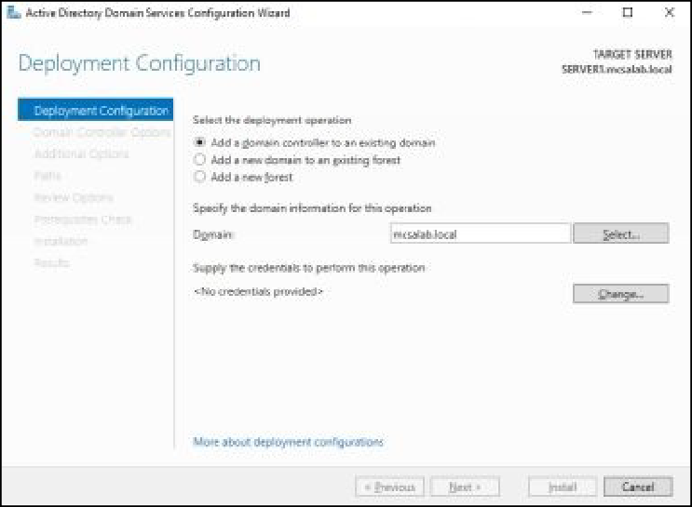

1. In the **Supply the credentials to perform this operation** section,

click **Change**.

1. On the **Windows Security** dialog box, in the **Username** text box, type **MCSALAB\Administrator**, in the **Password** box, type

**Password@123**, as shown in the following figure.

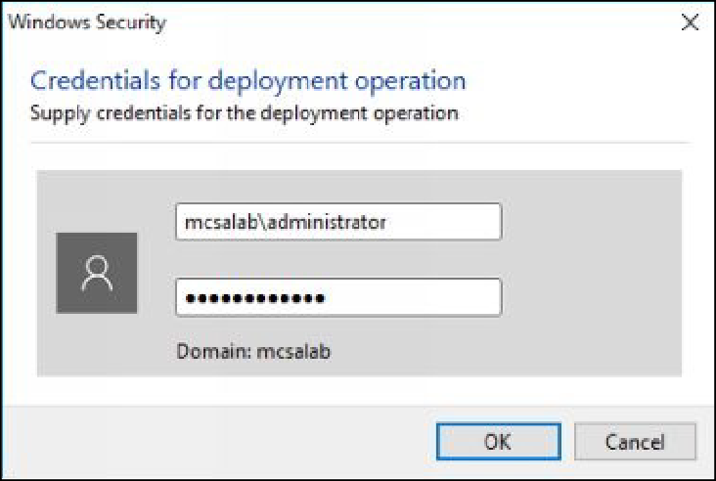

1. Click **OK** and then click **Next**.
2. On the **Domain Controller Options** page, make sure that **Domain Name System (DNS) server** check box is selected, and then clear

the **Global Catalog (GC)** check box.

1. In the **Type the Directory Services Restore Mode (DSRM) password** section, type **Password@123**, in the **Password** and **Confirm password** text boxes, as shown in the following figure,

and then click **Next**.

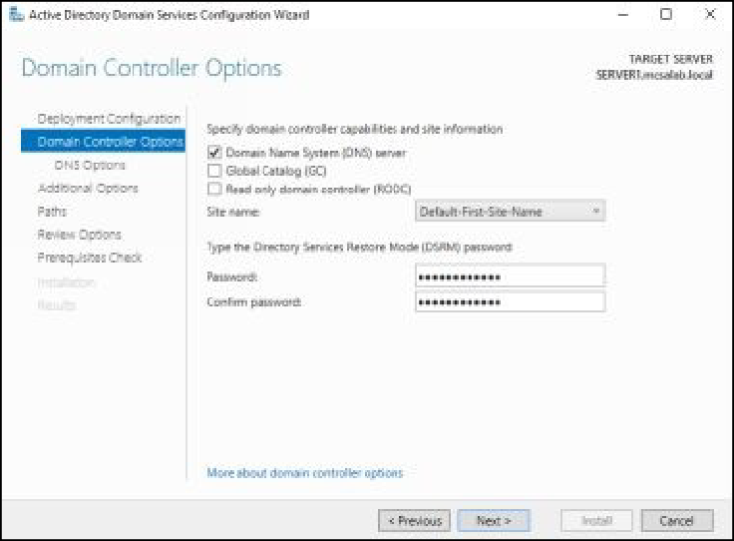

1. Click Next, until the **Prerequisites Check** page is displayed.
2. On the **Prerequisites Check** page, review the warnings, and then

click **Install**.

1. The installation process will start, click **Close**, once the installation

is completed.

1. The server will restart. Wait for server to restart.

# Task 3: Configuring SERVER1 as a Global Catalog Server

1. Switch and sign in to **SERVER1** with the MCSALAB\Administrator account
2. On the **Server Manager** console, click **Tools,** and then click **Active**

## Directory Sites and Services.

1. On the **Active Directory Sites and Services** console, expand

**Sites\Default-First-Site-Name\Servers,** and then click **SERVER1**, as shown in the following figure.

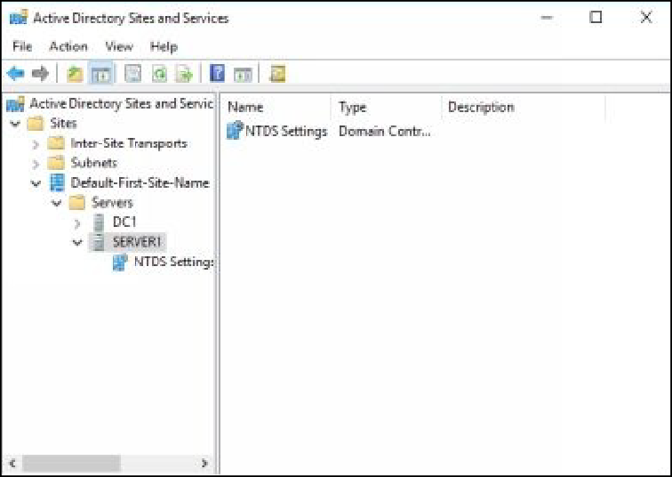

1. In the left pane, select and right-click **NTDS Settings**, and then

select **Properties**.

1. On the **NTDS Settings Properties** dialog box, select the **Global Catalog** check box, as shown in the following figure, and then click

**OK**.

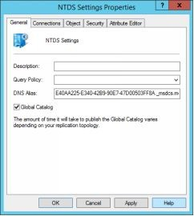

1. Close the **Active Directory Sites and Services** console.

***Results****: After completing this exercise, you will have explored the Server Manager console and promoted a member server to be a domain controller.* Shut down and revert the DC1 and SERVER1 virtual machines to prepare for the next exercise.

# Exercise 5: Installing a Domain Controller by Using IFM

In this exercise, you will learn how to configure a domain controller using the IFM data file. The Install From Media (IFM) is a feature that allows you to configure a server as a domain controller. This feature helps you to reduce the network bandwidth consumption used during the additional domain controller configuration. IFM allows you to export the Active Directory database file (NTDS) to an external media which can be used to configure an additional domain controller.

Start the DC1 and SERVER1 virtual machines to perform this exercise.

# Task 1: Generating a IFM Data File

1. Sign in to **DC1** with the MCSA\Administrator account.
2. Open the **Run** dialog box, in the **Open** text box, type **cmd**, and then

press **Enter**.

1. On the **Command Prompt** window, type the following commands, and then press **Enter** after each one, as shown in the following

figure.

## Ntdsutil Activate instance ntds IFM Create sysvol full C:\IFM

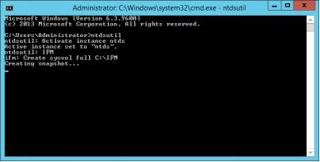

**Task 2: Adding the AD DS Role to the Member Server**

1. Switch and sign in to **SERVER1** with the

MCSALAB\Administrator account.

1. Open the **Command Prompt** window, type the following command, and then press **Enter**, as shown in the following figure.

## Net use Z: \\DC1\c$\IFM

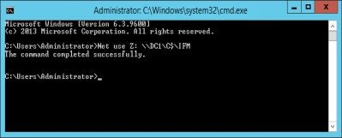

1. Open the **Server Manager** console, if required.
2. In the left pane, select **Local Server**.
3. In the toolbar, click **Manage, and then click Add Roles and Features**, as shown in the following figure.

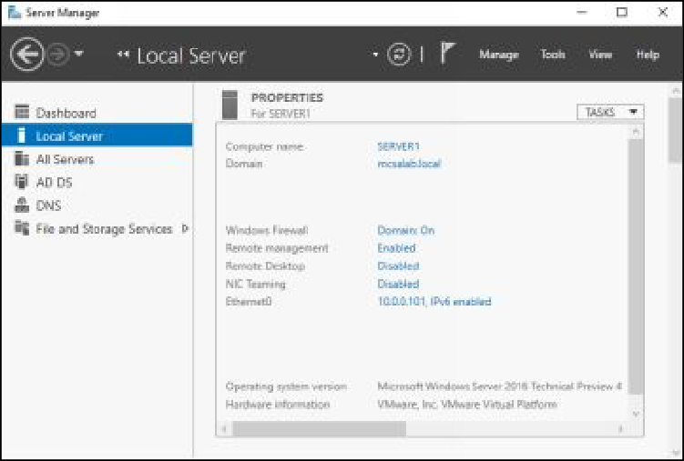

1. On the **Before you begin** page of the **Add Roles and Features**

**Wizard**, click **Next**.

1. On the **Select installation type** page, make sure that the **Role- based or feature-based installation** radio button is selected, and

then click **Next**.

1. On the **Select destination server** page, make sure that the

**SERVER1** server is selected, and then click **Next**.

1. On the **Select server roles** page, select the **Active Directory**

**Domain Services** check box.

1. On the **Add Roles and Features Wizard** dialog box, click **Add**

**Features**, and then click **Next**.

1. On the **Select Features** page, click **Next**.
2. On the **Active Directory Domain Services** page, click **Next**.
3. On the **Confirm installation selections** page, select the **Restart the destination server automatically if required** check box.
4. On the **Add Roles and Features Wizard** message box, as shown in the following figure, read the message, and then click **Yes**.

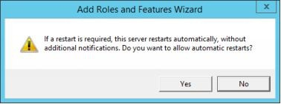

1. On the **Confirm installation selections** page, click **Install**.
2. The installation process will start. Click **Close**, once the installation

is completed.

***Note****: If you see a warning regarding the DNS server delegation, click OK.*

# Task 3: Configuring SERVER1 as a New Domain Controller Using the IFM Data File

1. On **SERVER1**, open the **Command Prompt** window, if required.
2. On the **Command Prompt** window, type the following commands, and then press **Enter**, as shown in the following figure.

**Robocopy Z: C:\IFM *copyall* s**

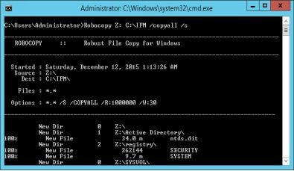

1. Close the **Command Prompt** window, once the copying process is

completed.

1. On the **Server Manager** console, click the **Notifications** button.
2. In the **Post-deployment Configuration** box, click the **Promote this server to a domain controller** link.
3. On the **Deployment Configuration** page, make sure that the **Add a domain controller to an existing domain** radio button is selected.
4. Make sure that the **mcsalab.local** text is written in the **Domain** text box, as shown in the following figure.

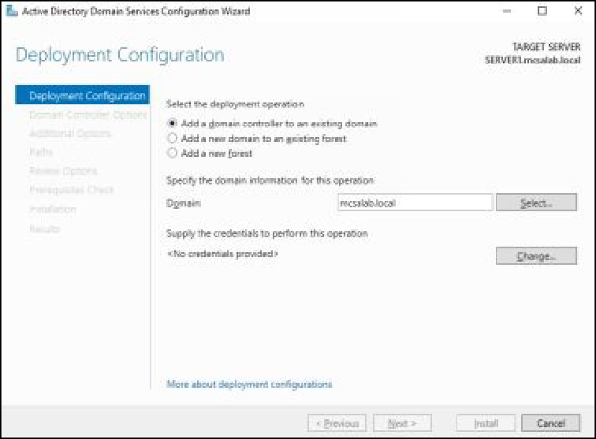

1. In the **Supply the credentials to perform this operation** section,

click **Change**.

***Note****: If you are already logged in as MCSA\Administrator account, you don’t*

*need to change the credentials on this page. If so, move directly to the Domain Controller Options page.*

1. On the **Windows Security** dialog box, in the **Username** text box, type **MCSALAB\Administrator**, in the **Password** text box, type

## Password@123.

1. Click **OK**, and then click **Next**.
2. On the **Domain Controller Options** page, make sure that the

## Domain Name System (DNS) server and Global Catalog (GC)

check boxes are selected.

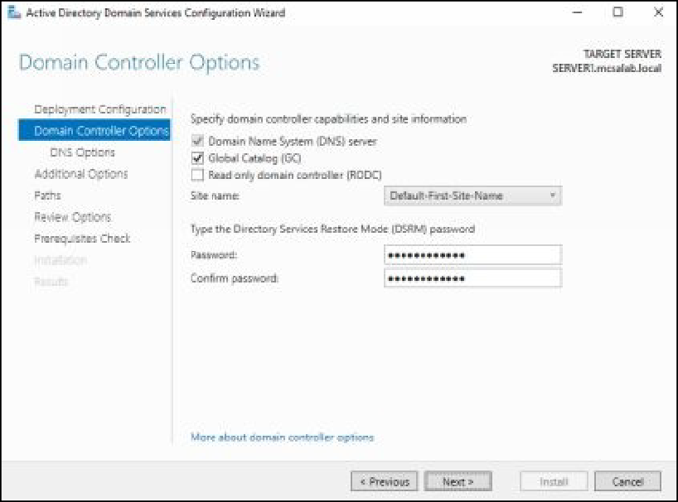

1. Under the **DSRM password** section, type **Password@123** in the

**Password** and **Confirm password** text boxes and then click **Next**.

1. On the **DNS Options** page, click **Next**.
2. On the **Additional Options** page, select the **Install from media**

check box.

1. In the **Path** text box, type **C:\IFM**, as shown in the following

figure.

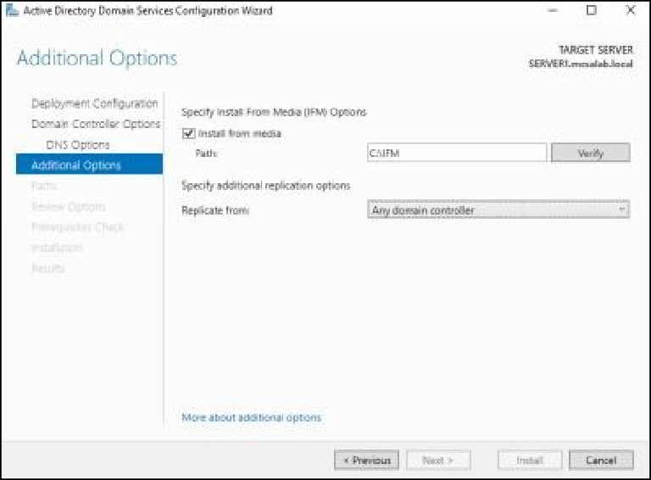

1. Click **Verify**. Once the path has been verified, click **Next**.
2. On the **Paths** page, click **Next**.
3. On the **Review Options** page, click **Next**.
4. On the **Prerequisites Check** page, click **Install**. The installation process will start and the server will restart, once the configuration

is completed. Wait for the server to restart.

***Results****: After completing this exercise, you will have installed an additional domain controller for the branch office by using IFM.*

Shut down and revert the DC1 and SERVER1 virtual machines to prepare for the next exercise*.*

# Exercise 6: Managing Organizational Units and Groups in AD DS

Active Directory objects are used to access the various network resources for the various purposes. Once you configured a domain controller, you need to create and manage Active Directory objects, such as OUs, groups, and users. You can delegate the administrative permissions to the Active Directory objects.

In this exercise, you will learn how to create Active Directory objects, how to delegate the permissions, and how to configure home folders. In addition, you will also learn how to reset and rejoin the computer accounts.

Start the DC1 and CLIENT1 virtual machines to perform this exercise.

# Task 1: Managing Organizational Units and Groups

1. Sign in to **DC1** with the MCSALAB\Administrator account.
2. On the **Server Manager** console, click **Tools, and then click Active Directory Users and Computers**.
3. On the **Active Directory Users and Computers** console, select and right-click **mcsalab.local**, and then select **New**, and then click

**Organizational Unit**, as shown in the following figure.

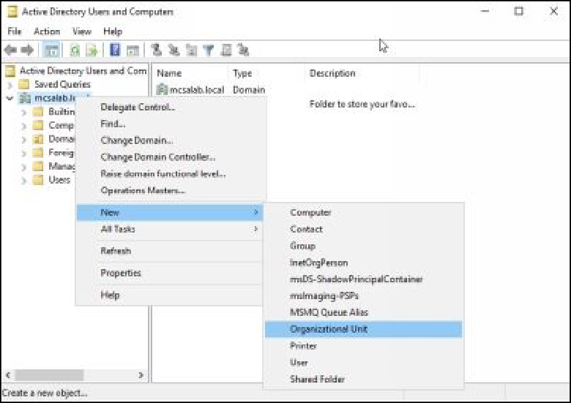

1. On the **New Object – Organizational Unit** dialog box, in the

**Name** text box, type **Training**, as shown in the following figure, and then click **OK**.

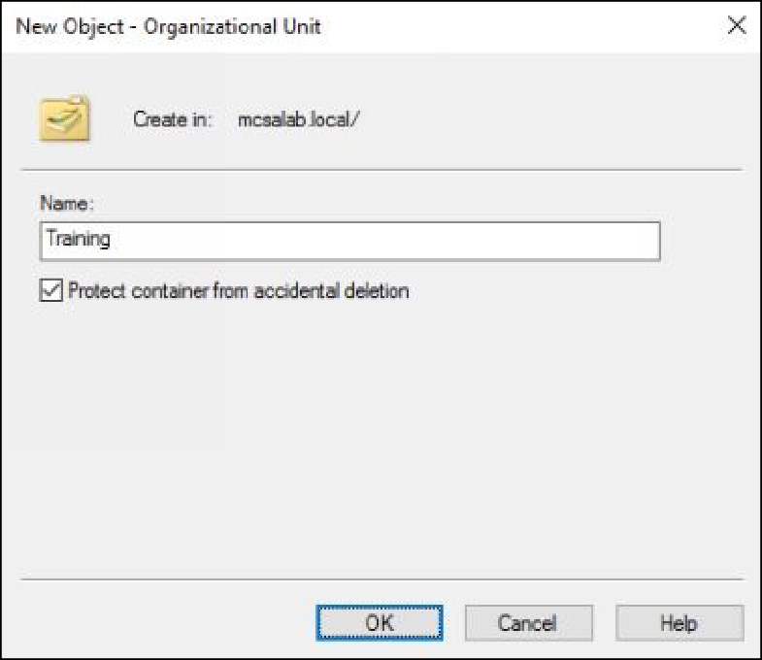

1. Select and right-click the **Training** OU in the left pane, and then

select **New**, and then click Group.

1. On the **New Object – Group** dialog box, in the **Group name** text box, type **Students**, as shown in the following figure, and then click

**OK**.

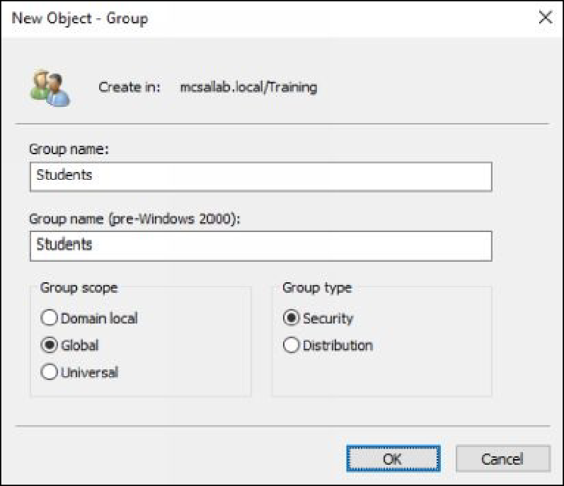

1. Select and right-click **mcsalab.local**, in the left pane, and then select **New**, and then click **Organizational Unit**.
2. On the **New Object – Organizational Unit** dialog box, in the

**Name** text box, type **Development**, and then click **OK**.

1. Select and right-click the D**evelopment** OU, and then select **New,**

and then click **Group**.

1. On the **New Object – Group** dialog box, in the **Group name** text box, type **Trainers**, and then click **OK**.
2. Select and right-click the **Development** OU, and then select **New**,

and then click **Group**.

1. On the **New Object – Group** dialog box, in the **Group name** text box, type **Managers**, and then click **OK**.
2. In the right pane, select and right-click the **Trainers** group, and then select **Move**, as shown in the following figure.

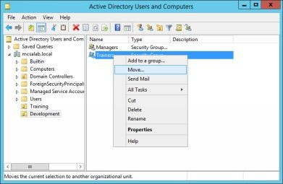

1. On the **Move** dialog box, select the **Training** OU, as shown in the following figure, and then click **OK**.

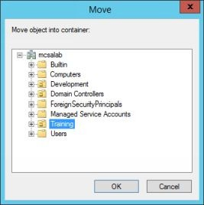

1. In the left pane, select the **Training** OU.
2. In the right pane, select and right-click **Trainers**, and then select

## Delete.

1. On the **Active Directory Domain Services** message box, click

**Yes**. Make sure that the **Trainers** group is deleted.

# Task 2: Delegating the Permissions

1. Make sure that the **Active Directory Users and Computers**

console is active on **DC1**.

1. In the left pane, select and right-click the **Training** OU, and then

select **Delegate Control**, as shown in the following figure.

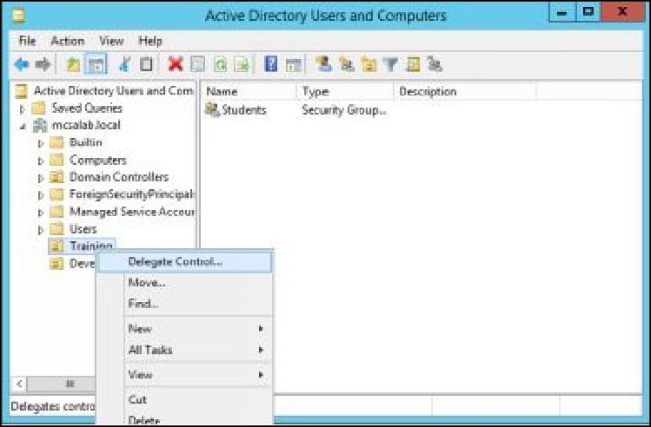

1. On the welcome page of the **Delegation of Control Wizard**, and

click **Next**.

1. On the **Users or Groups** page, click **Add**.
2. On the **Select Users, Computers, or Groups** dialog box, in the

**Enter the object names to select (examples)** text box, type

**Students**, as shown in the following figure, and then click **OK**.

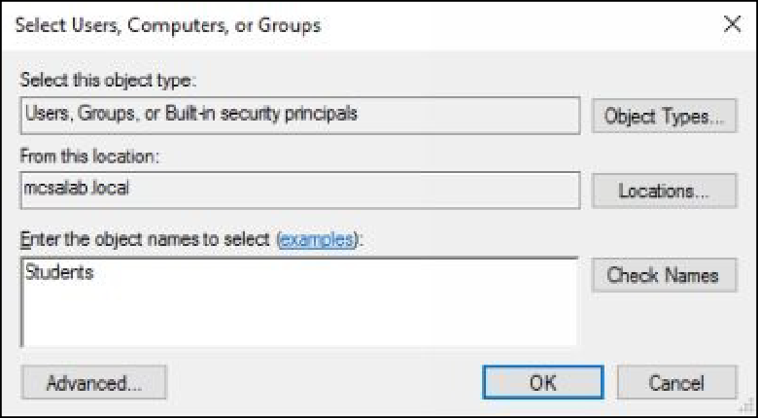

1. On the **Users or Groups** page, click **Next**.
2. On the **Tasks to Delegate** page, make sure that the **Delegate the following common tasks** radio button is selected.
3. Select the **Create, delete, and manage user accounts** check box, as shown in the following figure, and then click **Next**.

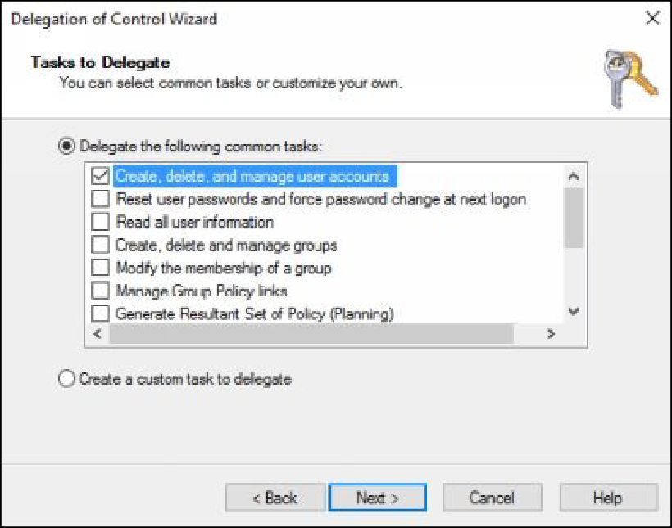

1. On the **Completing the Delegation of Control Wizard** page, click

## Finish.

1. Select and right-click the **Training** OU, and then select **New**, and

then click **User**.

1. On the **New Object - User** dialog box, type **Marsh**, in the **First name** and **User logon name** text boxes, as shown in the following

figure, and then click **Next**.

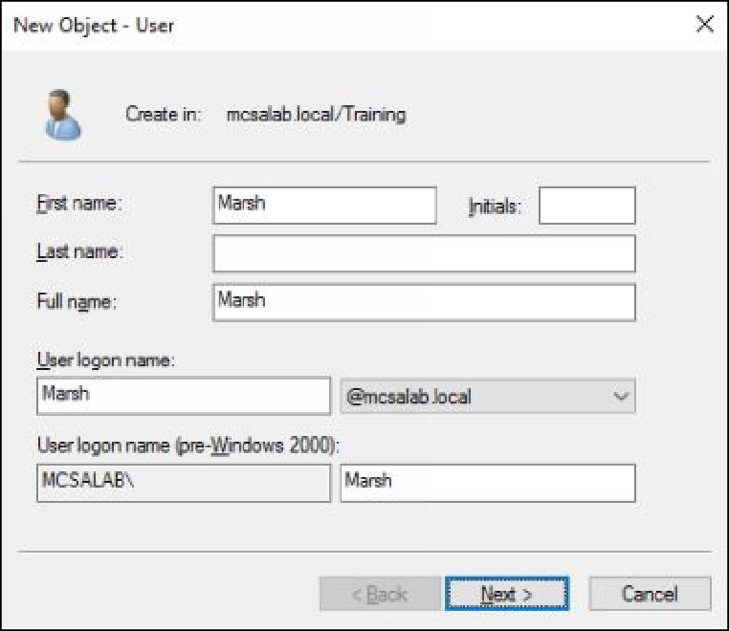

1. In the **Password** and **Confirm password** text boxes, type

## Password@123.

1. Clear the **User must change password at next logon** check box, select the **Password never expires** check box, as shown in the

following figure.

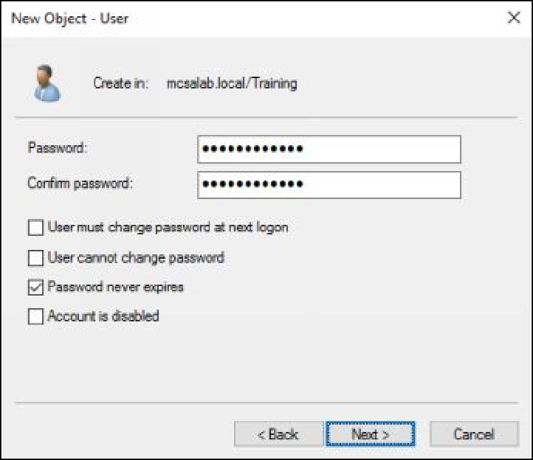

1. Click **Next**, and then click **Finish**.
2. Minimize the **Active Directory Users and Computers** console.

# Task 3: Configuring Home Folders for User Accounts

1. On DC1, create a folder named **Marsh Data**, under the

**C:\Users\Public** folder, as shown in the following figure.

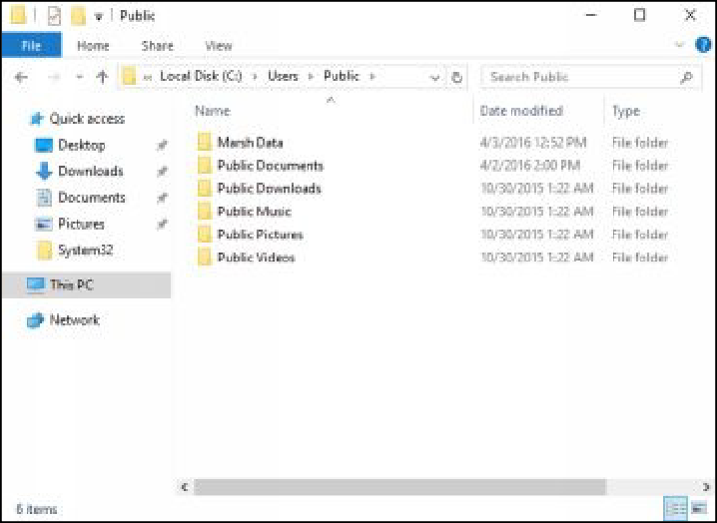

1. Select and right-click the **Marsh Data** folder, and then select

## Properties.

1. On the **Marsh Data Properties** dialog box, select the **Sharing** tab,

as shown in the following figure.

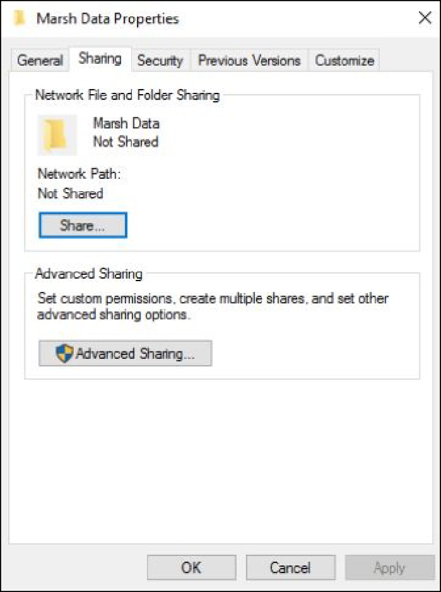

1. Click **Advanced Sharing**.
2. On the **Advanced Sharing** dialog box, select the **Share this folder**

check box, as shown in the following figure.

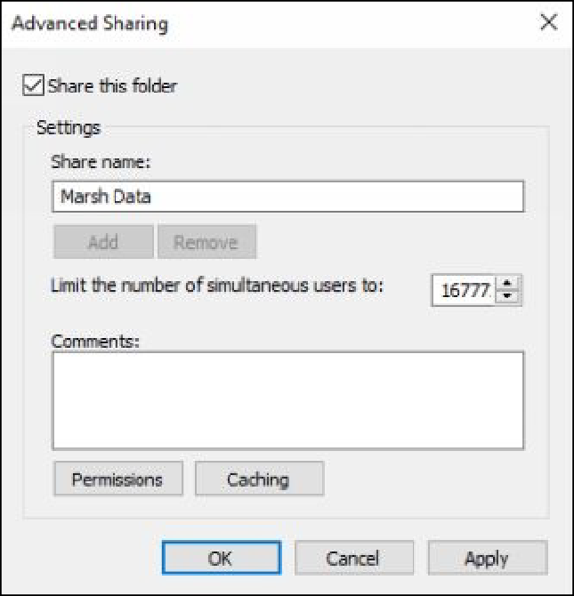

1. Click **Permissions**.
2. On the **Permissions for Marsh Data** dialog box, in the

**Permissions for Everyone** section, select the **Full Control** check box, as shown in the following figure.

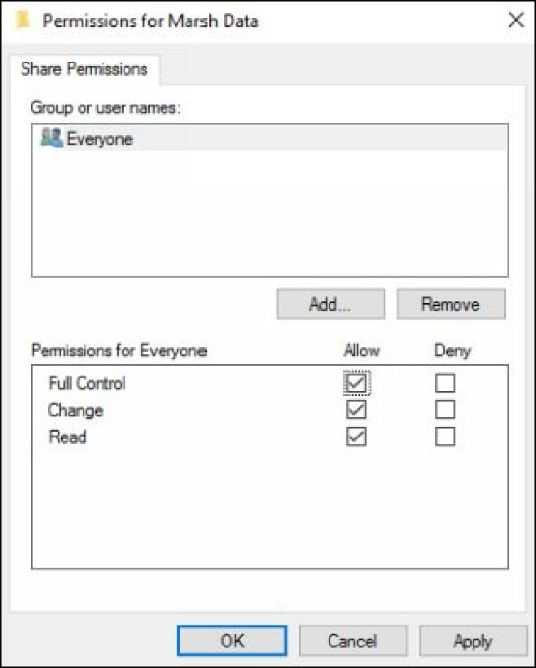

1. Click **Apply**, and then click **OK**.
2. Click **OK** to close **Advanced Sharing** dialog box, and then click

## Close.

1. Close the **Windows Explorer** window.
2. Switch to the **Active Directory Users and Computers** console.
3. Select and right-click the **Marsh** user, and then select **Properties**.
4. On the **Marsh Properties** dialog box, select the **Profile** tab.
5. Under the **Home folder** section, select the **Connect** radio button.
6. In the **To** text box, type **\\DC1\Marsh Data\Marsh**, as shown in the following figure, and then click **Apply**.

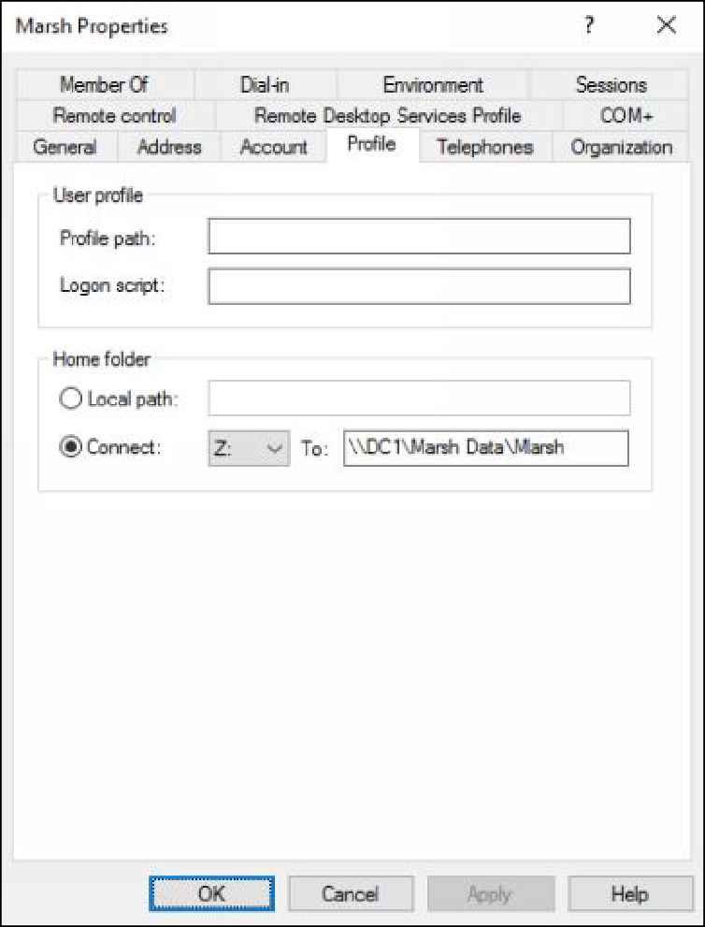

***Note****: By default all the domain users are denied to sign in to the Domain Controller server. In the next steps, we are going to make Marsh as the member of Print Operators group to sign in to Domain Controller to test the exercise.*

*You will learn more about the user rights and permissions in the upcoming exercises.*

1. Select the **Member Of** tab, and then click **Add**.
2. On the **Select Groups** dialog box, in the **Enter the object names to select (example)** text box, type **Print Operators**, as shown in

the following figure.

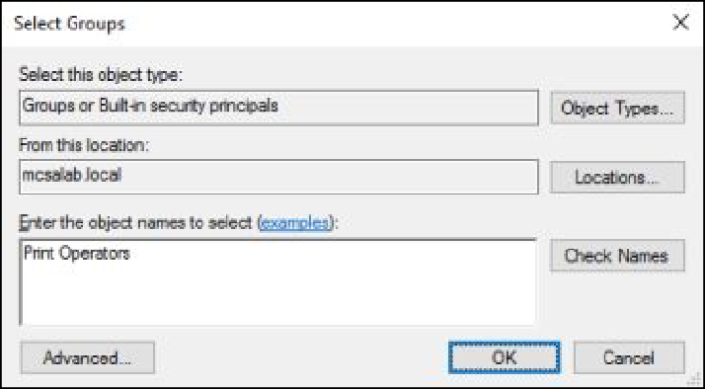

1. Click **Check Names**, and then click **OK**.
2. On the **Member Of** tab, and click again **Add**.
3. On the **Select Groups** dialog box, in the **Enter the object names to select (example)** text box, type **Students**.
4. Click **Check Names**, and then click **OK**.

***Note****: You have added the Marsh user to Students group to test the delegated permissions.*

1. Click **OK** to close the **Marsh Properties** dialog box.
2. Close the **Active Directory Users and Computers** console.

# Task 4: Testing and Verifying the Home Folders and Delegated Permissions

1. On **DC1**, open the **Run** dialog box, type **logoff** and then click **OK**

to sign out from the **MCSALAB\Administrator** account, as shown in the following figure.

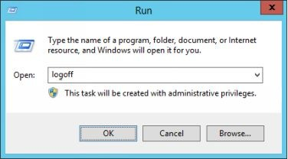

1. Switch to **Other user** and **Sign in** as **Marsh** with the password as

**Password@123**, as shown in the following figure.

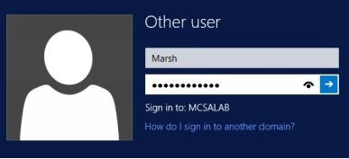

1. Press the **Windows+E** keys to open the **Windows Explorer**

window.

1. Verify that drive **Z** is mapped to **(\\DC1\Marsh Data),** as shown in

the following figure.

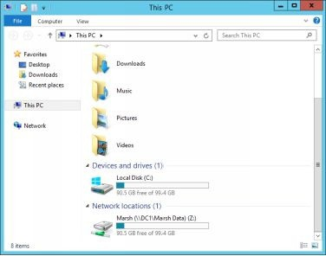

1. Double-click **Marsh (\\DC1\Marsh Data) (Z:)**.

***Note****: You should be able to access this drive without any errors. If you receive no errors, you have been successful.*

1. Close the **Windows Explorer** window.
2. Open the **Run** dialog box, type **dsa.msc**, in the **Open** text box, and

then press **Enter**.

1. On the **User Account Control** dialog box, in the **User name** text

box, type **Marsh**.

1. In the **Password** text box, type **Password@123**, as shown in the following figure, and then click **Yes**.

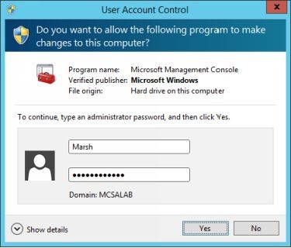

1. On the **Active Directory Users and Computers** console, expand

## mcsalab.local.

1. Select and right-click **Training, and then click New**, and then

click **User**.

1. On the **New Object – User** dialog box, in the **First name** and **User logon name** text boxes, type **Test User2**, and then click **Next**.
2. In the **Password** and **Confirm password** text boxes, type

## Password@123.

1. Click **Next**, and then click **Finish**.
2. Make sure that the **Test User1** account is created, under the

## Training OU.

1. Select and right-click **Development, and then click New**, and then

click **User**.

1. On the **New Object – User** dialog box, in the **First name** and **User logon name** text boxes, type **Test User2**, and then click **Next**.
2. In the **Password** and **Confirm password** text boxes, type

**Password@123**, click **Next**, and then click **Finish**.

1. Make sure that you get the following error message.

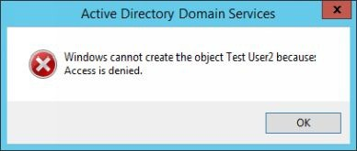

1. Click **OK**, and then click **Cancel**.
2. Close the **Active Directory Users and Computers** console.
3. Sign out from the **Marsh** user.

# Task 5: Resetting the Computer Accounts

1. Sign in to **DC1** with the MCSALAB\Marsh account.
2. On the **Server Manager** console, click **Tools, and then click Active Directory Users and Computers**.
3. On the **Active Directory Users and Computers** console, expand

## mcsalab.local.

1. In the left pane, select **Computers**.
2. In the right pane, select and right-click **CLIENT1**, and then click

**Reset Account**, as shown in the following figure.

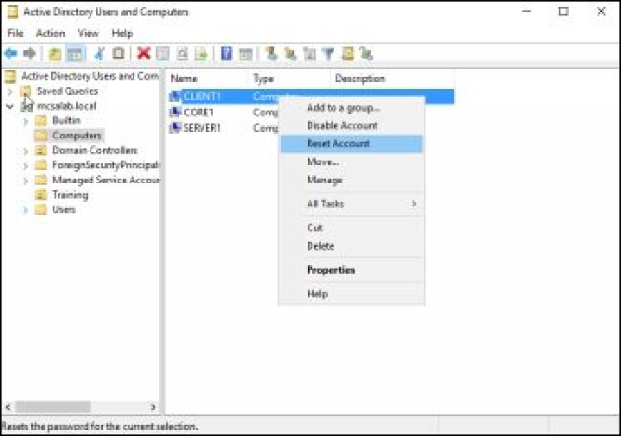

1. On the **Active Directory Domain Services** message box, click **Yes**,

and the click **OK**.

# Task 6: Examining the Behavior when a User Logins on Client.

1. Try to Sign in to **CLIENT1** with the MCSALAB\Marsh account.
2. A message displays stating that **The trust relationship between this workstation and the primary domain failed**, as shown in the

following figure.

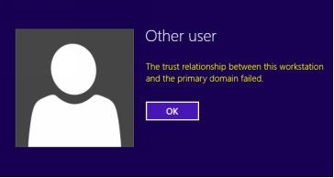

# Task 7: Rejoining the Domain to Reconnect the Computer Account

1. Sign in to **CLIENT** as CLIENT1\Administrator with the password

as **Password@123**.

1. Open the **System Properties** dialog box, click **Network ID**.
2. On the **Select the option that describes your network** page, as shown in the following figure, click **Next**.

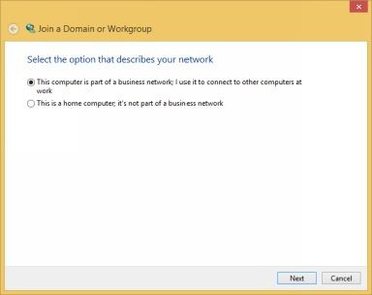

1. On the **Is your company network on a domain?** page, click **Next**.
2. On the **You will need the following information** page, click **Next**.
3. On the **Type your user name**, **password**, and **domain name for your domain account** page, in the **User name** text box, type

Administrator.

1. In the **Password** text box, type **Password@123**.
2. In the **Domain name** text box, type **MCSALAB.LOCAL**, as shown in the following figure, and then click **Next**.

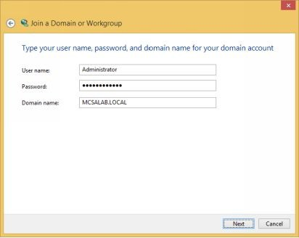

1. On the **User Account and Domain Information** dialog box, click

**Yes**.

1. On the **Do you want to enable a domain user account on this computer?** page, select the **Do not add a domain user account**

radio button, and then click **Next**.

1. Click **Finish**, and then click **OK**.
2. On the **Microsoft Windows** dialog box, click **Restart Now**. Wait

for system to restart.

1. Sign in as **MCSALAB\Marsh** with the password as

## Password@123.

1. Make sure that you are able to sign in.

***Results****: After this exercise, you have successfully created and tested Organizational Units, Groups, Users, Home Folders, and the Delegation of Control Wizard. In addition, you should also have successfully reset a trust relationship* Shut down and revert the DC1 and CLIENT1 virtual machines to prepare for the next exercise.

# Exercise 7: Using Windows PowerShell to Create User Accounts and Groups

As discussed earlier, Window PowerShell is a command-line interface used to manage Windows servers and clients. You can also use Windows PowerShell to manage the Active Directory objects.

In this exercise, you will learn how to manage Active Directory objects using Window PowerShell. In addition, you will also learn how to export and import the Active Directory objects using Window PowerShell.

Start the DC1 and CLIENT1 virtual machines to perform this exercise.

# Task 1: Creating a User Account Using Windows PowerShell

1. Sign in to **DC1** with the MCSALAB\Administrator account.
2. On the taskbar, click the **Windows PowerShell** icon.
3. At the **Windows PowerShell** prompt, type **cd\** and then press Enter.
4. To create an **Organizational Unit** named **BranchOffice**, type the following command, and then press Enter:

## New-ADOrganizationalUnit BranchOffice

1. To create a user named **Peter** under the **BranchOffice** OU, type the following command, and then press Enter:

## New-ADUser -Name Peter -DisplayName "Peter Mark" -Path "ou=BranchOffice,dc=mcsalab,dc=local"

1. To set the password for **Peter** user, type the following command,

and then press **Enter**:

**Set-ADAccountPassword Peter** When prompted for the current password, press **Enter**.

When prompted for the desired password, type **Password@123**, and then press **Enter**.

When prompted to repeat the password, type **Password@123**, and then press **Enter**.

1. To enable the **Peter** user, type the following command, and then

press **Enter**.

## Enable-ADAccount Peter

1. Switch to the **CLIENT1** virtual machine.
2. On **CLIENT1**, sign in as **Peter** with the password as

## Password@123.

1. Verify that sign in is successful, and then sign out of **CLIENT1**.

# Task 2: Creating Groups Using Windows PowerShell

1. Switch back to **DC1**.
2. At the **Windows PowerShell** prompt, type the following command to create a new security (global) group named **BranchUsers**, and

then press **Enter**.

## New-ADGroup BranchUsers -Path "ou=BranchOffice,dc=mcsalab,dc=local"

1. At the **GroupScope** prompt: type **Global** and then press **Enter**, as

shown in the following figure.

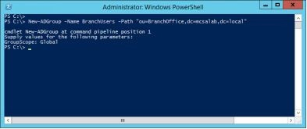

1. To add the **Peter** user as member of the **BranchUsers** group, type the following command, and then press **Enter**.

## Add-ADGroupMember BranchUsers -Members Peter

1. To view the members of the **BranchUsers** group, type the following command, and then press **Enter**.

## Get-ADGroupMember BranchUsers

**Task 3: Exporting User Accounts Using the ldifde Tool**

1. At the **Windows PowerShell** prompt, type the following command, and then press **Enter**, as shown in the following figure.

## ldifde -f MyUsers

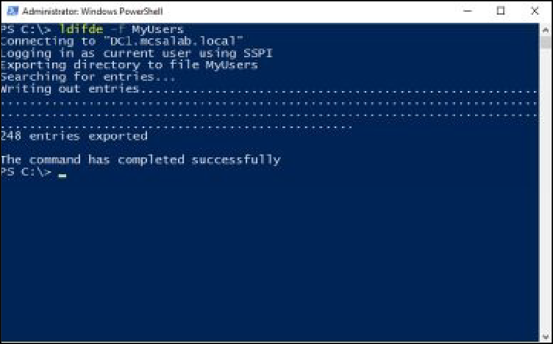

1. At the **Windows PowerShell** prompt, type notepad **MyUsers** and

then press **Enter**.

1. Review the **MyUsers** file and close the **Notepad**.

***Results****: After completing this exercise, you have managed AD DS objects using Windows PowerShell.*

Shut down and revert the DC1 and CLIENT1 virtual machines to prepare for the next exercise.

# Exercise 8: Installing and Configuring the DHCP Server Role

Dynamic Host Configuration Protocol (DHCP) is as service that is used to provide TCP/IP settings, such as IP address, subnet mask, default gateway, and DNS server to the clients, automatically. In a large enterprise network, it is difficult to manage IP addresses manually. Hence, DHCP can be a useful feature to manage the IP addresses in a large enterprise network.

In this exercise, you will learn how to install the DHCP server role and how to configure the DHCP scope. In addition, you will also learn how to use the DHCP reservation feature to reserve a specific IP address for a specific client.

Start the DC1 and CLIENT1 virtual machines to perform this exercise.

# Task 1: Installing the DHCP Server Role

1. Sign in to **DC1** with MCSALAB\Administrator account.
2. Open the **Server Manager** console, if required.
3. On the **Server Manager** console, click the **Add roles and features**

link.

1. On the **Add Roles and Features Wizard**, click **Next**.
2. On the **Select installation type** page, make sure that the **Role- based or feature-based installation** radio button is selected, and

then click **Next**.

1. On the **Select destination server** page, click **Next**.
2. On the **Select server roles** page, select the **DHCP Server** check

box.

1. On the **Add Roles and Features Wizard** dialog box, click **Add**

## Features.

1. The **Select server roles** page is returned, as shown in the following

figure, click **Next**.

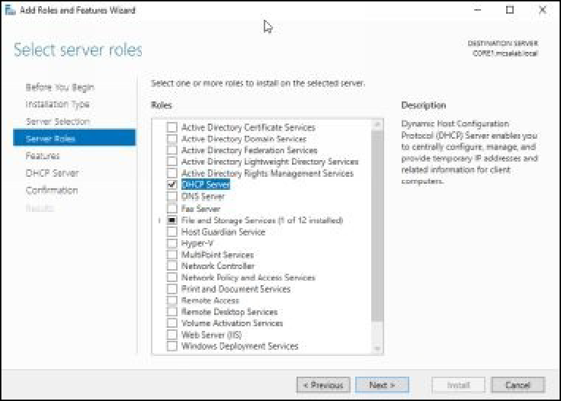

1. Complete the installation process.

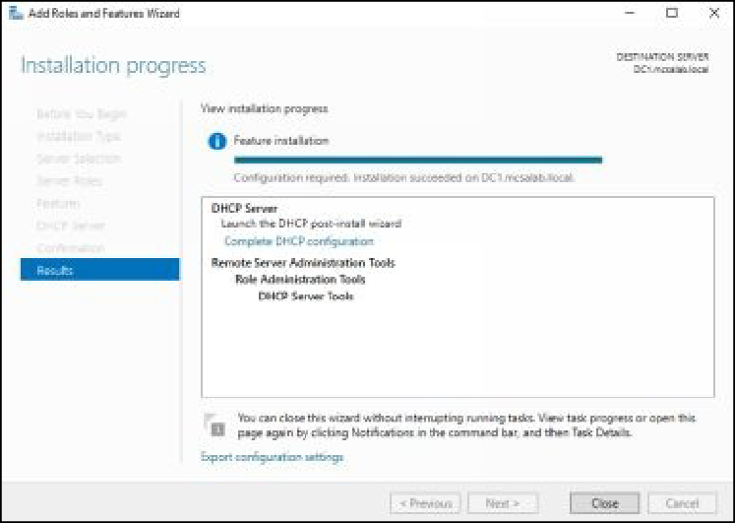

# Task 2: Configuring the DHCP Scope

1. On the **Server Manager** console, click **Tools**, and then click

## DHCP.

1. On the **DHCP** console, in the left pane, expand **dc1.mcsalab.local**.
2. Select and right-click **dc1.mcsalab.local**, and then select

## Authorize.

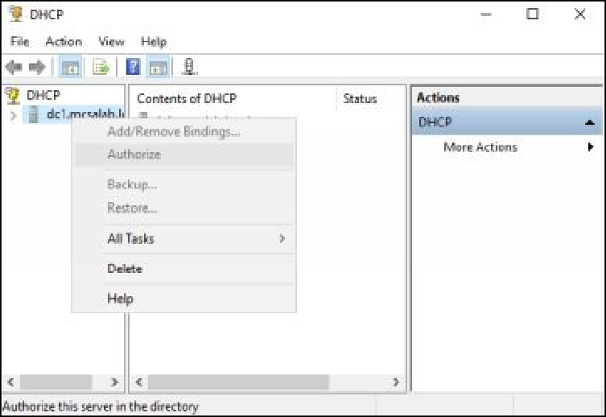

1. Select and right-click **dc1.mcsalab.local**, and then click **Refresh**.

Notice that the icons next to IPv4 IPv6 changes color from red to green, as shown in the following figure.

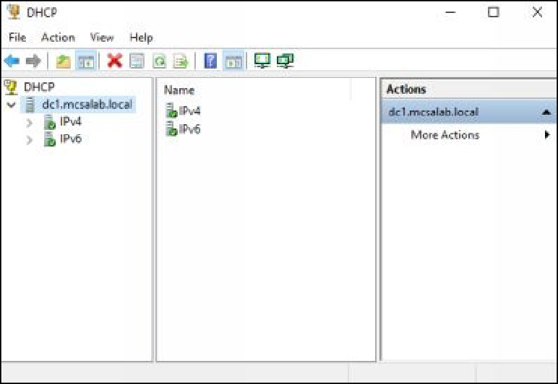

1. On the **DHCP** console, select and right-click **IPv4**, and then select

## New Scope.

1. On the welcome page of the **New Scope Wizard**, click **Next**.
2. On the **Scope Name** page, in the **Name** text box, type

**DHCPScope1**, as shown in the following figure, and then click

## Next.

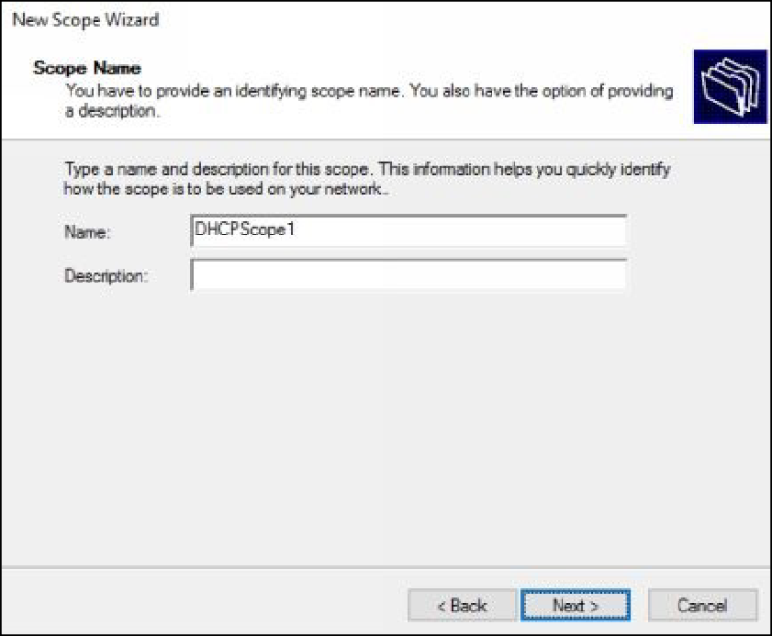

1. On the **IP Address Range** page, provide the following information, as shown in the following figure, and then click **Next**.

Start IP address: **10.0.0.225** End IP address: **10.0.0.250** Length: **8**







Subnet mask: **255.0.0.0**



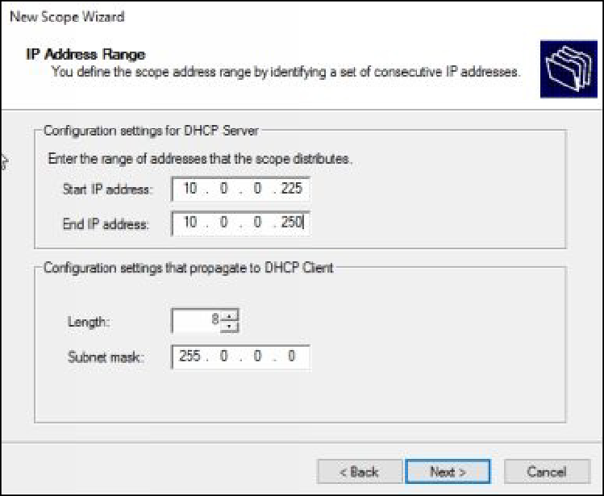

1. On the **Add Exclusions and Delay** page, exclude the following IP address range, as shown in the following figure.

Start IP address: **10.0.0.225**



End IP address: **10.0.0.230**



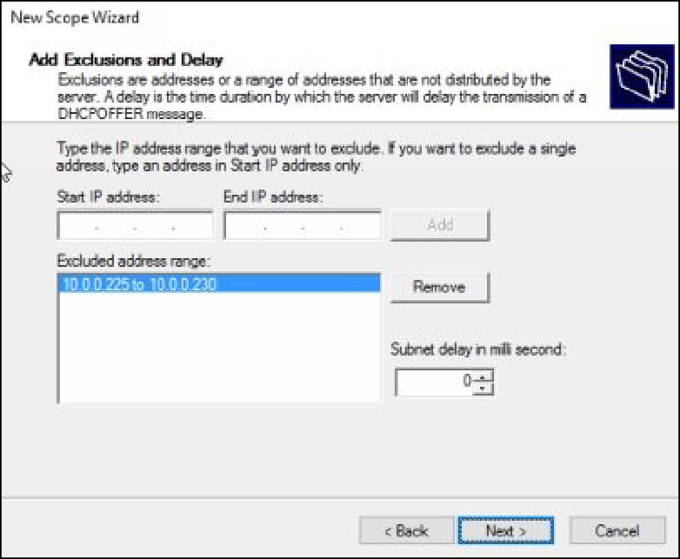

1. Click **Add**, and then click **Next**.
2. On the **Lease Duration** page, review the default lease duration

limit, and then click **Next**.

1. On the **Configure DHCP Options** page, make sure that the **Yes**, I want to configure these option now radio button is selected, as

shown in the following figure, and then click **Next**.

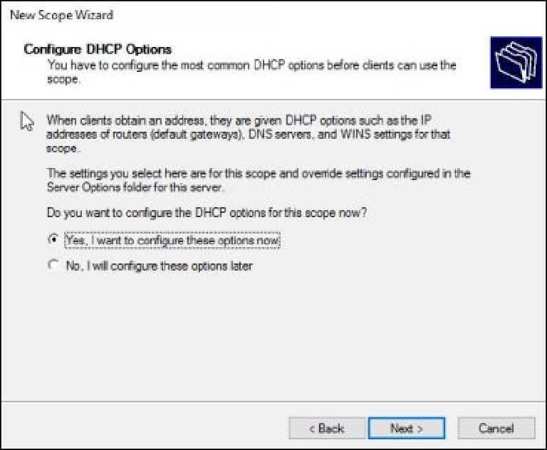

1. On the **Router (Default Gateway)** page, in the **IP address** text box, type **10.0.0.0.1**, as shown in the following figure.

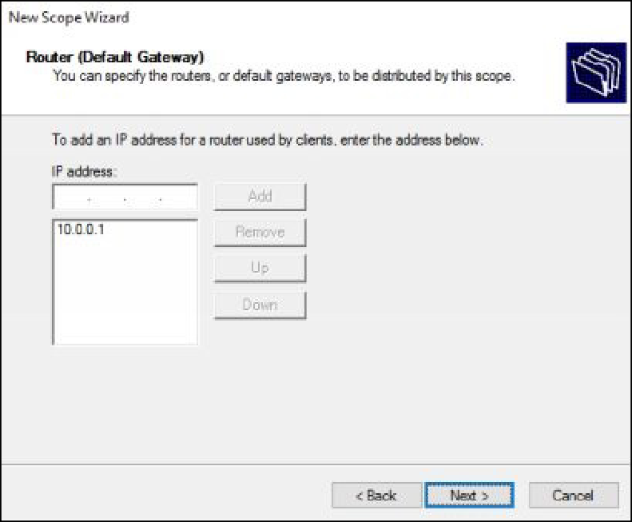

1. Click **Add**, and then click **Next**.
2. On the **Domain Name and DNS Servers** page, make sure that

**10.0.0.100** is written under the **IP address** column, as shown in the following figure, and then click **Next**.

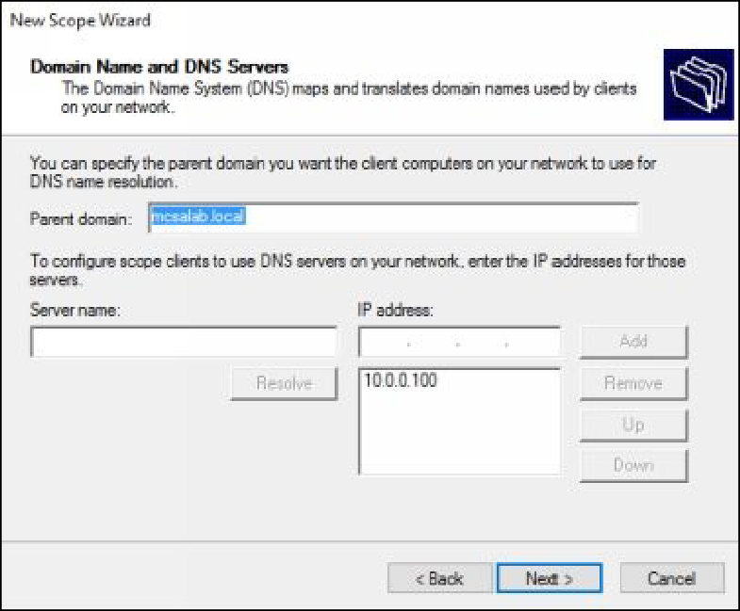

1. On the **WINS Servers** page, click **Next**.
2. On the **Activate Scope** page, make sure that the **Yes, I want to activate this scope now** radio button is selected, as shown in the

following figure, and then click **Next**.

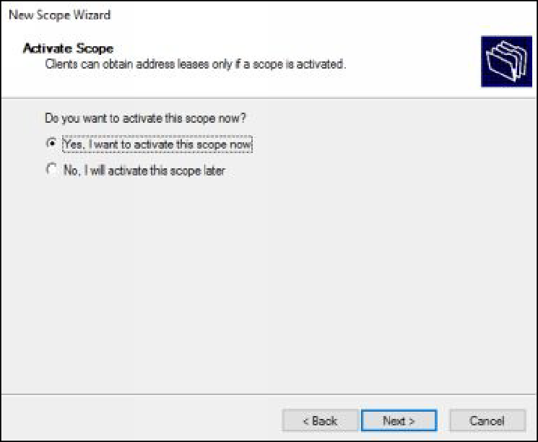

1. On the **Completing the New Scope Wizard** page, click **Finish**.
2. Select and right-click **IPv4**, and then select **Refresh**.
3. Make sure that the IPv4 node is marked with the green color, as

shown in the following figure.

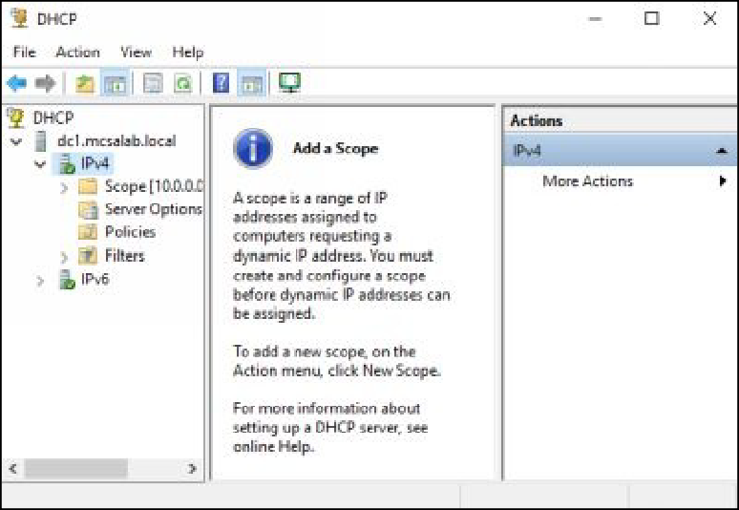

# Task 3: Configuring DHCP Client

1. Open the **Network Connections** window, select and right-click the active network adapter and then select **Properties**.
2. On the **Properties** dialog box, scroll down, select **Internet Protocol Version 4 (TCP/IPv4)**, and then click **Properties**.
3. On the **Internet Protocol Version 4 (TCP/IPv4) Properties** dialog box, select the **Obtain an IP address automatically** radio button, select the **Obtain DNS server address automatically** radio button,

as shown in the following figure.

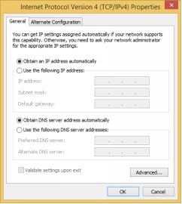

1. Click **OK**, and then click **Close**.
2. Open the **Run** dialog box, type **cmd**, and then press **Enter**.
3. On the **Command Prompt** window, type **ipconfig /renew**, as shown in the following figure, and then press **Enter**.

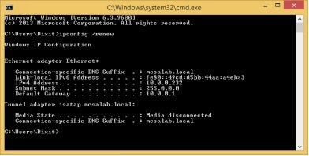

1. Type the **ipconfig /all** command and verify that **CLIENT1** has received TCP/IP settings, such as IP address, subnet mask, default gateway, and DNS server’s IP address, as shown in the following

figure.

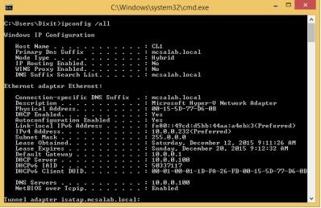

# Task 4: Configuring DHCP Reservation

1. On **CLIENT1**, on the **Command Prompt** window, type **ipconfig**

**/all**, and then press **Enter**.

1. Find and write down the **Physical Address** of the **CLIENT1**

network adapter, in this case it is **00-15-5D-77-D6-0B**, as shown in the following figure.

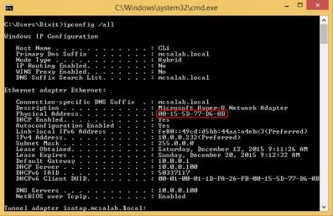

***Note****: The physical address is a unique 48 bit address, which is assigned by IEEE and network adapter’s vendor.*

1. Switch and sign in (if required) to **DC1** with the

MCSALAB\Administrator account.

1. Make sure that the **DHCP** console is active. If not, open the **DHCP**

console.

1. On the **DHCP** console, expand **dc1.mcsalab.local**, and then click

## IPv4.

1. Select and right-click **Reservations**, and then select **New Reservation**, as shown in the following figure.

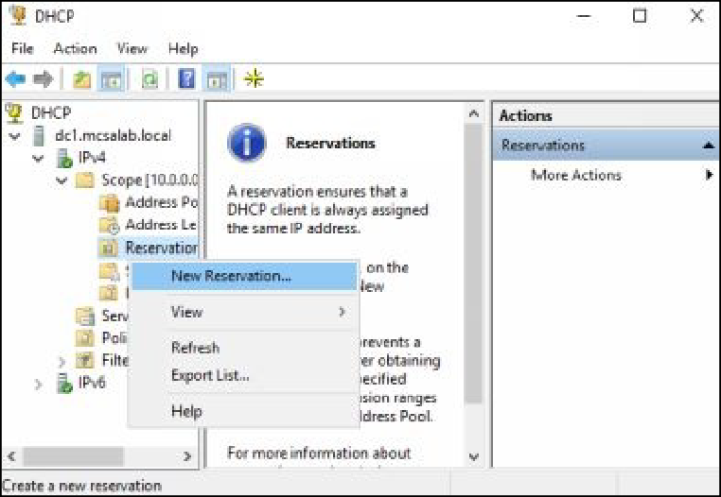

1. On the **New Reservation** dialog box, in the **Reservation Name** text

box, type **CLIENT1**.

1. In the **IP address** text box, type **10.0.0.240**.
2. In the **MAC address** text box, type the physical address of the

**CLIENT1** machine (00-15-5D-77-D6-0B), as shown in the following figure.

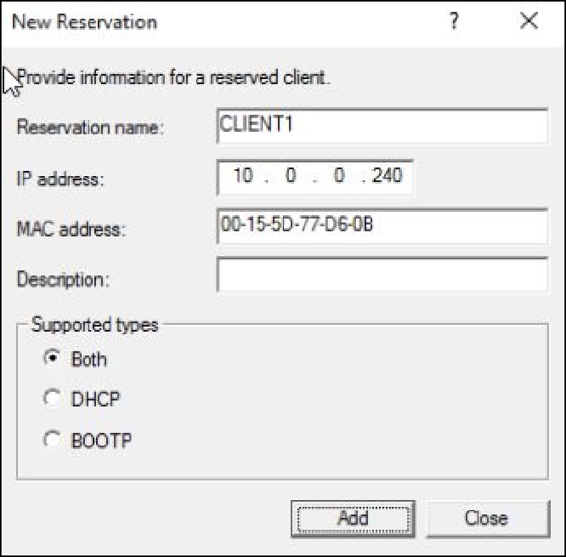

***Note****: Replace the physical address text with the actual physical address of your CLIENT1 machine.*

1. Click **Add**, and then click **Close**.
2. Switch back and sign in to **CLIENT1**.
3. On the **Command Prompt** window, type **ipconfig /release**, and then press **Enter** to release the existing IP address.
4. On the **Command Prompt** window, type **ipconfig /renew**, and then press **Enter** to obtain a new IP address.
5. On the **Command Prompt** window, verify that IP address of

**CLIENT1** is now **10.0.0.240**, as shown in the following figure.

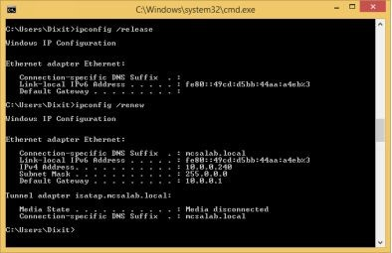

1. Close the **Command Prompt** window.

***Results****: After completing this exercise, you should have configured DHCP scope, DHCP options, and DHCP reservation.*

Shut down and revert the DC1 and CLIENT1 virtual machines to prepare for the next exercise.

# Exercise 9: Installing and Configuring DNS

Domain Name System (DNS) is a service that is used to perform the name resolution. Name resolution is a process to map domain names in to IP addresses and vice versa. The systems communicate to each other using the IP addresses, however it is difficult to remember the IP addresses of each client in a large enterprise network. DNS service allows you to communicate with the systems using the domain names, which is easier to remember than IP addresses.

In this exercise, you will learn how to install and configure the DNS server role.

In addition, you will also learn how configure DNS forwarder and how to manage DNS cache.

Start the DC1, SERVER1, and CLIENT1 virtual machines to perform this exercise.

# Task 1: Configuring SERVER1 as a Domain Controller without Installing the DNS Server Role

1. Sign in to **SERVER1** with the Administrator account.
2. On the **Server Manager** console, click the **Add roles and features**

link.

1. On the **Before you begin page** of the **Add Roles and Features**

**Wizard**, click **Next**.

1. On the **Select installation type** page, click **Next**.
2. On the **Select destination server** page, make sure that

**SERVER1.mcsalab.local** is selected, and then click **Next**.

1. On the **Select server roles** page, select the **Active Directory**

**Domain Services** check box.

1. On the **Add Roles and Features Wizard** dialog box, click **Add**

**Features**, and then click **Next**.

1. On the **Select features** page, click **Next**.
2. On the **Active Directory Domain Services** page, click **Next**.
3. On the **Confirm installation selections** page, click **Install**.
4. The installation process will start. Click **Close**, once the installation

succeeded.

1. On the **Server Manager** console, click the **Notifications** icon, and then click the **Promote this server to a domain controller** link, as

shown in the following figure.

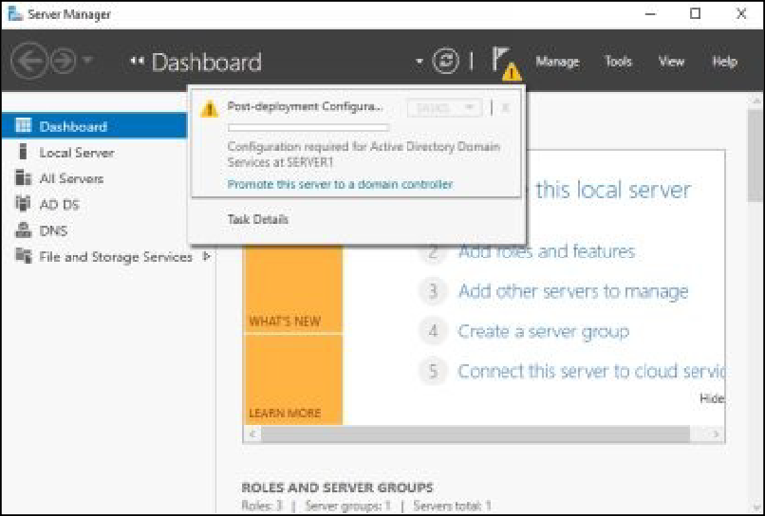

1. On the **Deployment Configuration** page of the **Active Directory Domain Services Configuration Wizard**, make sure that the **Add**

**a domain controller to an existing domain** radio button is selected.

## Under the Supply the credentials to perform this operation

section, click **Change**.

1. On the **Windows Security** dialog box, in the **User name** text box, type **MCSALAB\Administrator**. In the **Password** text box, type

## Password@123.

1. The **Deployment Configuration** page is returned, as shown in the following figure. Review the selected options, and then click **Next**.

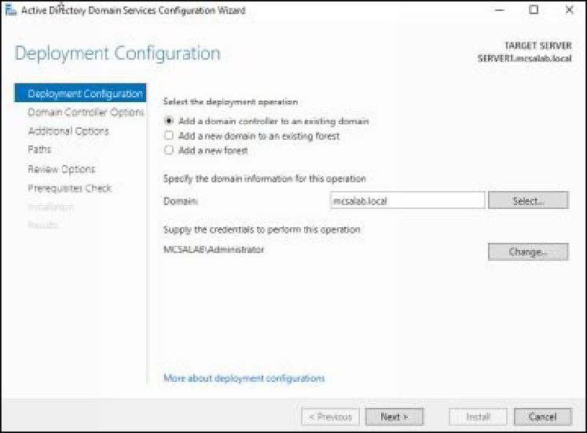

1. On the **Domain Controller Options** page, clear the **Domain Name**

**System (DNS) server** check box.

1. Under the DSRM password section, type **Password@123** in the

**Password** and **Confirm password** text boxes, as shown in the following figure, and then click **Next**.

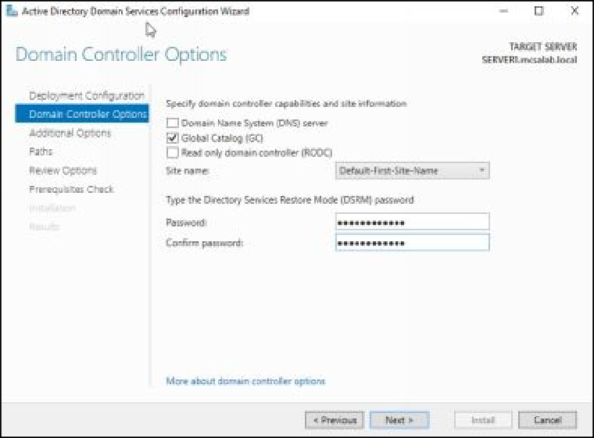

1. Click **Next**, until the **Prerequisites Check** page is displayed.
2. On the **Prerequisites Check** page, click **Install**.
3. The installation process will start and the server will restart automatically. After **SERVER1** restarts, sign in to **SERVER1** with

the MCSALAB\Administrator account.

# Task 2: Creating and Configuring the Myzone.local Zone on DC1

1. Sign in to **DC1** with the MCSALAB\Administrator account.
2. On the **Server Manager** console, click **Tools**, and then click **DNS**.
3. On the **DNS Manager** console, expand **DC1**, select and right-click

**Forward Lookup Zones**, and then select **New Zone**, as shown in the following figure.

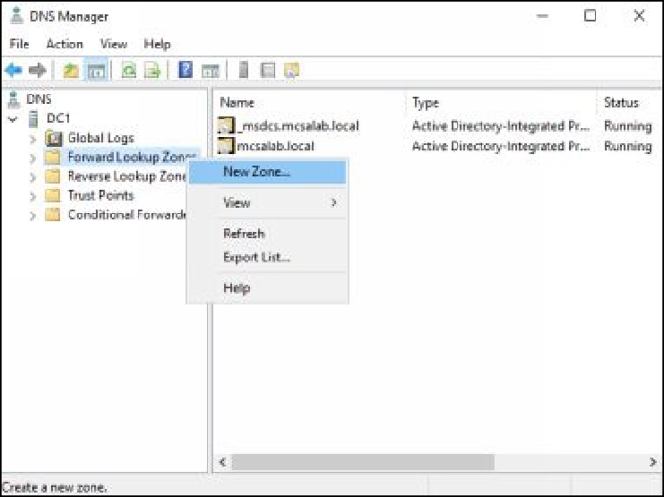

1. On the welcome page of the **New Zone Wizard**, click **Next**.
2. On the **Zone Type** page, make sure that the **Primary zone** radio

button is selected.

1. Clear the **Store the zone in Active Directory** check box, as shown in the following figure, and then click **Next**.

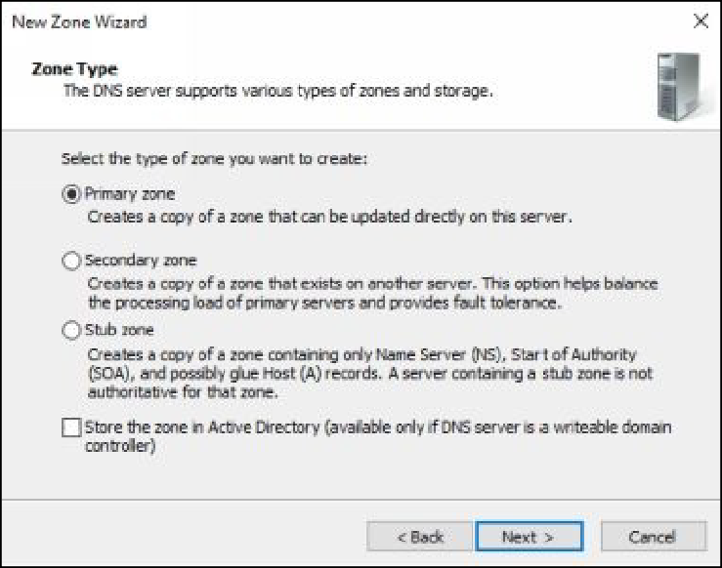

1. On the **Zone Name** page, in the **Zone name** text box, type

**Myzone.local**, as shown in the following figure, and then click

## Next.

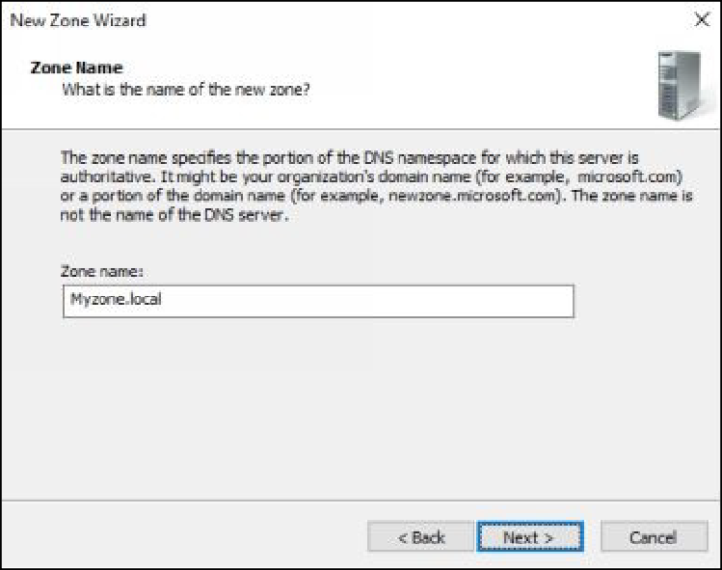

1. On the **Zone File** page, click **Next**.
2. On the **Dynamic Update** page, make sure that the **Do not allow dynamic updates** radio button is selected, as shown in the

following figure, and then click **Next**.

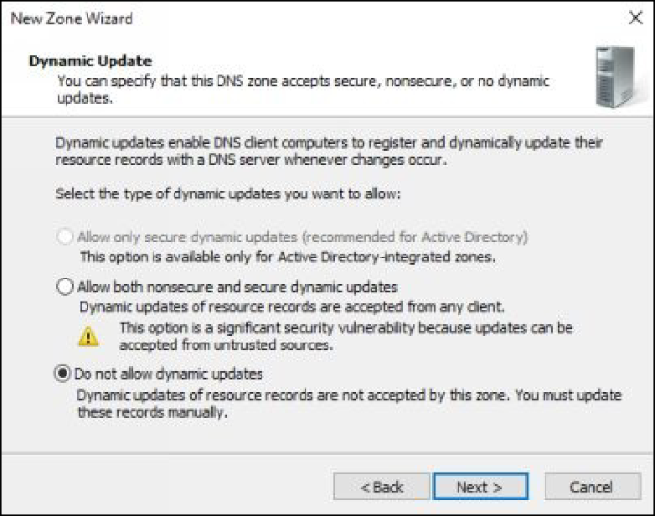

1. On the **Completing the New Zone Wizard** page, as shown in the following figure, review the zone configuration options, and then

click **Finish**.

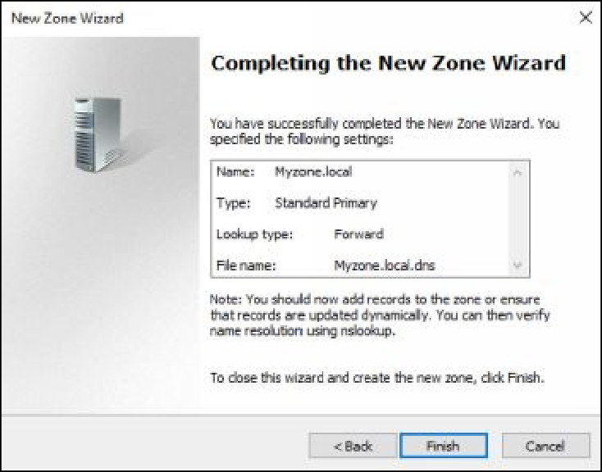

1. On the **DNS Manager** console, expand **Forward Lookup Zones**.
2. Select and right-click the **Myzone.local** zone, and then select **New Host (A or AAAA)**, as shown in the following figure.

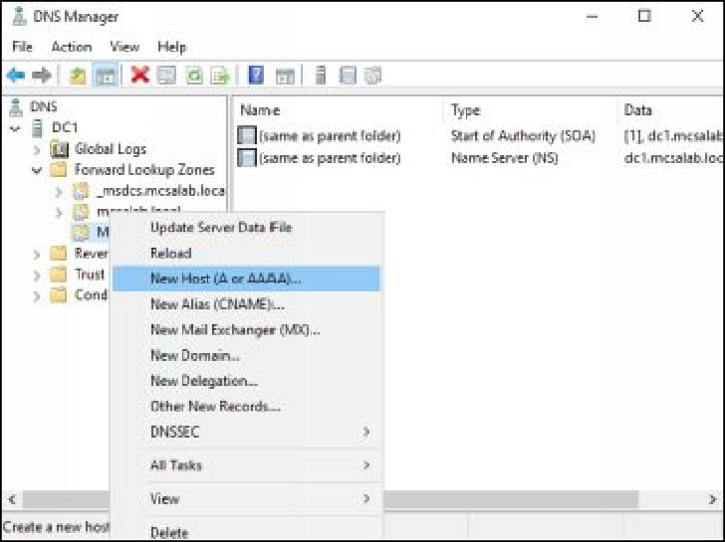

1. On the **New Host** dialog box, in the **Name** text box, type [**www**.](http://www/) In the **IP address** text box, type **10.0.0.101**, as shown in the following

figure, and then click **Add Host**.

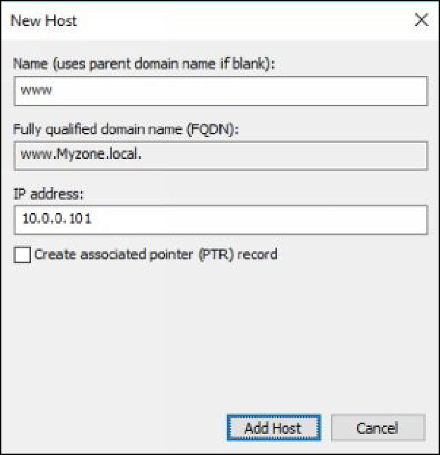

1. On the **DNS** message box, click **OK**.
2. On the **New Host** dialog box, click **Done**.
3. Leave the **DNS Manager** console active.

# Task 3: Adding the DNS Server Role on the

**SERVER1**

1. Switch and Sign in to **SERVER1** with the MCSALAB\Administrator account.
2. On the **Server Manager** console, click the **Add roles and features**

link.

1. On the **Before you begin** page of the **Add Roles and Features**

**Wizard**, click **Next**.

1. On the **Select installation type** page, click **Next**.
2. On the **Select destination server** page, make sure that

**SERVER1.mcsalab.local** is selected, and then click **Next**.

1. On the **Select server roles** page, select the **DNS Server** check box.
2. On the **Add Roles and Features Wizard** dialog box, click **Add**

## Features.

1. The **Select Server roles** page is returned, as shown in the

following, click **Next**.

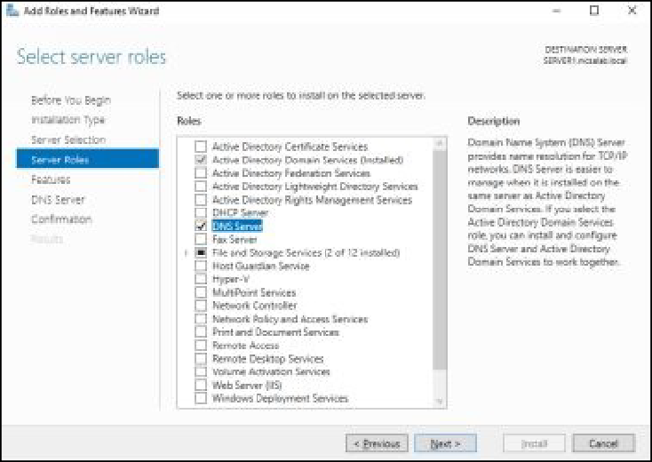

1. On the **Select Features** page, click **Next**.
2. On the **DNS Server** page, click **Next**.
3. On the **Confirm installation selections** page, click **Install**.
4. The installation process will start. Click **Close**, once the installation

succeeded.

# Task 4: Verifying Replication of the mcsalab.local Zone

1. On **SERVER1**, on the **Server Manager** console, click **Tools**, and

then click **DNS**.

1. On the **DNS Manager** console, expand **SERVER1**, and then

expand **Forward Lookup Zones**.

1. Right-click **Forward Lookup Zone** and then select **Refresh**.
2. Make sure that the **_msdcs.mcsalab.local** and **mcsalab.local** zones

are displayed.

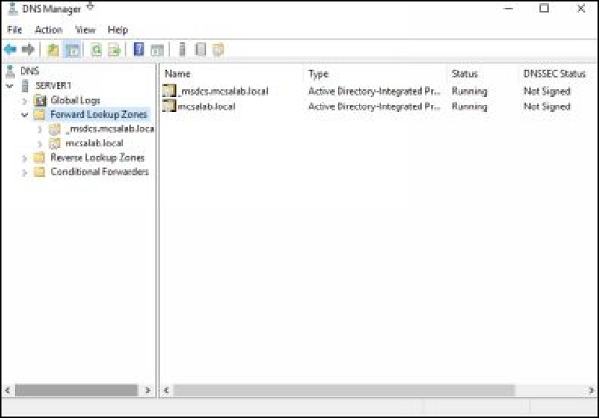

***Note****: If the zone list is empty, proceed to the next step, otherwise close the DNS Manager console*.

1. On **SERVER1**, switch back to the **Server Manager** console, click

**Tools**, and then click **Active Directory Sites and Services**.

1. On the **Active Directory Sites and Services** console, expand **Sites**, and then click **Default-First-Site-Name**, and then click **Servers**,

and then click **DC1**.

1. Select **NTDS Settings**, in the right pane, select and right-click the SERVER1 replication connection, and select **Replicate Now**, as

shown in the following figure.

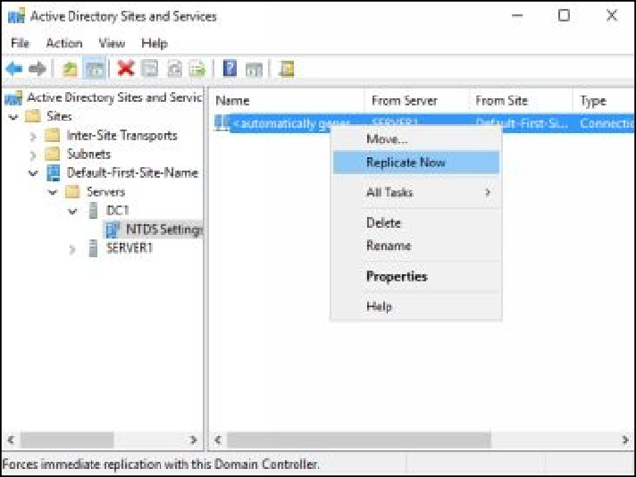

***Note****: If you receive an error message, proceed to the next step, and then retry this step after 5 minutes.*

1. In the left pane, expand **SERVER1**, and then select **NTDS**

## Settings.

1. In the right pane, select and right-click the DC1 replication connection, select **Replicate Now**, and then click **OK**.
2. Switch back to the **DNS Manager** console, select and right-click

**Forward Lookup Zones**, and then click **Refresh**.

1. Make sure that **the _msdcs.mcsalab.local** and **mcsalab.local** zones

are displayed.

1. Close the **DNS Manager** console.

# Task 5: Configuring DNS Forwarder

1. Switch and sign in to **DC1**.
2. Open the **DNS Manager** console.
3. On the **DNS Manager** console, select and right-click **DC1**, and then select **Properties**, as shown in the following figure.

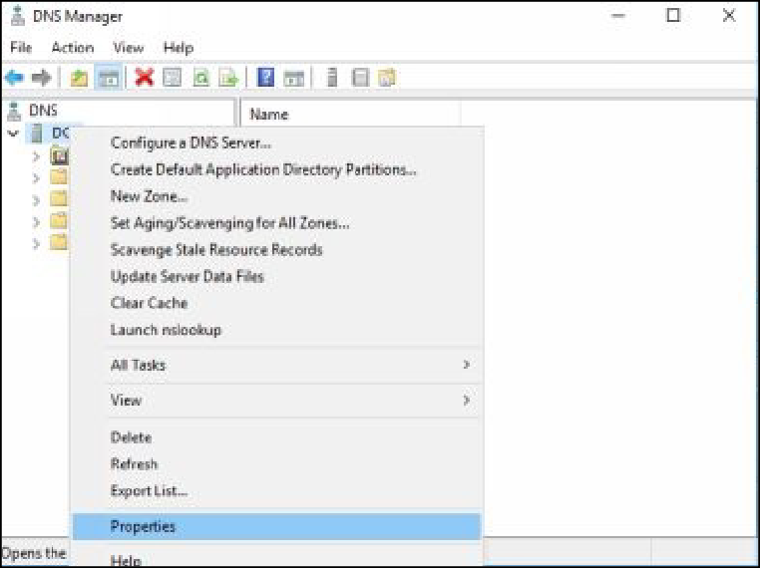

1. On the **DC1 Properties** dialog box, select the **Forwarders** tab, as

shown in the following figure.

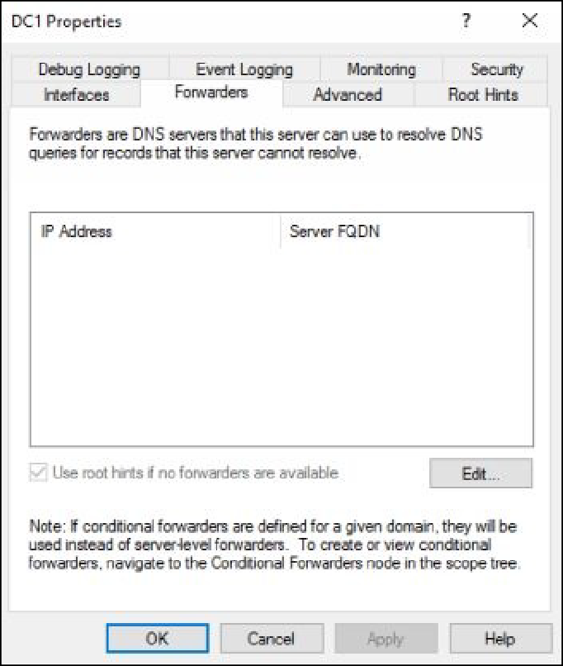

1. On the **Forwarders** tab, click **Edit**.
2. On the **Edit Forwarders** dialog box, type **10.0.0.101**, as shown in

the following figure, and then click **OK**.

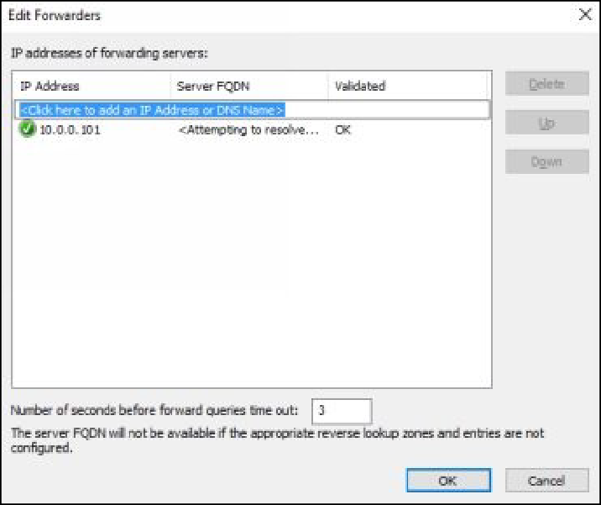

1. On the **DC1** dialog box, click **OK**.
2. On the **DNS Manager** console, select and right-click **DC1**, and then click **All Tasks**, and then click **Restart**.
3. Switch and sign in to **CLIENT1**.
4. Open the **Command Prompt** window.
5. On the **Command Prompt** window, type **ping** [**www.myzone.local**,](http://www.myzone.local/) and the press **Enter**.
6. Make sure that you are able to resolve the [**www.myzone.local**](http://www.myzone.local/)

FQDN successfully, as shown in the following figure.

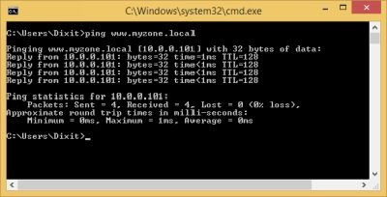

1. On the **Command Prompt** window, type **nslookup**, and then press

## Enter.

1. At the **nslookup** prompt, type [**www.myzone.local**,](http://www.myzone.local/) and then press

## Enter.

1. Make sure that you receive an IP address for this host, as shown in

the following figure.

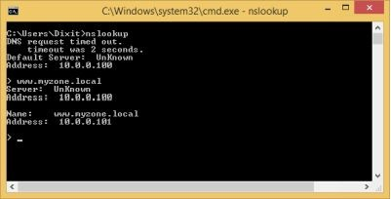

1. Leave the **Command Prompt** window active.

# Task 6: Managing the DNS Cache

1. On CLIENT1, on the **Command Prompt** window, type the following command and then press **Enter**, as shown in the

following figure.

## ipconfig /displaydns

1. Examine the output and close the **Command Prompt** window.
2. Press the **Windows** key, and then type **cmd**.
3. Select and right-click **Command Prompt**, and then select **Run as administrator** as shown in the following figure.

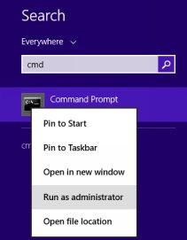

1. On the **User Account Control** dialog box, click **Yes**.
2. On the **Command Prompt** window, type the following command to clear the DNS cache, and then press **Enter**.

## ipconfig /flushdns

1. On the **Command Prompt** window, type the following command and verify that the DNS cache has been cleared, and then press

## Enter. ipconfig /displaydns

1. Close the **Command Prompt** window.

***Results****: After completing this exercise, you should have deployed DNS server, DNS zone, DNS forwarder, and DNS cache.*

Shut down and revert the DC1, SERVER1, and CLIENT1 virtual machines to prepare for the next exercise.

# 10: Implementing LAN Routing

LAN routing is a Window feature that enables you to communicate between different subnets. To communicate between different subnets, typically a device called router is used, but you can also use a Windows server, such as Windows Server 2016 server to perform the LAN routing. However, Windows Server 2016 does not support all the features supported by a router. It is typically helpful for a small network with the limited number of subnets.

In this exercise, you will learn how to use a Windows Server 2016 server as a software router to enable LAN routing between two or more subnets.

Start the DC1, ROUTER, and SERVER2 virtual machines to perform this exercise.

# Task 1: Installing the LAN Routing Feature on ROUTER

1. Sign in to **ROUTER** with the Administrator account.
2. On the **Server Manager** console, click the **Add roles and features**

link.

1. On the **Before you began page** of the **Add Roles and Features**

**Wizard**, click **Next**.

1. On the **Select installation type** page, click **Next**.
2. On the **Select destination server** page, click **Next**.
3. On the **Select Server roles** page, select the **Remote Access** check box, as shown in the following figure, and then click **Next**.

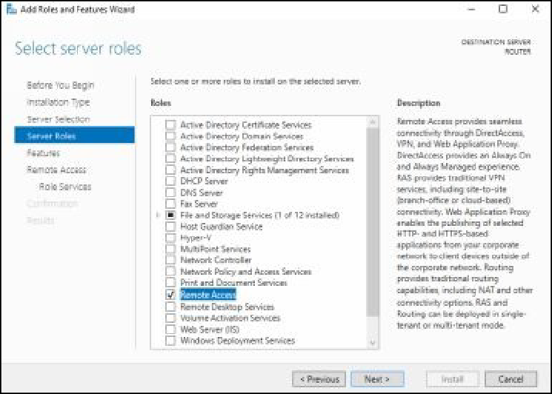

1. On the **Select features** page, click **Next**.
2. On the **Remote Access** page, click **Next**.
3. On the **Select roles services** page, select the **Routing** check box.
4. On the **Add Roles and Features Wizard** dialog box, click **Add**

## Features.

1. The **Select role services** page is returned, as shown in the

following figure, click **Next**.

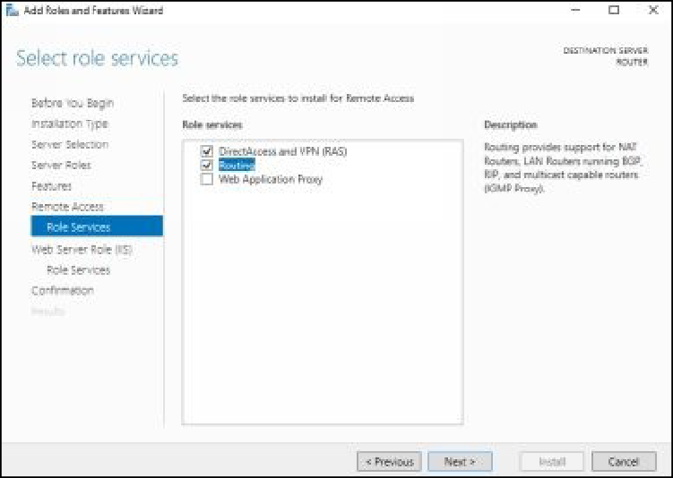

***Note****: The DirectAccess and VPN (RAS) check box will be selected automatically*.

1. On the **Web Server Role (IIS)** page, click **Next**.
2. On the **Select role services** page, click **Next**.
3. On the **Confirm installation selection** page, click **Install**.
4. Click **Close**, once the installation succeeded.

# Task 2: Configuring the LAN Routing Service on ROUTER

1. On the **Server Manager** console, click **Tools**, and then click

## Remote and Routing Access.

1. On the **Routing and Remote Access** console, select and right-click

**ROUTER (local)**, and then select **Configure and Enable Routing and Remote Access**, as shown in the following figure.

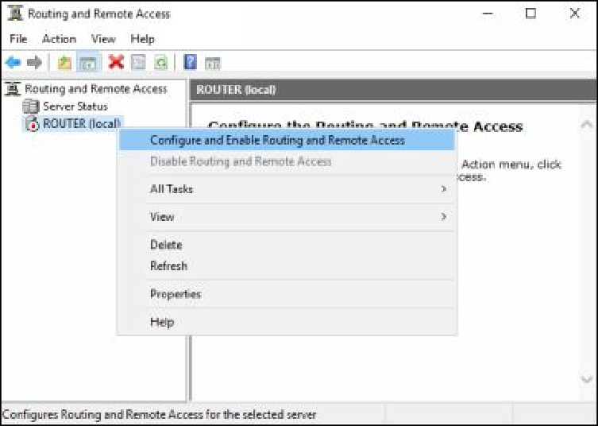

1. On the welcome page of the **Routing and Remote Access Server**

**Setup Wizard**, click **Next**.

1. On the **Configuration** page, select the **Custom configuration** radio button, as shown in the following figure, and then click **Next**.

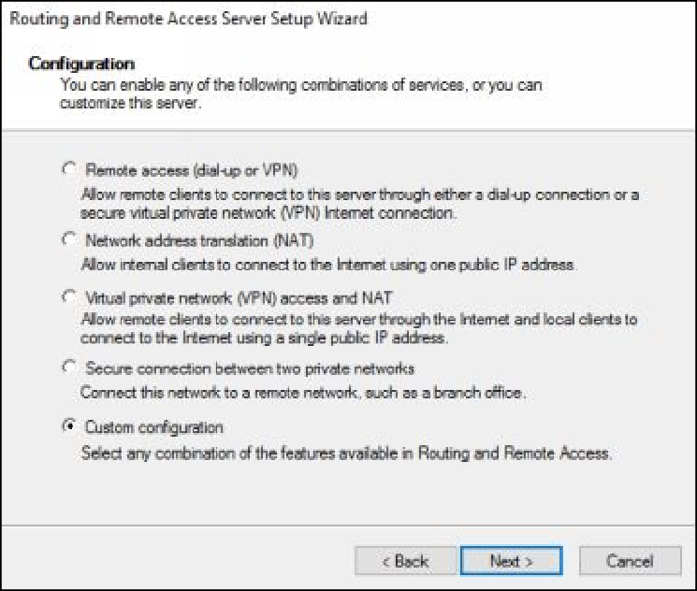

1. On the **Custom Configuration** page, select the **LAN routing** check box, as shown in the following figure.

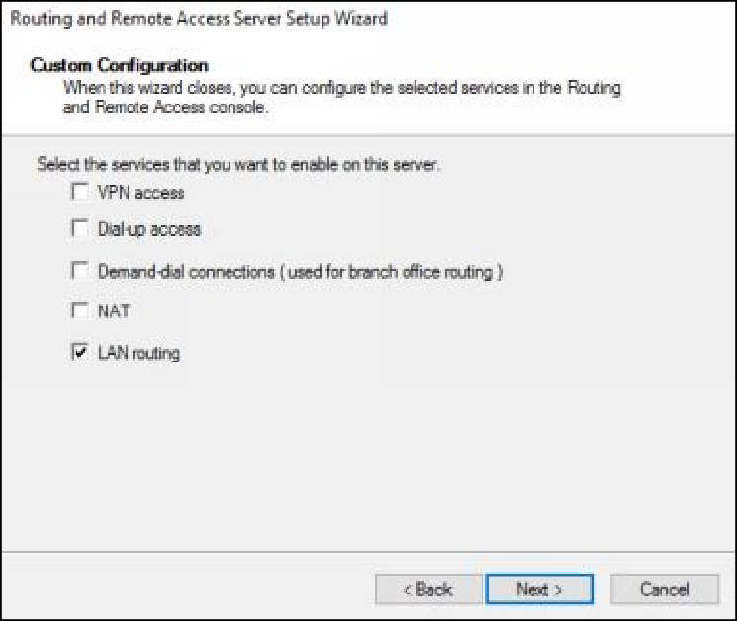

1. Click **Next**, and then click **Finish**.
2. On the service message box, click **Start Service**.
3. Make sure that the **ROUTER (local)** node’s color changes red to green, as shown in the following figure.

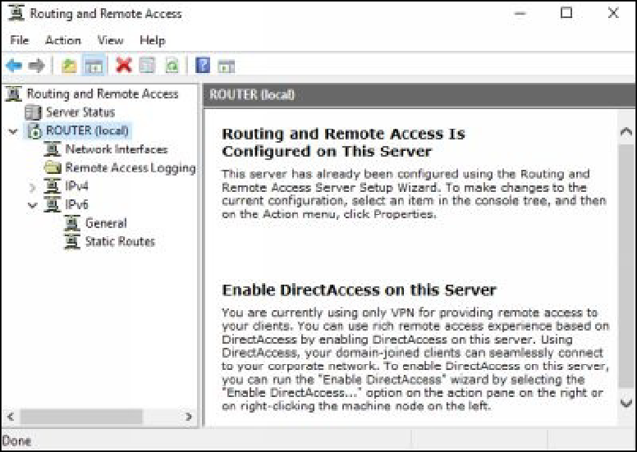

1. Close the **Routing and Remote Access** console.
2. On the **ROUTER** virtual machine, open the **Run** dialog box, type

**firewall.cpl** in the **Open** text box, and then press **Enter**.

1. On the **Windows Firewall** window, in the left pane, click the **Turn Windows Firewall on or off** link.
2. On the **Customize Settings** window, select the **Turn off Windows Firewall (not recommended)** radio button for each profile, as

shown in the following figure.

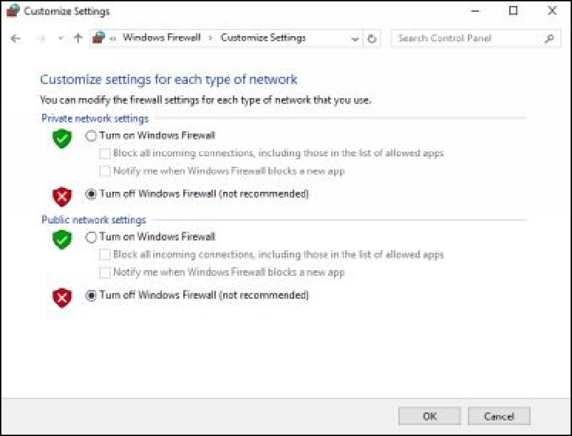

1. Close the **Customize Settings** window.

# Task 3: Testing the Connectivity between DC1 and SERVER2 Servers

1. Switch and sign in to **SERVER2** with the Administrator account.
2. Open the **Run** dialog box, type **firewall.cpl**, in the **Open** text box,

and then press **Enter**.

1. On the **Windows Firewall** window, in the left pane, click the **Turn Windows Firewall on or off** link.
2. On the **Customize Settings** window, select the **Turn off Windows Firewall (not recommended)** radio button for each firewall

profiles

1. Close the **Customize Settings** window.
2. Switch and sign in to **DC1** with MCSALAB\Administrator account.
3. Open the **Command Prompt** window, on the **Command Prompt**

window, type the following commands and then press **Enter** after each one.

## Ping 10.0.0.1

**Ping 192.168.0.1**

**Ping 192.168.0.2**

1. You should be able to communicate to all systems successfully, as

shown in the following figure.

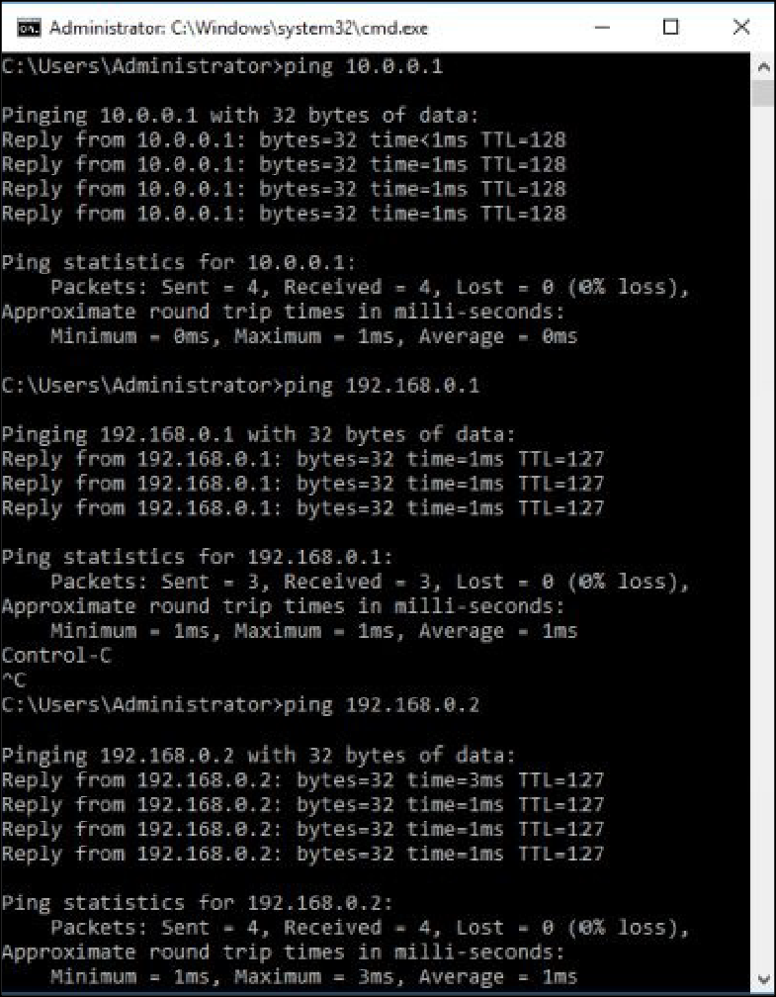

1. Close the **Command Prompt** window.

***Results****: After completing this exercise, you will have configured LAN routing between DC1 and SERVER2 servers.*

Do not shut down or revert any virtual machine, as these will be used in the next exercise.

# Exercise 11: Configuring IPv6 Addressing

IPv6 addressing scheme provides more unique addresses and is more secure than traditional IPv4 addressing scheme. An IPv6 address comprises of eight blocks and each block can contain 16 (bit) hexadecimal digits. You can enable communication between IPv4 and IPv6 nodes using the various techniques, such as Teredo, ISATAP, and 6to4 tunneling.

In this exercise, you will learn how to configure IPv6 addresses on Window- based systems.

Make sure that the DC1, ROUTER, and SERVER2 virtual machines are running before start this exercise.

# Task 1: Disabling IPv6 Address on DC1

1. Switch and Sign in to **SERVER2** with the Administrator account.
2. On the taskbar, click the **Windows PowerShell** icon.
3. At the **Windows PowerShell** prompt, type **ping 10.0.0.100**, and

then press **Enter**.

1. Verify that you are able communicate with the DC1 (10.0.0.100) server, as shown in the following figure.

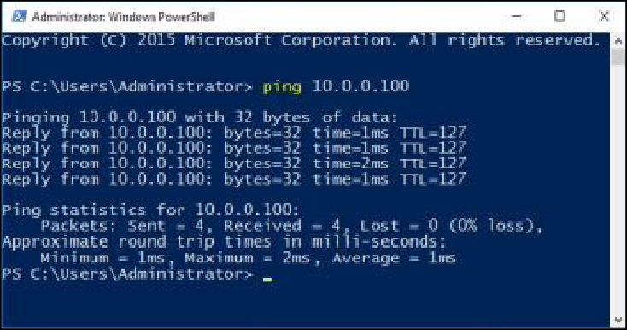

1. Switch and Sign in to **DC1** with the MCSALAB\Administrator

account.

1. On the **Server Manager** console, in the left pane, click **Local**

## Server.

1. In the **Properties** pane, click the **10.0.0.100, IPv6 enabled** link, as

shown in the following figure.

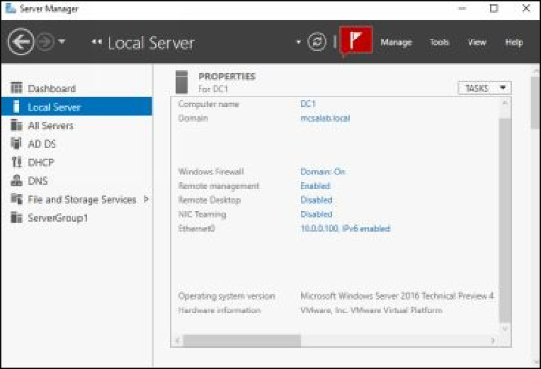

1. On the **Network Connections** window, select and right-click your network adapter, and then select **Properties**, as shown in the

following figure.

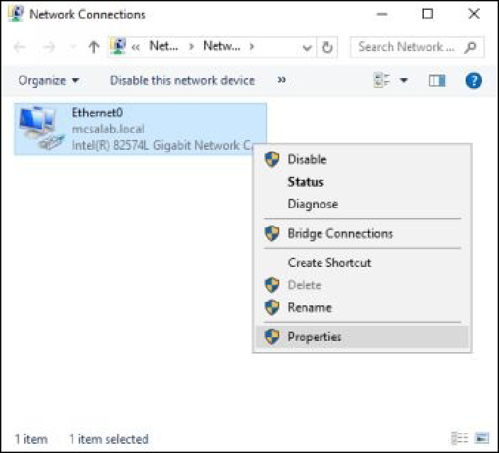

1. On the network adapter’s properties dialog box, clear the **Internet Protocol Version 6 (TCP/IPv6)** check box, as shown in the

following figure, and then click **OK**.

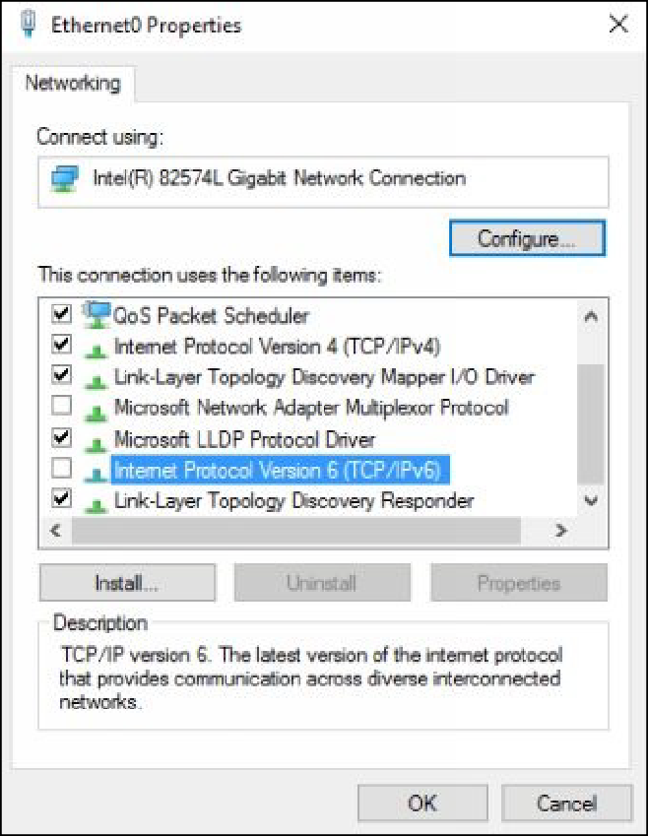

1. Close the **Network Connections** window.
2. On the **Server Manager** console, verify that your network adapter lists only **10.0.0.100**, as shown in the following figure. You may need to refresh the **Server Manager** console. Notice that DC1 is

now an IPv4-only host.

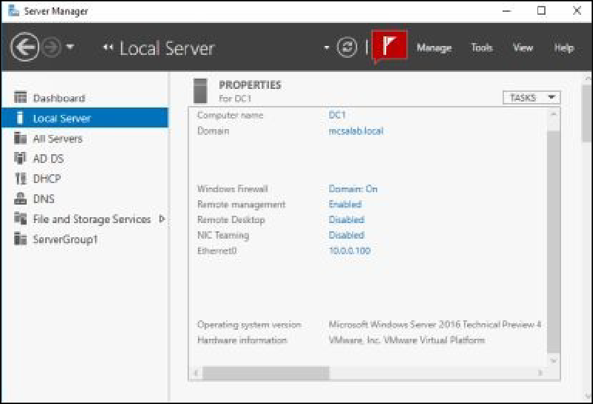

# Task 2: Disabling IPv4 Address on SERVER2

1. Switch and Sign in to **SERVER2** with the Administrator account.
2. On the **Server Manager** console, in the left pane, click **Local**

## Server.

1. In the **Properties** pane, click the **192.168.0.2, IPv6 enabled** link.
2. On the **Network Connections** window, select and right-click active network adapter, and then select **Properties**.
3. On the network adapter’s properties dialog box, clear the **Internet Protocol Version 4 (TCP/IPv4)** check box, as shown in the

following figure, and then click **OK**.

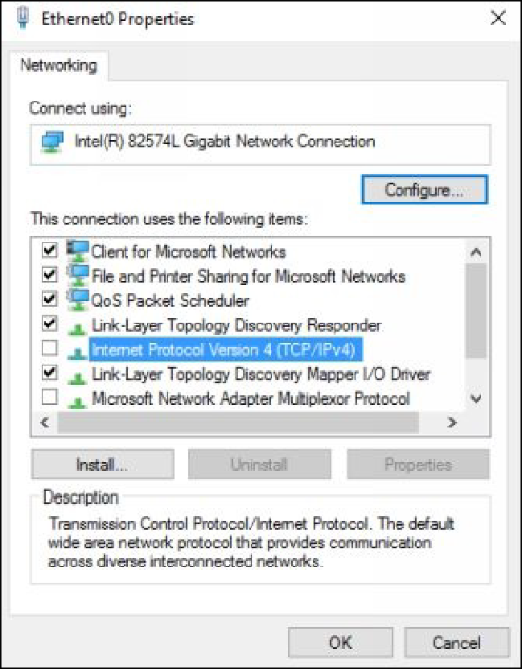

1. Close the **Network Connections** window.
2. On the **Server Manager** console, verify that network adapter now lists only IPv6 enabled, as shown in the following figure. You may

need to refresh the **Server Manager console**. Notice that

**SERVER2** is now an IPv6-only host.

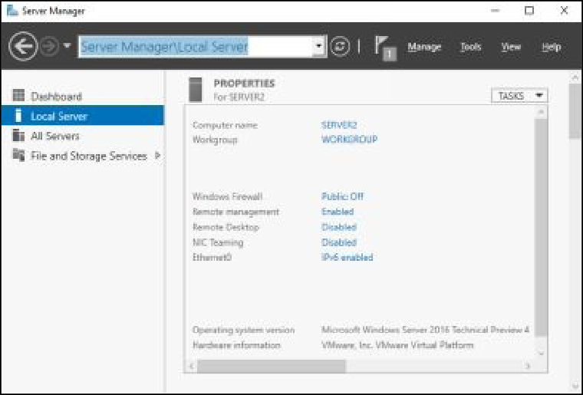

# Task 3: Configuring an IPv6 Network on ROUTER

1. Switch and Sign in to **ROUTER** with the Administrator account.
2. On the taskbar, click the **Windows PowerShell** icon.
3. To configure a network address that will be used on the IPv6 network, at the **Windows PowerShell** prompt, type the following cmdlet, and then press **Enter**, as shown in the following figure.

## New-NetRoute -InterfaceAlias "Ethernet1" -DestinationPrefix 2001:AABB:0:1::/64 -Publish Yes

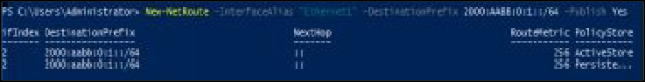

***Note****: Ethernet1 is the name of the network adapter connected to the external subnet.*

1. To allow clients to obtain the IPv6 network address automatically from **ROUTER**, at the **Windows PowerShell** prompt, type the

following cmdlet, and then press **Enter**, as shown in the following figure.

## Set-NetIPInterface -InterfaceAlias "Ethernet1" -AddressFamily IPv6 -Advertising Enabled

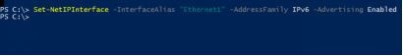

1. At the **Windows PowerShell** prompt, type **ipconfig.exe**, and then press **Enter**. Notice that **Ethernet1** now has an IPv6 address on the

**2001:AABB:0:1::/64** network, as shown in the following figure. This address will be used for communication on the IPv6-only network.

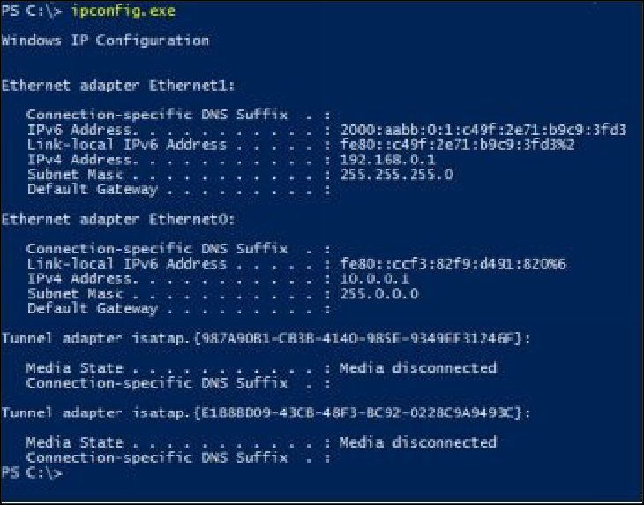

# Task 4: Verifying IPv6 Address on SERVER2

1. Switch and Sign in to **SERVER2** with the Administrator account.
2. On the taskbar, click the **Windows PowerShell** icon.
3. At the **Windows PowerShell** prompt, type **ipconfig.exe**, and then press **Enter**. Notice that your network adapter now has an IPv6 address on the on the **2001:AABB:0:1::/64** network, as shown in

the following figure.

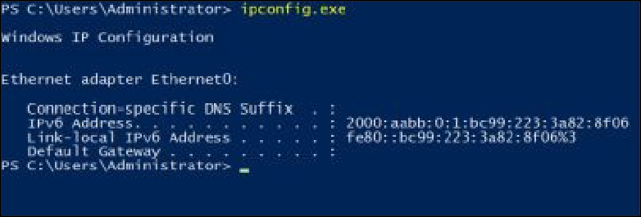

1. The network address was obtained from the router through the

stateless configuration.

***Results****: After completing the exercise, you will have configured an IPv6-based network.*

Shut down and revert the DC1, SERVER2 and ROUTER virtual machines to prepare for the next exercise.

# Exercise 12: Installing and Configuring Disk Storage

Disks are used to store the system data as well as personnel data. There are various storage technologies, such as SATA, IDE, iSCSI, and Fibre Channel that can be used to store the data. In a virtualized environment, you can add additional virtual hard disks to the virtual machines, and then you can create additional volumes on these disks.

In this exercise, you will learn how to manage disks on a Window server.

Further, you will learn how to shrink and extend volumes.

# Task 1: Adding New Virtual Disks to DC1

1. Make sure that the **DC1** virtual machine is powered off.
2. On your host machine, on the **VMware** console, select and right- click the **DC1** virtual machine, and then select **Settings**.
3. On the virtual machine’s setting dialog box, ensure that **Hard Disk**

is selected, and then click **Next**.

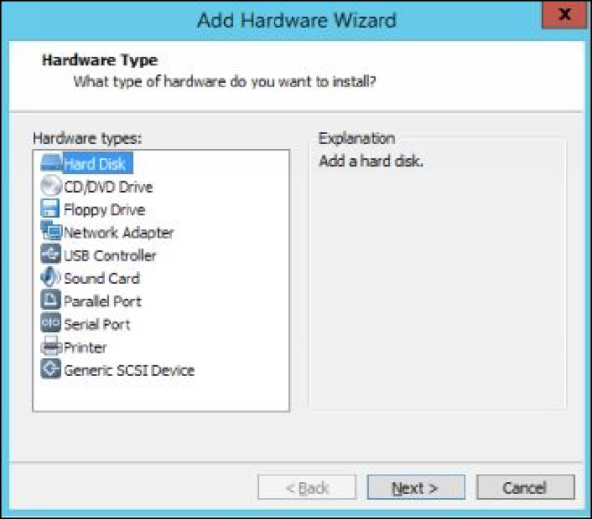

1. On the **Select a Disk Type** page, accept the default selection

(**SCSI**), and then click **Next.**

1. On the **Select a Disk** page, make sure that the **Create a new virtual disk** radio button is selected, and then click **Next.**

.

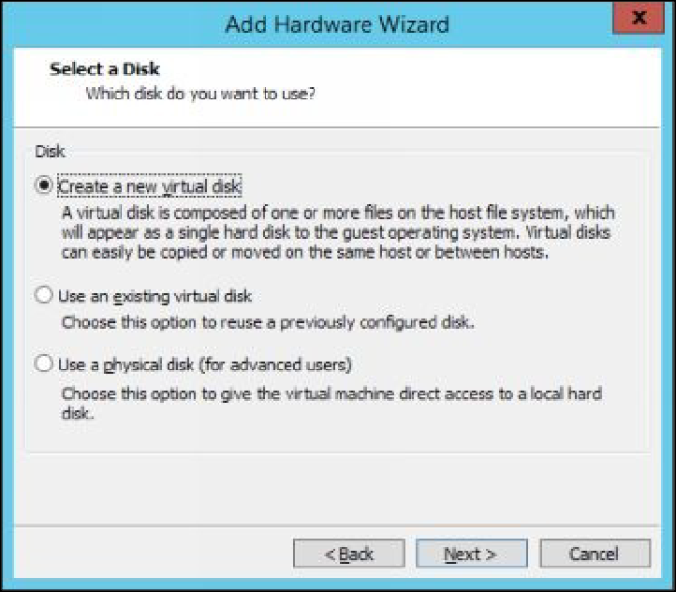

1. On the **Specify Disk Capacity** page, set the disk size as **10** GB, select the **Store virtual disk as a single file** radio button, and then

click **Next**.

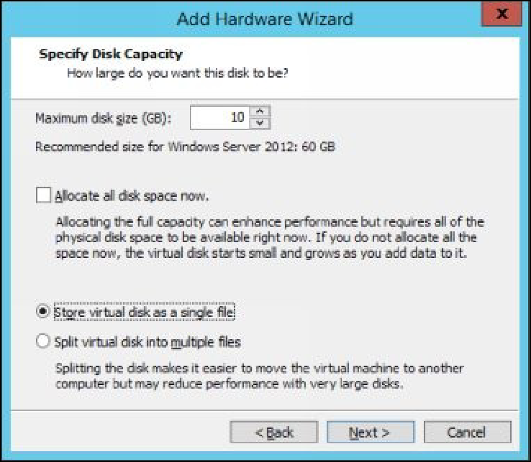

1. On the **Specify Disk File** page, accept the default file name, and

then click **Finish**.

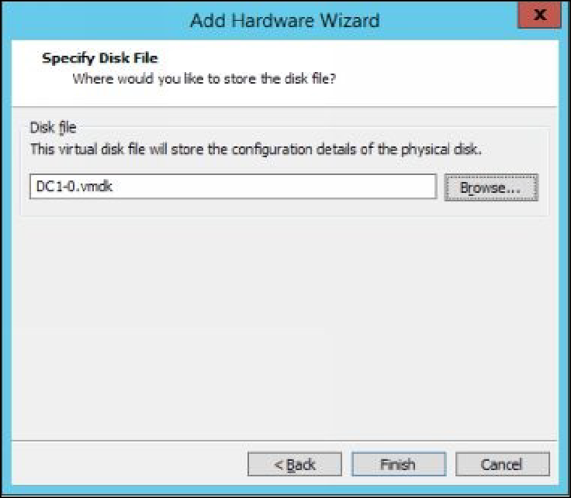

1. Add one more new virtual disk with following settings:

Store virtual disk as a single file.



Size: **10** GB.



File name : **Accept default**.



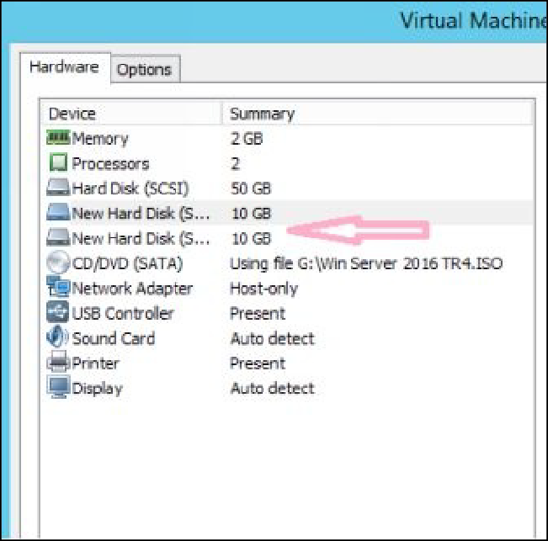

# Task 2: Initializing the Added Disks

1. Power on the **DC1** virtual machine.
2. Open the **Server Manager** console.
3. On the **Server Manager** console, click **Tools**, and then click

## Computer Management.

1. On the **Computer Management** console, under the **Storage** node,

select **Disk Management**.

1. In the **Disks** pane, select and right-click **Disk 1**, and then select

**Online**, as shown in the following figure.

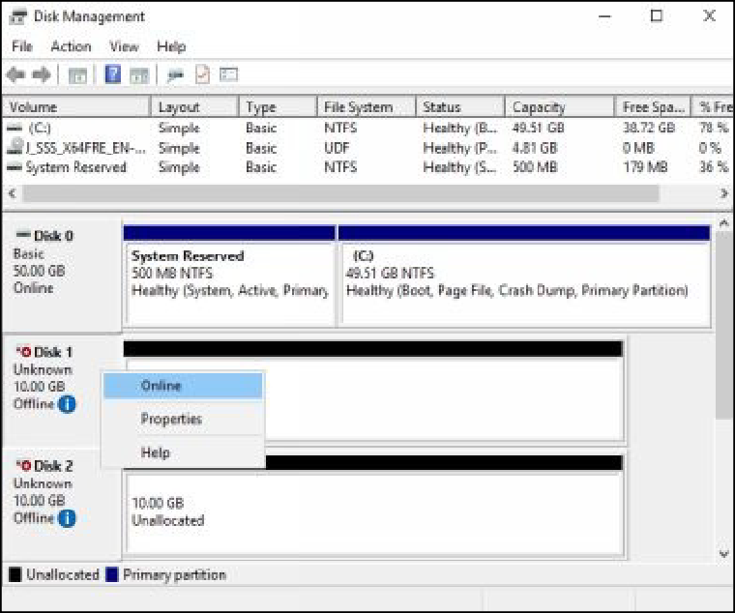

1. Select and right-click **Disk 1**, and then select **Initialize Disk**.
2. On the **Initialize Disk** dialog box, make sure that the **Disk 1** check box is selected, select the **GPT (GUID Partition Table)** radio

button, and then click **OK**.

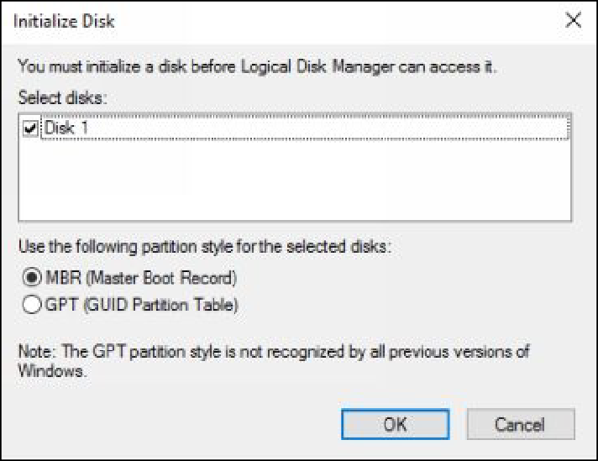

***Note****: The GPT partition table supports more features than the traditional MBR partition table.*

1. In the **Disks** pane, select and right-click **Disk 2**, and then select

## Online.

1. Select and right-click **Disk 2**, and then select **Initialize Disk**.
2. On the **Initialize Disk** dialog box, make sure that the **Disk 2** check box is selected, select the **GPT (GUID Partition Table)** radio

button, and then click **OK**.

# Task 3: Creating and Formatting Simple Volumes

1. On the **Computer Management** console, under the **Disk Management** node, select and right-click the **Unallocated** space of

**Disk 1**, and then select **New Simple Volume**, as shown in the following figure.

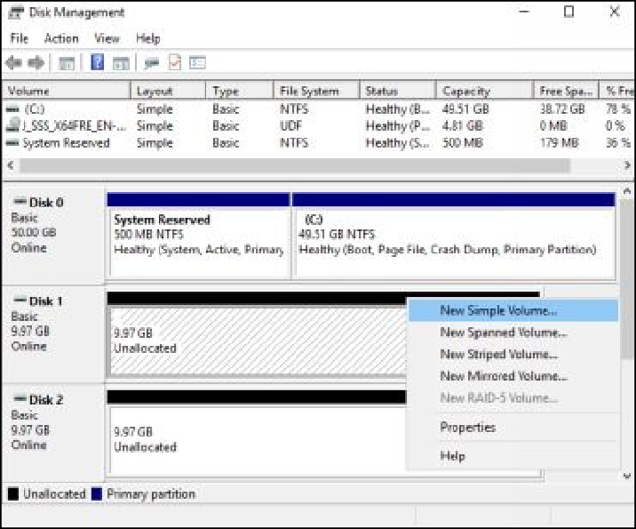

1. On the **Welcome to the New Simple Volume Wizard** page, click

## Next.

1. On the **Specify Volume Size** page, in the **Simple volume size MB**

value box, type **5000**, as shown in the following figure, and then click **Next**.

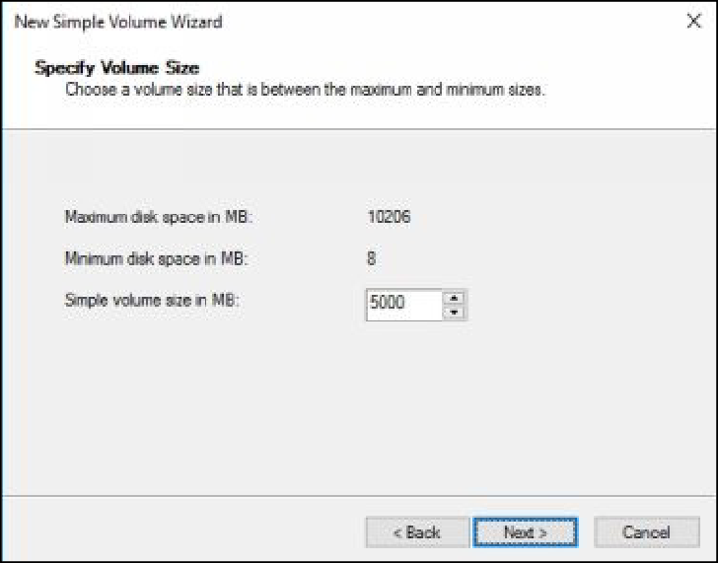

1. On the **Assign Drive Letter or Path** page, make sure that the **Assign the following drive letter** check box is selected, accept the default drive letter, as shown in the following figure, and then click

## Next.

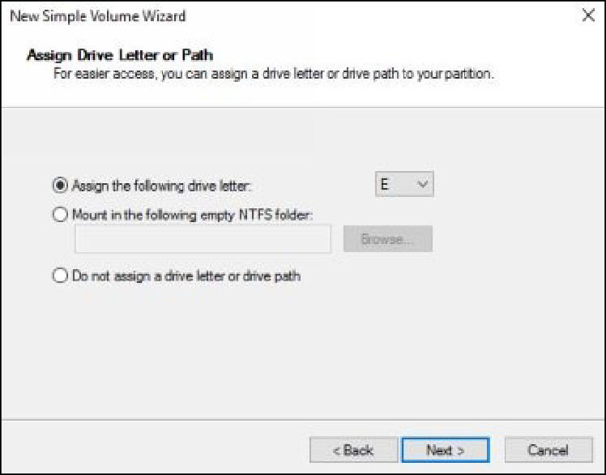

1. On the **Format Partition** page, in the **Volume label** text box, type

**Volume1**, as shown in the following figure, and then click **Next**.

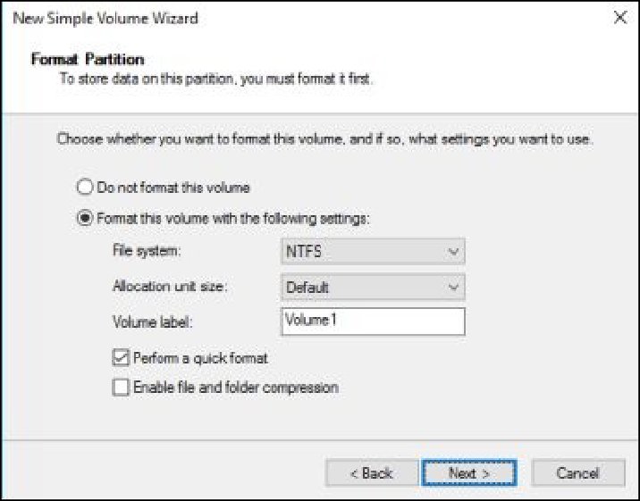

1. On the **Completing the New Simple Volume Wizard** page, click

## Finish.

1. On the **Disk Management** console, select and right-click the

**Unallocated** space of **Disk 2**, and then select **New Simple Volume**.

1. On the **Welcome to the New Simple Volume Wizard** page, click

## Next.

1. On the **Specify Volume Size** page, in the **Simple volume size in**

**MB** value box, type **5000**, and then click **Next**.

1. On the **Assign Drive Letter or Path** page, make sure that the

**Assign the following drive letter** check box is selected, accept the default drive letter, and then click **Next**.

1. On the **Format Partition** page, in the **Volume label** text box, type

**Volume2**, and then click **Next**.

1. On the **Completing the New Simple Volume Wizard** page, click

## Finish.

1. Leave the **Computer Management** console active.
2. Press the **Windows+E** keys to open the **Windows Explorer**

window.

1. Verify that the **Volume1** and **Volume2** are created, as shown in the

following figure.

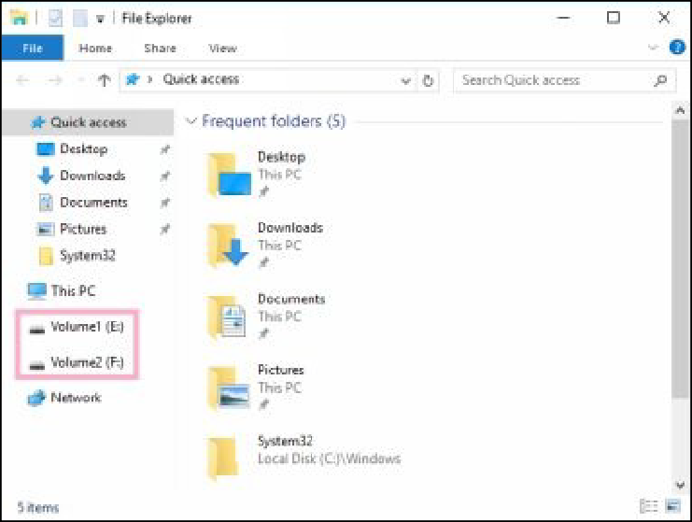

1. Close the **Windows Explorer** window.

# Task 4: Shrinking the Volumes

1. On **DC1**, switch to the **Computer Management** console.
2. On the **Computer Management** console, under the **Disk Management** node, select and right-click **Volume1**, and then select

**Shrink Volume**, as shown in the following figure.

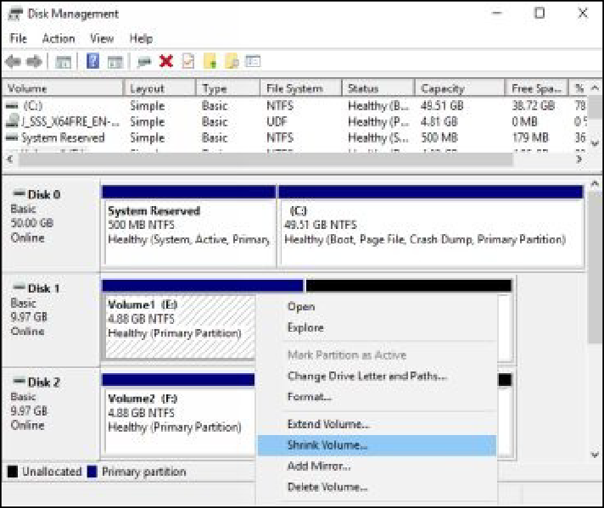

1. On the shrink dialog box, in the **Enter the amount of space to shrink in MB** value box, type **1000**, as shown in the following

figure, and then click **Shrink**.

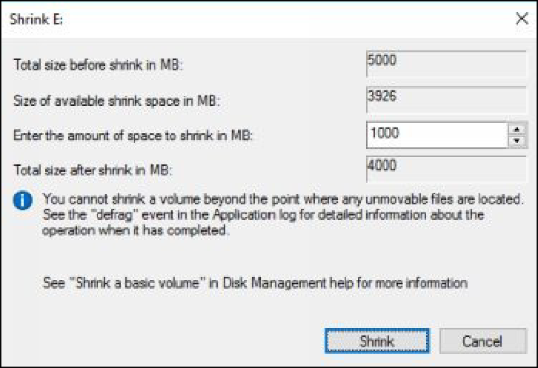

# Task 5: Extending the Volumes

1. On the **Computer Management** console, under the **Disk Management** node, select and right-click **Volume2**, and then select

## Extend Volume.

1. On the **Welcome to the Extended Volume Wizard** page, click

## Next.

1. On the **Select Disks** page, in the **Select the amount of space in**

**MB** value box, type **3000**, as shown in the following figure, and then click **Next**.

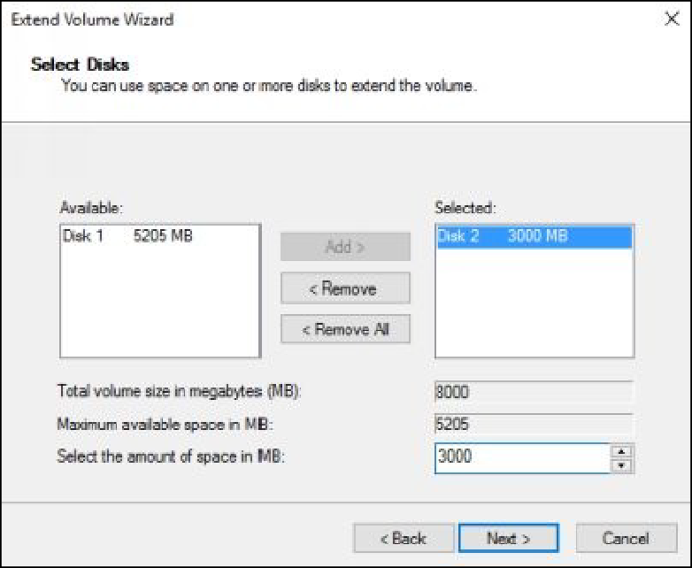

1. On the **Completing the Extended Volume Wizard** page, click

## Finish.

1. Press the **Windows+E** keys to open the **Windows Explorer**

window, verify that the volumes’ sizes are reflected.

***Results****: After completing this exercise, you should have initialized new disks, and created and formatted simple volumes. In addition, you should also have shrink and extended the volumes.*

Do not shut down or revert the DC1 virtual machine, as it will be used in the next exercise.

# Exercise 13: Configuring a Redundant Storage Space

Redundant Array of Inexpensive Disk (RAID) is a storage technology that allows you to combine multiple hard disks in a single large hard disk. It also provides redundancy and fault tolerance in the event of a disk failure. RAID can be configured either as a hardware RAID (which requires a hardware controller device) or as a software RAID (which does not require any specific hardware device). RAID can be divided in to various RAID levels and each RAID level supports various features and limitations.

In this exercise, you will learn how to create storage pools, how to create and test a mirrored volume.

Ensure that the DC1 virtual machine is running and you have not reverted it in the previous state.

# Task 1: Creating a Storage Pool

1. Sign in to **DC1** and open the **Server Manager** console.
2. Open the **Disk Management** console, select and right-click **Disk 1**, and then delete the created volume. Also delete the volume for **Disk**

**2**, as shown in the following figure.

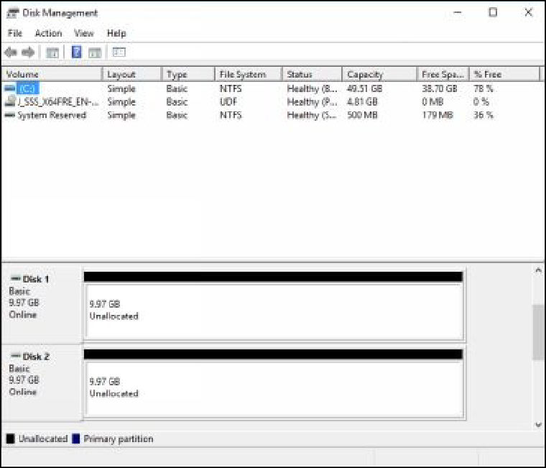

1. On the **Server Manager** console, in the left pane, select **File and Storage Services**, and then select **Storage Pools.**
2. In the **STORAGE POOLS** pane, click **TASKS**, and then click

## Rescan Storage.

1. Click again **TASKS**, and then click **New Storage Pool**, as shown in

the following figure.

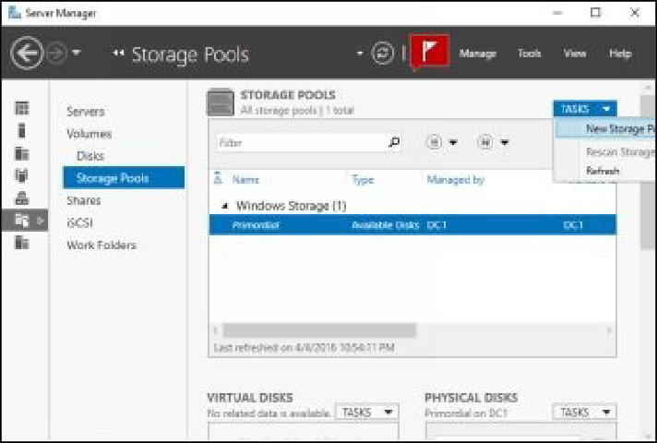

1. On the **Before you begin** page, click **Next**.
2. On the **Specify a storage pool name and subsystem** page, in the

**Name** text box, type **MyStoragePool1**, as shown in the following figure, and then click **Next**.

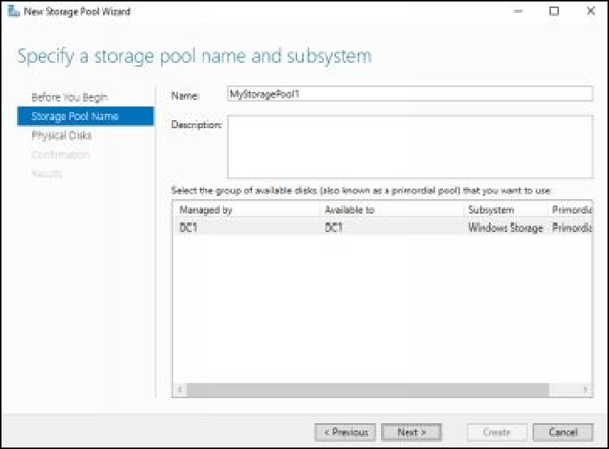

1. On the **Select physical disks for the storage pool** page, select the all available disk check boxes, as shown in the following figure, and

then click **Next**.

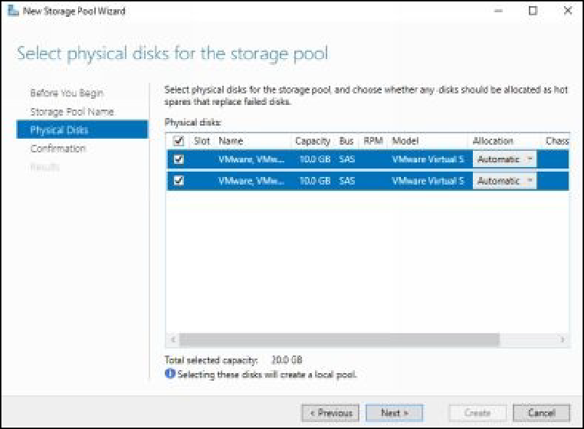

1. On the **Confirm selections** page, click **Create**.
2. On the **View results** page, click **Close**, once the task is competed.

# Task 2: Creating a Mirrored Virtual Disk

1. On **DC1**, on the **Server Manager** console, in the **Storage Spaces**

pane, select **MyStoragePool1**.

1. On the **VIRTUAL DISKS** pane, click **TASKS**, and then click **New Virtual Disk**, as shown in the following figure.

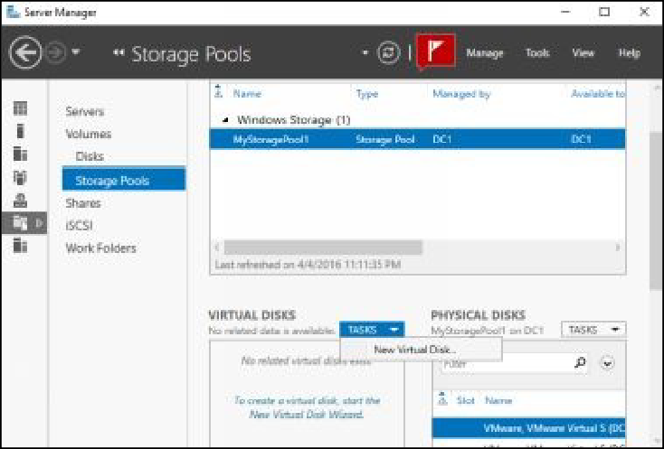

1. On the **Before you begin** page, click **Next**.
2. On the **Select the storage pool** page, make sure that

**MyStoragePool1** is selected, and then click **Next**.

1. On the **Specify the virtual disk name** page, in the **Name** text box, type **Mirrored Disk1**, as shown in the following figure, and then

click **Next**.

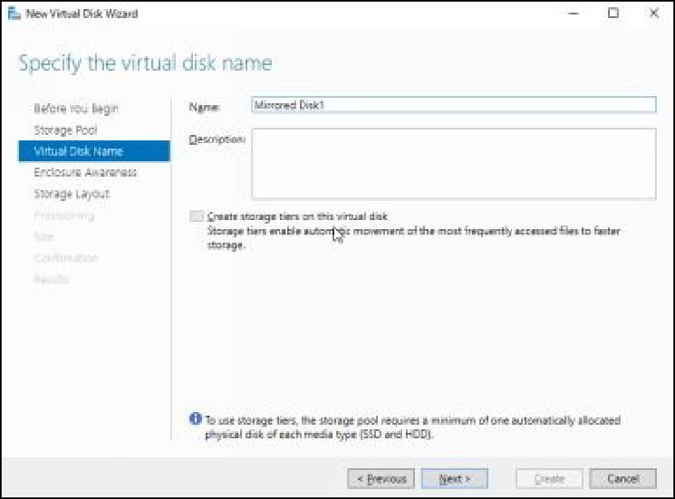

1. On the **Select the storage layout** page, in the **Layout** section, select

**Mirror**, as shown in the following figure, and then click **Next**.

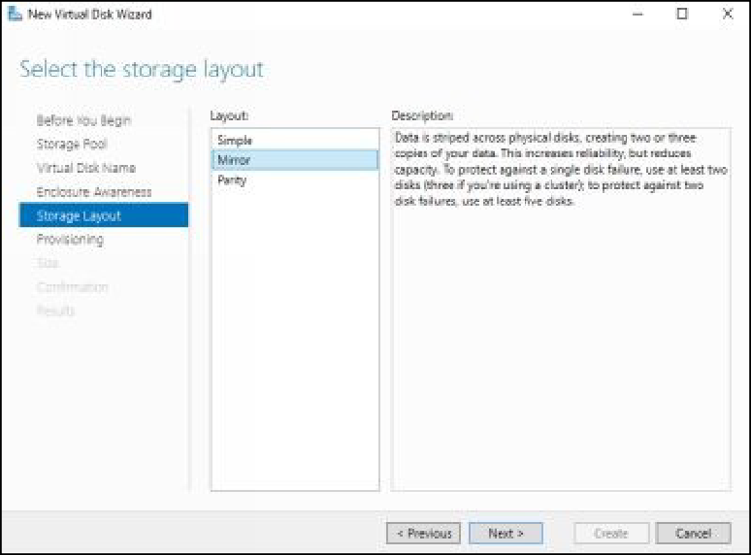

1. On the **Specify the provisioning type** page, select the **Thin** radio button, as shown in the following figure, and then click **Next**.

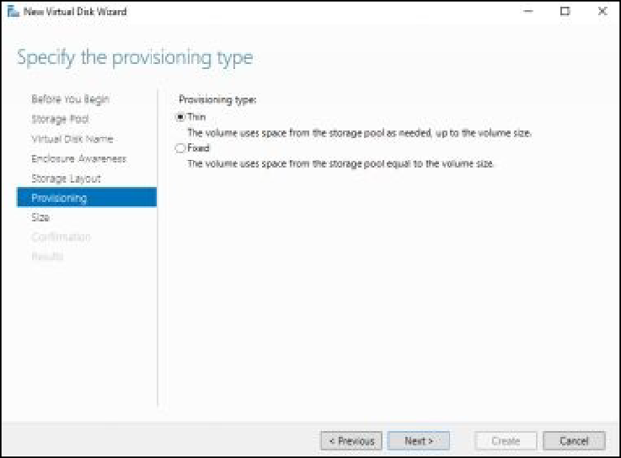

1. On the **Specify the size of the virtual disk** page, in the **Virtual disk size** box, type **5**, as shown in the following figure, and then

click **Next**.

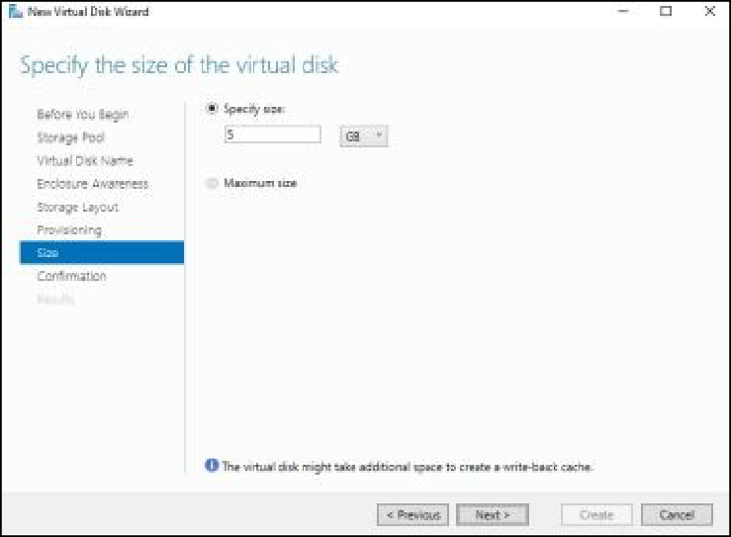

1. On the **Confirm selections** page, click **Create**.
2. On the **View results** page, wait until the task completes.
3. Make sure that the **Create a volume when this wizard closes**

check box is selected, and then click **Close**.

1. On the **Before you begin page of the New Volume Wizard**, click

## Next.

1. On the **Select the server and disk** page, in the **Disk** section, select the **Mirrored Disk1** virtual disk, as shown in the following figure,

and then click **Next**.

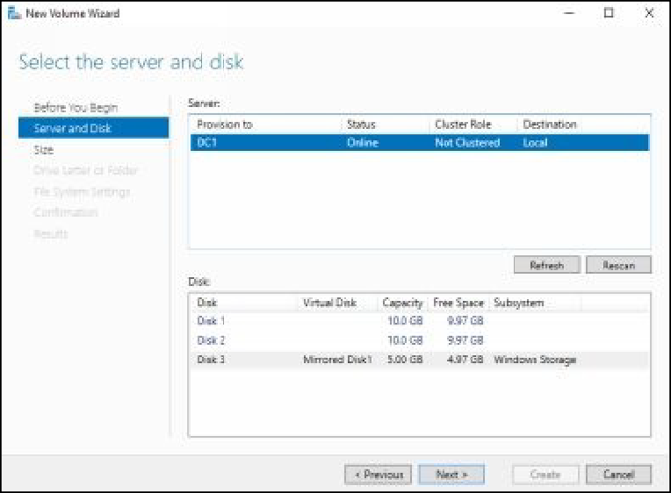

1. On the **Specify the size of the volume** page, click **Next**.
2. On the **Assign to a drive letter or folder** page, notice the Drive letter, as shown in the following figure, and then click **Next**.

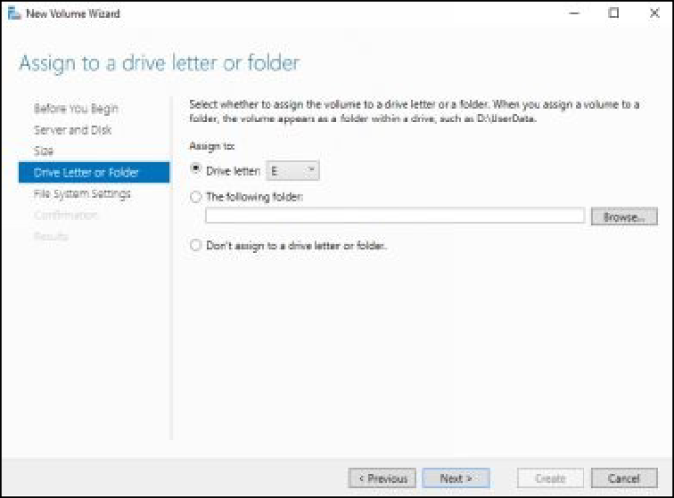

1. On the **Select file system settings** page, in the **File system** drop- down menu, ensure that **ReFS** is selected.
2. In the **Volume** label text box, type **Mirrored Volume1**, as shown in the following figure, and then click **Next**.

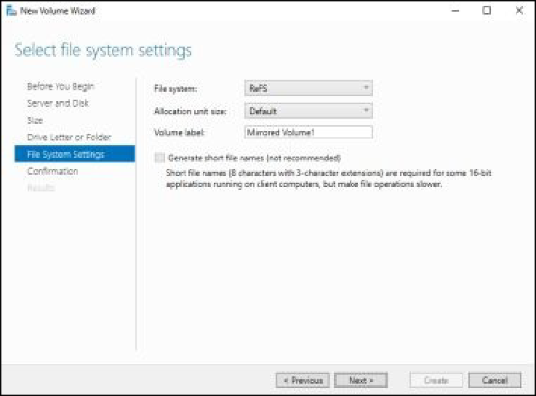

***Note****: ReFS is a new file system that supports more features than NTFS file system.*

1. On the **Confirm selections** page, click **Create**.
2. On the **Completion** page, click **Close**, once the task completes.

# Task 3: Creating a File in to Mirrored Volume1

1. Open the **Windows Explorer** window, double-click **Mirrored**

## Volume1.

1. Create the **MyTextFile1** file under **Mirrored Volume1,** as shown

in the following figure.

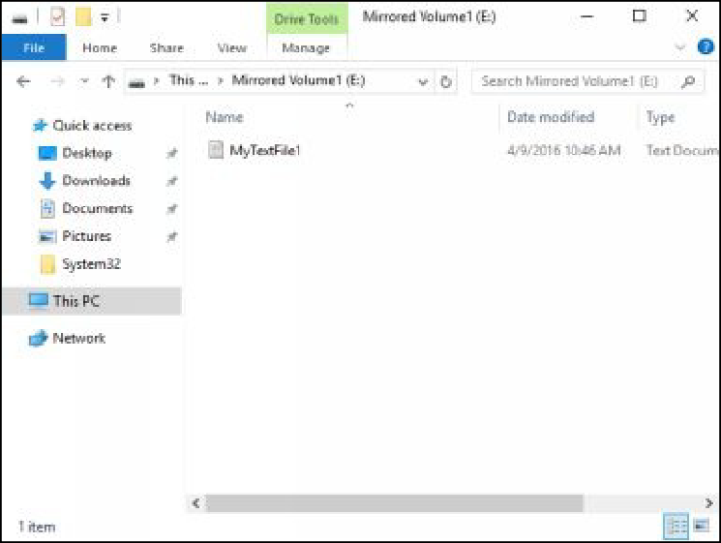

1. Close the **Windows Explorer** window.

# Task 4: Removing a Physical Drive

1. On your host machine, on the **VMware** console, select and right- click **DC1**, and then select **Settings**.
2. On the **Virtual Machine Settings** dialog box, select **Hard Disk 2**

hard drive, as shown in the following figure.

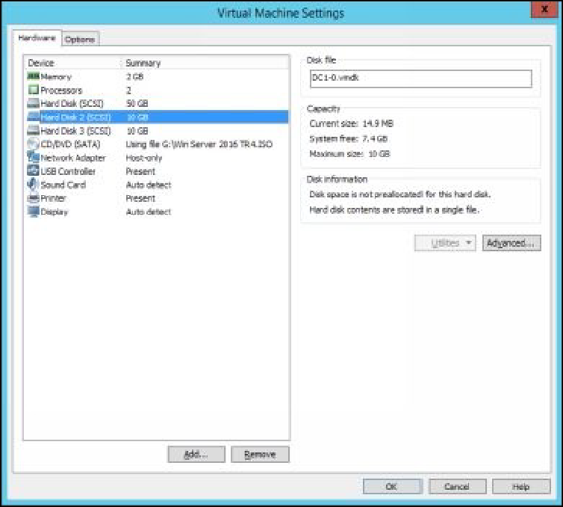

1. In the right pane, click **Remove**, and then click **OK**.

# Task 5: Verifying the File Availability

1. On **DC1**, switch to the **Computer Management** console or open it

if required.

1. Make sure that the **Disk Management** node is selected, verify that the **Disk 2** is disappeared from the disk list, as shown in the

following figure.

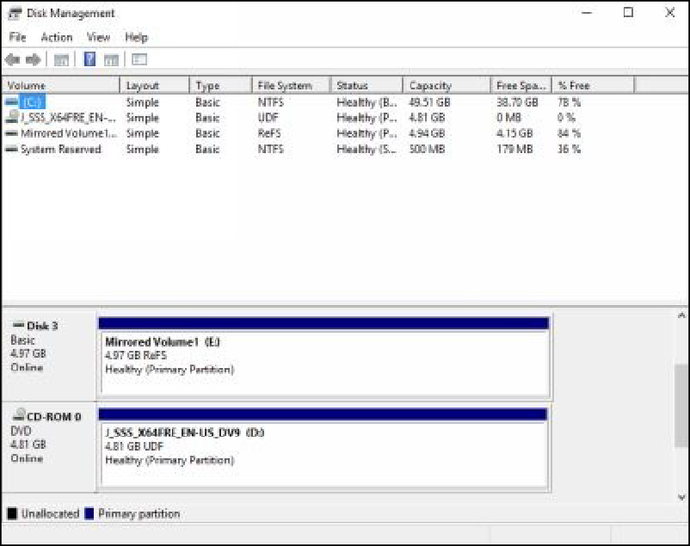

1. Open the **Windows Explorer** window.
2. On the **Windows Explorer** window, double-click **Mirrored**

## Volume1.

1. Verify that the **MyTextFile1** file is still available.
2. Close the **Windows Explorer** window.

***Results****: After completing this exercise, you should have created a storage pool and added some disks to it. Then you should have created a mirrored virtual disk from the storage pool. In addition, after removing a physical drive, you should have verified that the virtual disk was still available and accessible.*

Shut down and revert the DC1 virtual machine to prepare for the net exercise.

# Exercise 14: Implementing File Sharing

File sharing allows you to share and access the files on a network. You can also set the desired permissions (NTFS and shared permissions) on a file share for the various users. In addition, you can enable the access-based enumeration feature on a file share, which allows users to access only those shared files for which they have the access permission.

Start the DC1, SERVER1, and CLIENT1 virtual machines to perform this exercise.

# Task 1: Creating the Folder Structure for the New Share

Before start to this exercise, you need to create **Peter** and **Shawn** user accounts on the **DC1** virtual machine. To do this, you need to perform the following steps:

1. Sign in to **DC1** with the MCSALAB\Administrator account.
2. Open the **Active Directory Users and Computers** console, and then expand the **mcsalab.local** node.
3. Select and right-click **Users** in the left pane, select **New**, and then click **User**.
4. Follow the simple steps to create the **Peter** and **Shawn** user accounts.
5. The following figure displays the **Active Directory Users and Computers** console. **Peter** and **Shawn** user accounts are listed under

the **Users** node.

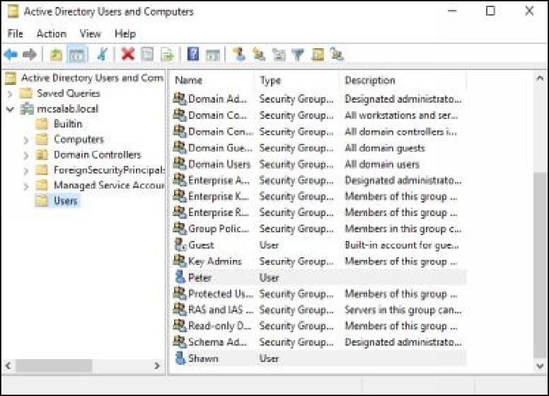

***Note****: If you face problems to create user accounts, you may refer the exercise 6 and 7.*

1. Switch and Sign in to **SERVER1** with the MCSALAB\Administrator account.
2. Open the **Windows Explorer** window, in the navigation pane, double-click **Local Disk (C:)**.
3. Create a folder named **MyData**.
4. Double-click the **MyData** folder.
5. Create the **Marketing** and **Sales** folders under it, as shown in the following figure.

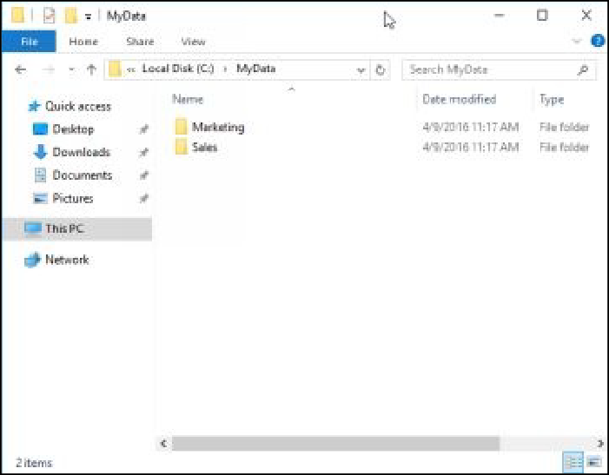

# Task 2: Configuring NTFS Permissions on the Folder Structure

1. On SERVER1, on the **Windows Explorer** window, navigate to

drive **Local Drive (C:)**.

1. Select and right-click the **MyData** folder, and then select

## Properties.

1. On the **MyData Properties** dialog box, select **Security**, and then click **Advanced**, as shown in the following figure.

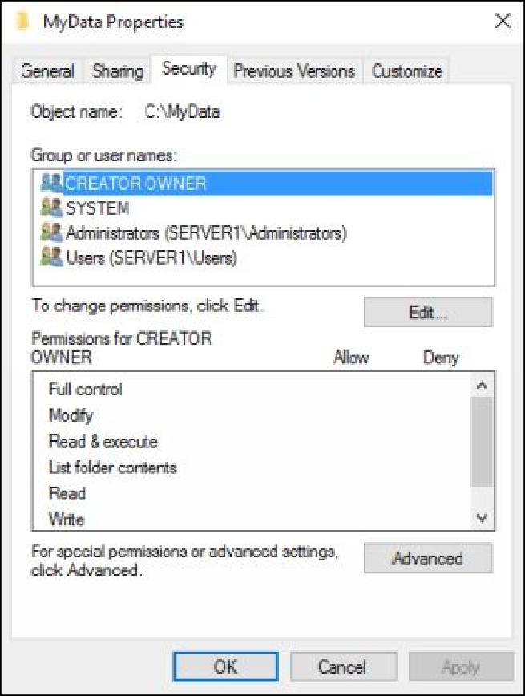

1. On the **Advanced Security Settings** for **MyData** dialog box, click

## Disable Inheritance.

1. On the **Block Inheritance** dialog box, as shown in the following figure, select the **Convert inherited permissions into explicit**

**permissions on this object** option, and then click **OK**.

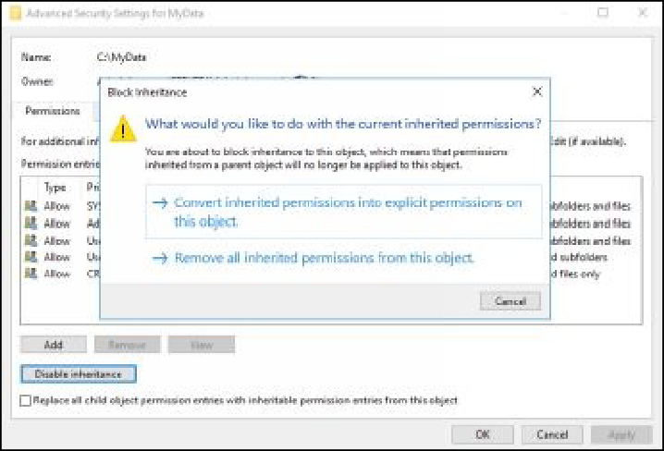

1. Click **OK** twice to close the **MyData Properties** dialog box.
2. On the **Windows Explorer** window, double-click the **MyData**

folder.

1. Select and right-click the **Marketing** folder, and then select

## Properties.

1. On the **Marketing Properties** dialog box, click **Security**, and then

click **Advanced**.

1. On the **Advanced Security Settings for Marketing** dialog box,

click **Disable Inheritance**.

1. On the **Block Inheritance** dialog box, select the **Convert inherited permissions into explicit permissions on this object** option.
2. **Remove** the **Read & Execute** and **Special permissions** for **Users (SERVER1\Users)**, as shown in the following figure, and then

click **OK**.

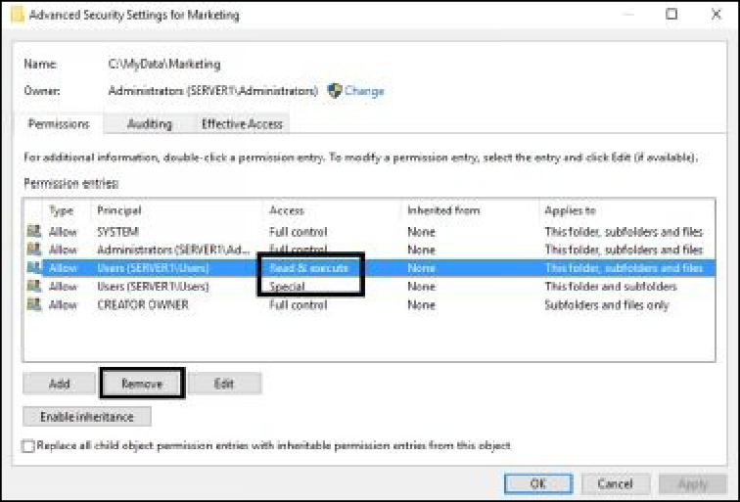

1. On the **Security** tab, click **Edit**.
2. On the **Permissions for Marketing** dialog box, click **Add**.

## On the Select Users, Computers, Service Accounts, and Groups

dialog box, type **Peter**, click **Check Names**, as shown in the following figure, and then click **OK**.

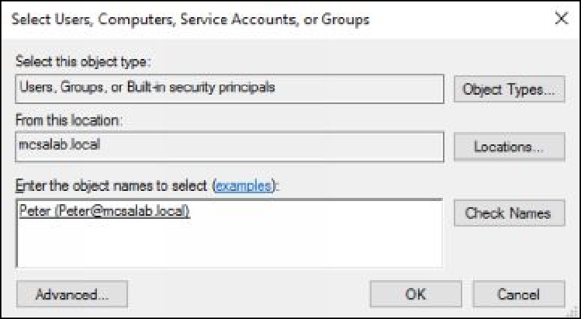

***Note:*** *You may asked to provide Domain administrator credentials.*

1. On the **Permissions for Marketing** dialog box, select the **Modify**

check box under the **Allow** section, as shown in the following figure.

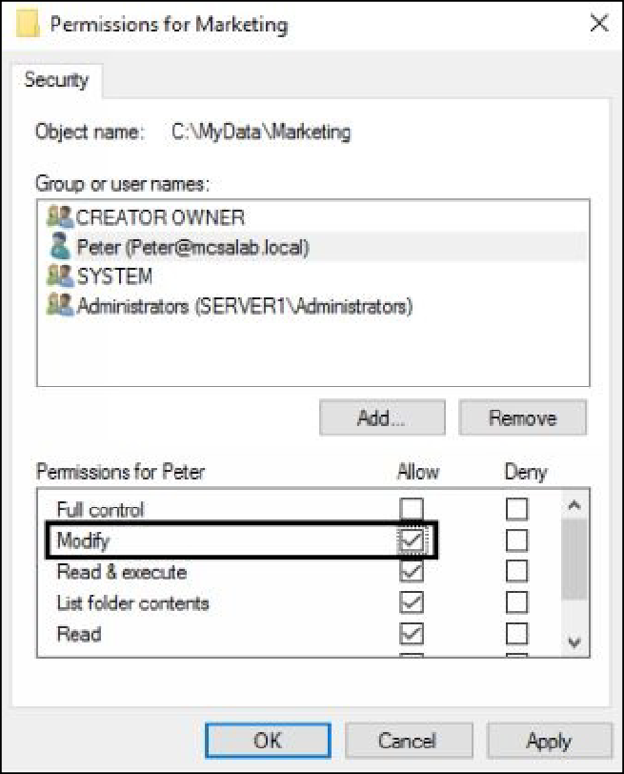

1. Click **OK** to close the **Permissions for Marketing** dialog box.
2. Click **OK** to close the **Marketing Properties** dialog box.

# Task 3: Sharing the Folder

1. On **SERVER1**, select and right-click the **MyData** folder, and then

select **Properties**.

1. On the **MyData Properties** dialog box, select the **Sharing** tab, and

then click **Advanced Sharing**.

1. On the **Advanced Sharing** dialog box, select the **Share this folder**

check box, as shown in the following figure, and then click

## Permissions.

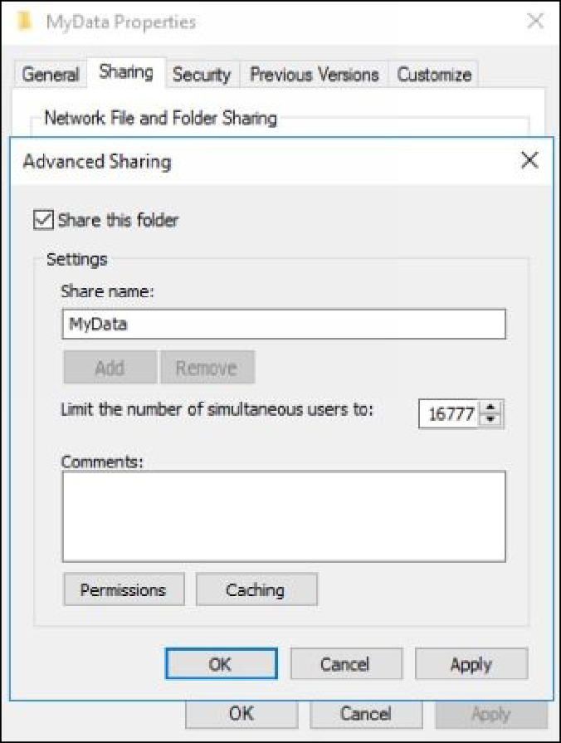

1. On the **Permissions for MyData** dialog box, as shown in the following figure, and then click **Add**.

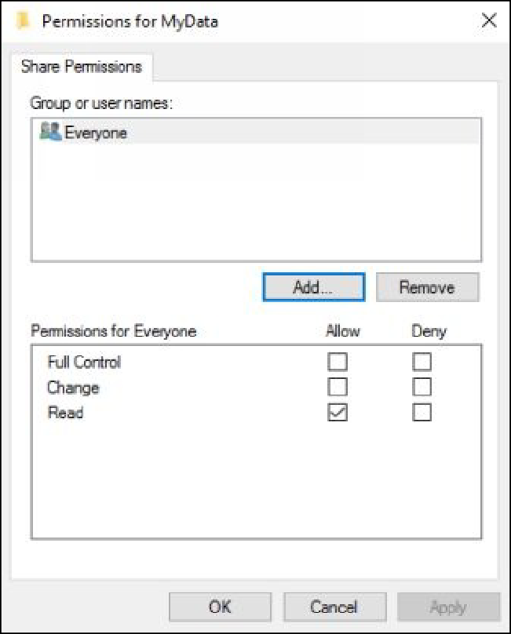

## On the Select Users, Computers, Service Accounts, or Groups

dialog box, in the **Enter the object names to select (examples):**

text area, type **Authenticated Users**.

1. Click **Check Names**, and then click **OK**.
2. On the **Permissions for MyData** dialog box, make sure that the **Authenticated Users** is selected in the **Share Permissions** section, and then select the **Change** check box under the **Allow** section, as

shown in the following figure.

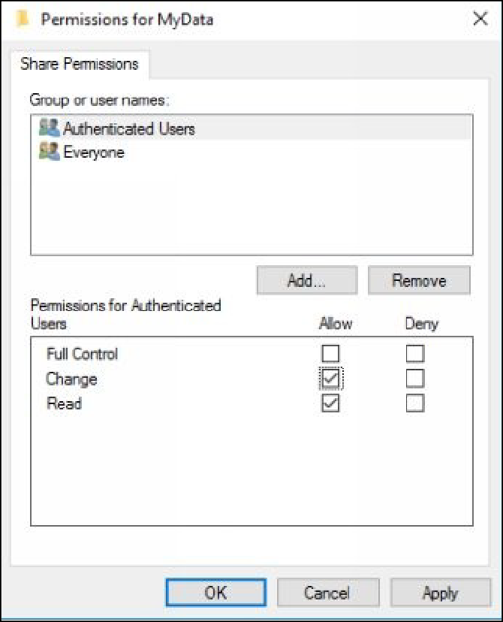

1. Click **OK** to close the **Permissions for MyData** dialog box.
2. Click **OK** to close the **Advanced Sharing** window.
3. Click **Close** to close the **MyData Properties** dialog box.

# Task 4: Accessing the Shared Folder

1. Switch and Sign in to **CLIENT1** with the MCSALAB\Peter

account.

1. Open the **Run** dialog box, type **\\SERVER1\MyData**, and then

press **Enter**.

1. Double-click the **Marketing** folder.

***Note****: Peter should be able to access to the Marketing folder.*

1. Sign out of **CLIENT1**.

# Task 5: Enabling Access-based Enumeration

1. Switch back and Sign in to **SERVER1** with the MCSALAB\Administrator account.
2. Open the **Server Manager** console, on the **Server Manager**

console, in the left pane, select **File and Storage Services**.

1. On the **File and Storage Services** page, click **Shares**.
2. In the **Shares** pane, select and right-click **MyData**, and then click

**Properties**, as shown in the following figure.

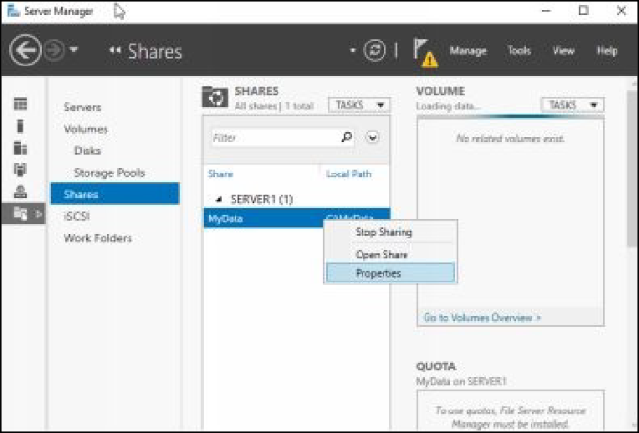

1. On the **MyData Properties** dialog box, in the left pane, select

**Settings**, and then select the **Enable access-based enumeration**

check box, as shown in the following figure.

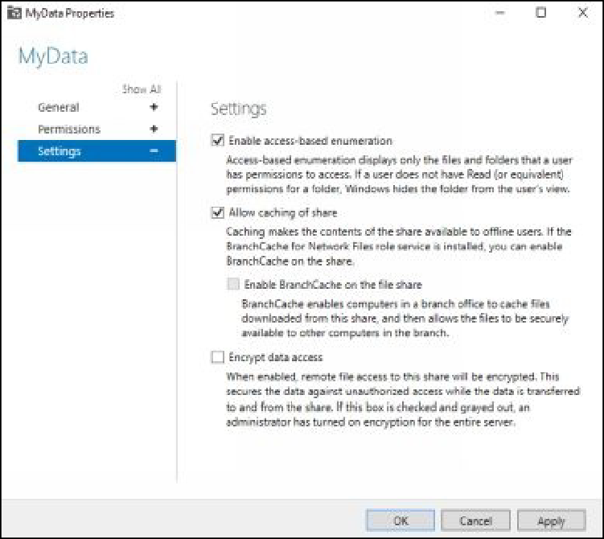

1. Click **OK** to close the **MyData Properties** dialog box.
2. Close the **Server Manager** console.

# Task 6: Testing the Access-based Enumeration Configuration

1. Switch back and sign in to **CLIENT1** with the **MCSALAB\Shawn**

account.

1. Click the **Desktop** tile.
2. Open the **Run** dialog box, in the **Open** text box, type

**\\SERVER1\MyData**, and then press **Enter**.

***Note****: Shawn should only be able to view the Sales folder, the folder for which he has been assigned permissions.*

1. Sign out of **CLINET1**.

***Results****: After completing this exercise, you should have created and tested a file share. In addition, you should also have tested the access-based enumeration feature for the shared folder.*

Shut down and revert the DC1, SERVER1, and CLIENT1 virtual machines to prepare for the next exercise.

# Exercise 15: Implementing Shadow Copies

Shadow copy is a feature that allows you to recover the files (including the shared files) which are accidently overwritten or deleted. First, you need to enable this feature (on a desired disk) then you can create multiple shadow copy versions on a disk. However, shadow copy cannot be considered as an alternate of the Window backup feature, because it only works until the system is working on which you have enabled it. If the system goes down or crashed accidently, shadow copy cannot be used to recover the system or system’s data.

In this exercise, you will learn how to use the shadow copy feature to recover the accidently deleted files.

Start the DC1 and SERVER1 virtual machines to perform this exercise.

# Task 1: Configuring Shadow Copies

1. Sign in to **SERVER1** with the MCSALAB\Administrator account.
2. Open the **Windows Explorer** window.
3. Select and right-click **Local Disk (C:),** and then click **Configure**

## Shadow Copies.

1. On the **Shadow Copies** dialog box, make sure that **C:\** volume is

selected, and then click **Enable**.

1. On the **Enable Shadow Copies** message box, click **Yes**.
2. On the **Shadow Copies** dialog box, click **Settings**.
3. On the **Settings** dialog box, as shown in the following figure, click

## Schedule.

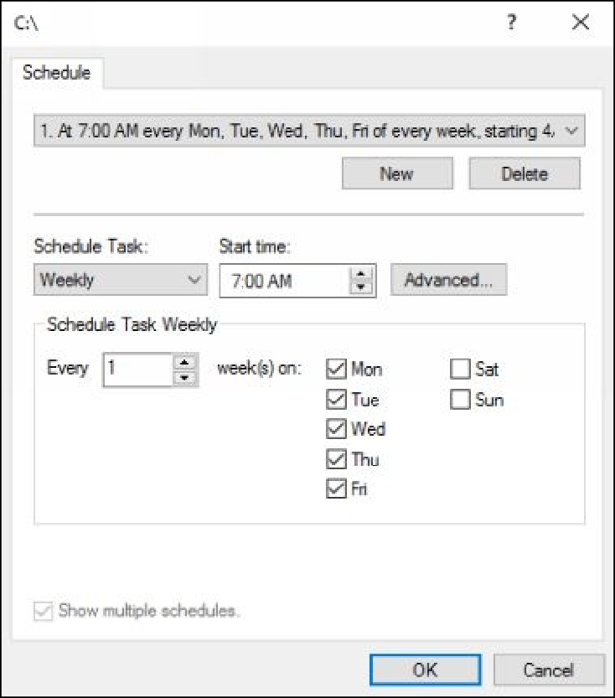

1. On the **C:\** schedule dialog box, review the various schedule

options, and then click **OK**.

1. On the **Settings** dialog box, click **OK**.
2. Click **OK** to close the **Settings** dialog box.
3. On the **Shadow Copies** dialog box, click **OK**.

# Task 2: Recovering a Deleted File Using Shadow Copy

1. On **SERVER1**, switch to the **Windows Explorer** window.
2. Navigate to **Local Disk (C:)**, and then click **Users**.
3. Select and right-click **Public**, and then click **Delete**.
4. Also delete the **Public** folder from **Recycle Bin**.
5. On the **Windows Explorer** window, select and right-click the

**Users** folder, and then click **Properties**.

1. On the **Users Properties** dialog box, click the **Previous Versions**

tab, as shown in the following figure.

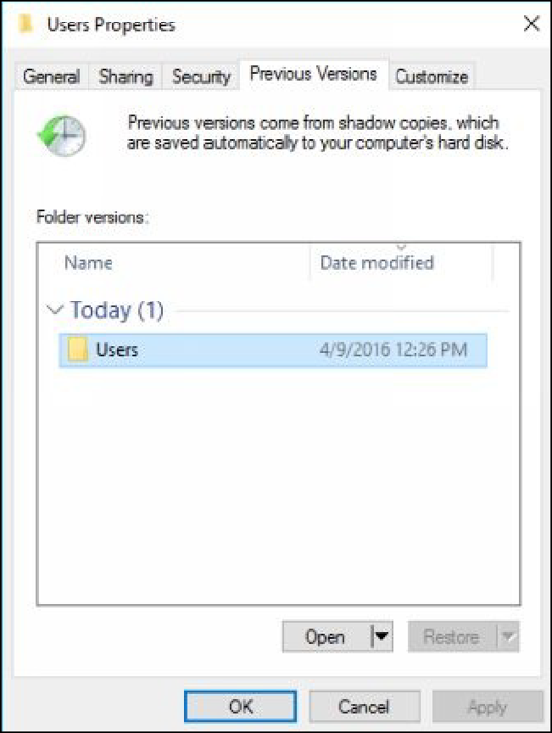

1. Select the folder version for the **Users** folder, and then click **Open**.
2. Verify that the **Public** is listed in the folder, select and right-click

**Public**, and then click **Copy**.

1. On the other **Windows Explorer** window, navigate to the **Local Disk (C:)\Users** folder, and then click **Paste**.
2. Close the **Windows Explorer** window.
3. Click **OK** and close all open windows.

***Results****: After completing this exercise, you should have configured the Shadow Copies feature to recover the accidently deleted file.*

1. Shut down and revert the DC1 and SERVER1 virtual machines to

prepare for the next exercise.

# Exercise 16: Implementing Network Printing

A printer is a hardware device which translate the soft copies in to hard copies.

A single printer can be shared on a network and then it can be accessed by multiple clients to send the print jobs. Once you shared a printer on a network, you need to connect it on each clients in order to send the print jobs. However, in a large enterprise network, where multiple printers are used to handle a number of thousand print jobs, you may need to configure the printer pool for ease print management.

In this exercise, you will learn how to install, share, and manage a network printer on a Windows-based network.

Start the DC1, SERVER1, and CLIENT1 virtual machines to perform this exercise.

# Task 1: Installing the Print and Document Services Server Role

1. Sign in to **SERVER1** as MCSALAB\Administrator.
2. On the **Server Manager** console, click **Manage**, and then click

## Add Roles and Features.

1. On the **Before you begin** page of the **Add Roles and Features**

**Wizard**, click **Next**.

1. On the **Select installation type** page, make sure that the **Role- based or feature-based installation** radio button is selected, and

then click **Next**.

1. On the **Select destination server** page, click **Next**.
2. On the **Select Server Roles** page, as shown in the following figure, select the **Print and Document Services** check box. If the **Add**

**Roles and Features Wizard** dialog box displays, click **Add Features**, and then click **Next**.

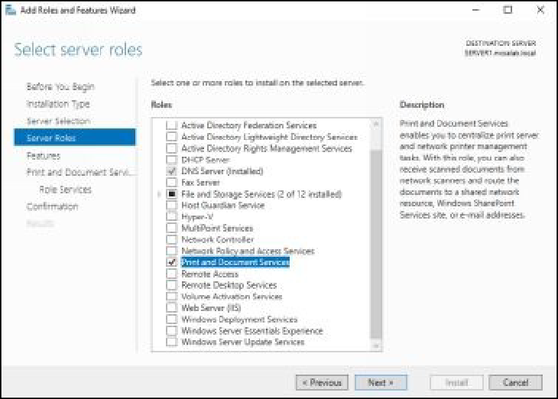

1. On the rest of the pages, click **Next** until the **Confirm Installation**

**Selections** page displays.

1. Click **Install** to install the required role services, and then click

**Close** once the installation succeeded.

# Task 2: Installing a New Printer

1. On the **Server Manager** console, click **Tools**, and then click **Print**

## Management.

1. On the **Print Management** console, expand **Printer Servers**, and

then click **SERVER1 (Local)**.

1. Select and right-click **Printers**, and then click **Add Printer**, as

shown in the following figure.

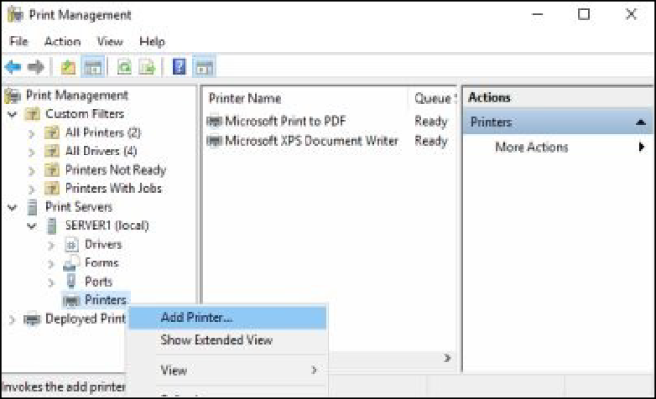

1. On the **Network Printer Installation Wizard** page, select the **Add a new printer using an existing port** radio button, as shown in the

following figure, and then click **Next**.

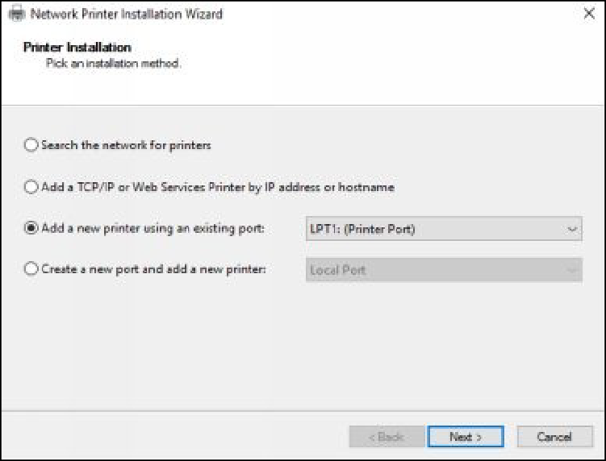

1. On the **Printer Driver** page, make sure that the **Install a new printer** radio button is selected, and then click **Next**.
2. On the **Printer Installation** page, select **Canon** in the

**Manufacture** list.

1. Select any of the printer model in the **Printers** list in the right pane, as shown in the following figure, and then click **Next**.

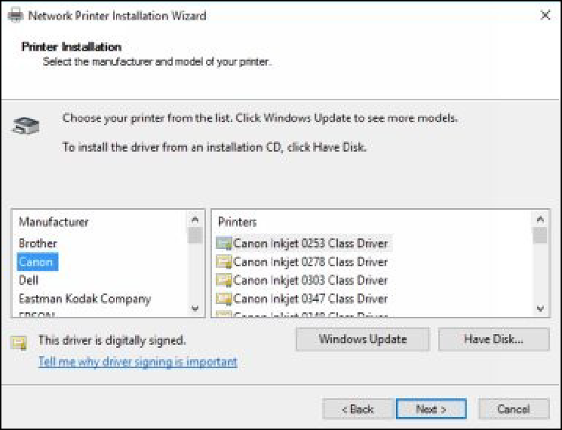

1. On the **Printer Name and Sharing Settings** page, click **Next**.
2. On the **Printer Found** page, click **Next**, and then click **Finish**.

# Task 3: Configuring Printer Pooling

1. On the **Print Management** console, select and right-click the recently added printer, and then click **Properties**.
2. On the printer properties dialog box, click the **Sharing** tab, select the **List in the directory** check box, as shown in the following

figure, and then click **Apply**.

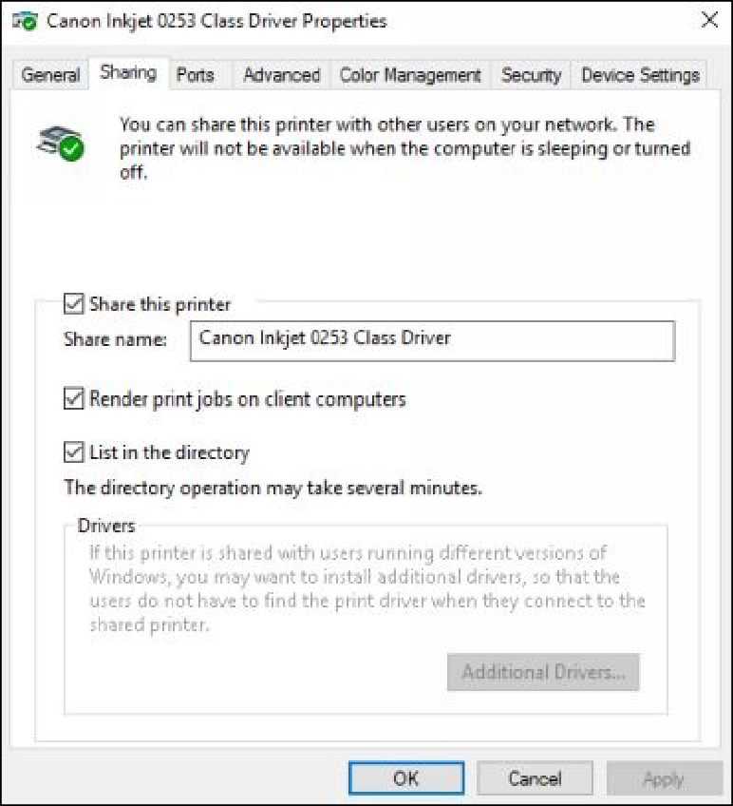

1. On the printer properties dialog box, click the **Ports** tab, select the

**Enable printer pooling** check box, and then select the **LPT2**: check box to select it as an additional port, as shown in the following figure.

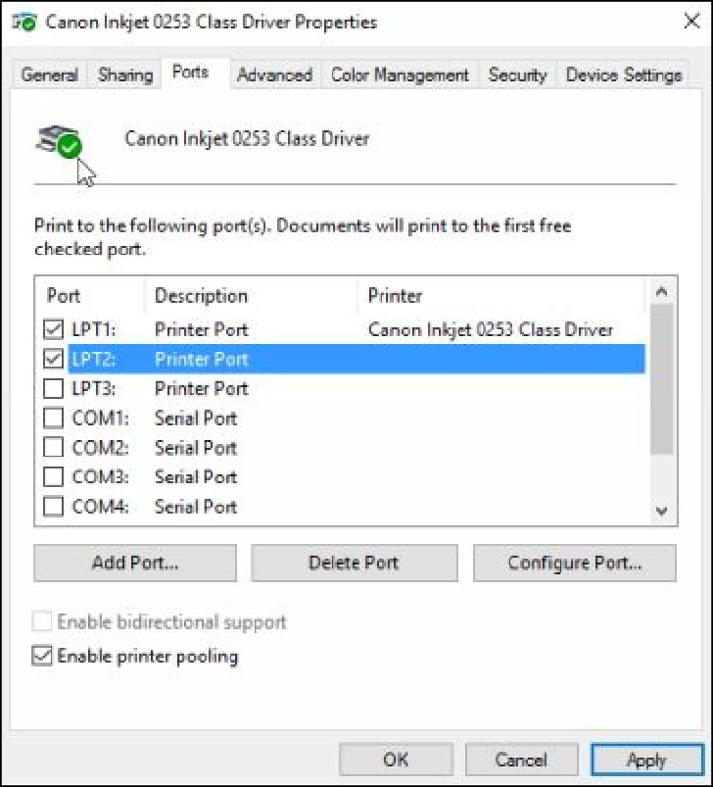

1. Click **OK** to close the printer properties dialog box.
2. Close the **Print Management** console.

# Task 4: Connecting a Printer on a Client

1. Switch and Sign in to **CLIENT1** as MCSALAB\Administrator with the password as **Password@123**.
2. Open **Control Panel**, on the **Control Panel** window, click the **Add a device** link under **Hardware and Sound.**
3. On the **Add a device** window, select the discovered printer, as shown in the following figure, and then click **Next**.

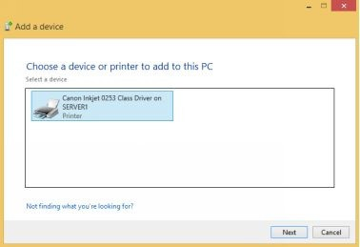

1. On the **Control Panel** window, click the **View devices and printers** link, under **Hardware and Sound**.
2. Make sure that the recently added printer is listed.

***Results****: After completing this exercise, you should have installed and configured a network printer. In addition, you should also have configured the printer pooling.*

Shut down and revert the DC1, SERVER1, and CLIENT1 virtual machines to prepare for the next exercise.

# Exercise 17: Implementing Group Policy Objects

A Group Policy Object (GPO) is a collection of security policies and settings that are used to control the users’ and computers’ behavior on a network. You can use various security policies to restrict the Active Directory objects from accessing the unwanted resources, such as features, services, files, or tools. Once you promote a server as a domain controller, the Default Domain Policy and Default Domain Controller Policy GPOs are created by default on the domain controller. These GPOs contain various preconfigured policies that are applied on the domain controllers and computers. However, you can create a new GPO with the custom security policies and settings using the Group Policy Management console.

In this exercise, you will learn how to create a GPO and how to configure a GPO to prevent Active Directory objects from accessing the resources on a Windows- based domain network.

Start the DC1 and CLIENT1 virtual machines to perform this exercise.

# Task 1: Creating a New GPO

1. Sign in to **DC1** with the MCSALAB\Administrator.
2. Open the **Server Manager** console, if required.
3. On the **Server Manager** console, click **Tools**, and then click

## Group Policy Management.

1. On the **Group Policy Management** console, expand **Forest: mcsalab.local**, and then click **Domains**.
2. Select and right-click **mcsalab.local**, and then select **Create a GPO in this domain**, as shown in the following figure.

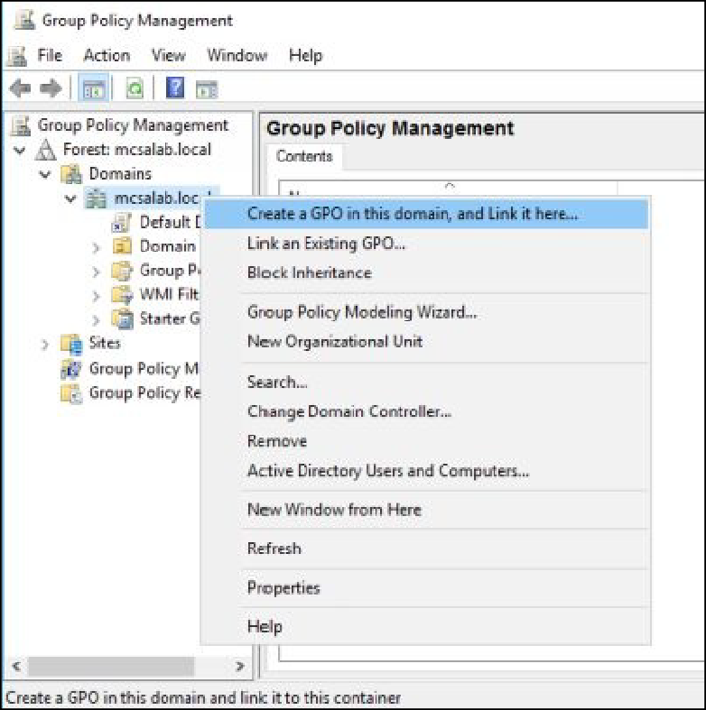

1. On the **New GPO** dialog box, in the **Name** text box, type **Internet Explorer GPO**, and then click **OK**.

# Task 2: Configuring the Internet Explorer GPO

1. On **DC1**, on the **Group Policy Management** console, select and right-click **Internet Explorer GPO**, and then click **Edit**.
2. On the **Group Policy Management Editor** console, navigate to

## User Configuration\Policies\Administrative Templates.

1. Select and right-click **All Settings**, and then select **Filter Options**,

as shown in the following figure.

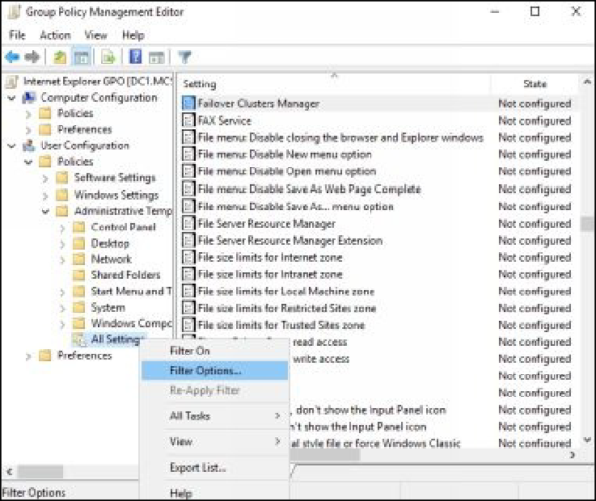

1. On the **Filter Options** dialog box, select the **Enable Keyword**

**Filters** check box.

1. In the **Filter for word(s):** text box, type **General**, as shown in the following figure, and then click **OK**.

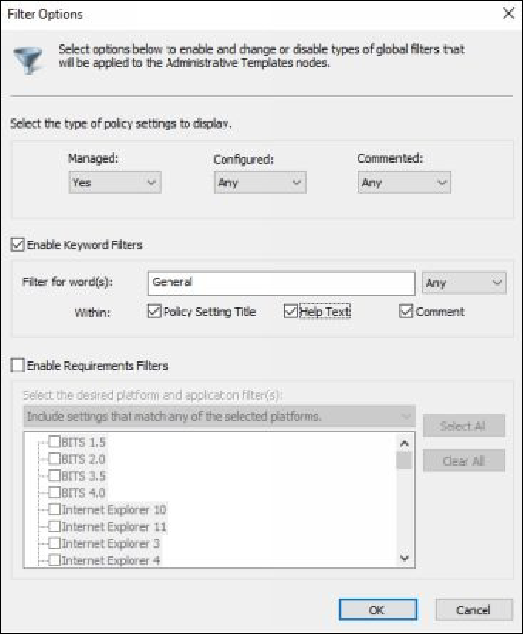

1. In the **Settings** pane in the right hand, select and right-click **Disable the General page**, and then select **Edit**, as shown in the following

figure.

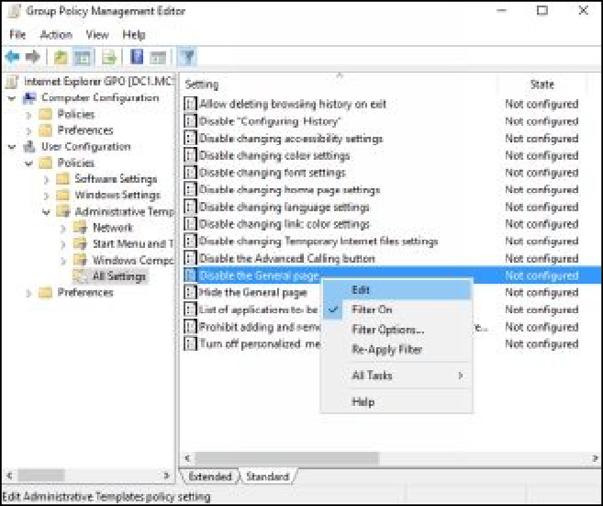

1. On the **Disable the General** page dialog box, select the **Enabled**

radio button, and then click **OK**.

1. Close the **Group Policy Management Editor** console.

# Task 3: Creating a Domain User to Test the GPO

1. On **DC1**, open the **Command Prompt** window.
2. Execute the following command, as shown in the following figure (type Password@123 when you are prompted for password).

## dsadd user cn=User1,”cn=users,dc=mcsalab,dc=local” –disabled no

**–pwd \***

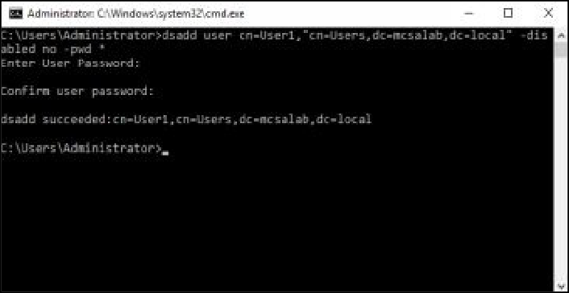

1. Close the **Command Prompt** window.

# Task 4: Testing the Internet Explorer GPO

1. Switch and Sign in to **CLIENT1** as MCSALAB\User1 with the

password as Password@123.

1. Open the **Run** dialog box, type **control** in the **Open** text box, and

then press **Enter**.

1. On the **Control Panel** window, click **Network and Internet**.
2. On the **Network and Internet** window, as shown in the following figure, click **Change your homepage**.

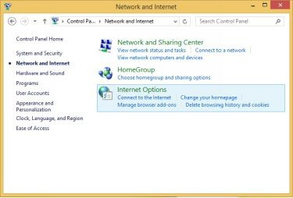

1. When you click the **Change your home** page link, you will get a message, as shown in the following figure.

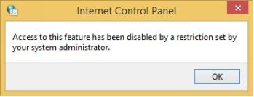

1. Click **OK** to close the **Internet Control Panel** message box.
2. On the **Control Panel** window, click **Internet Options**. Notice that, in the **Internet Properties** dialog box, the **General** tab is not

available, as shown in the following figure.

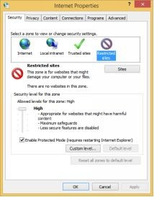

1. Close all open windows and sign out.

# Task 5: Configuring Security Filtering to Exempt a User from the Internet Explorer GPO

1. Switch and sign to **DC1**.
2. Open the **Group Policy Management** console, if required.
3. On the **Group Policy Management** console, select and right-click

## Internet Explorer GPO.

1. In the right pane, click the **Delegation** tab.
2. On the **Delegation** tab, click the **Advanced** button.
3. On the **Internet Explorer GPO Security Settings** dialog box, click

**Add**.

## On the Select Users, Computers, Service Accounts, or Groups

text box, type **User1**, as shown in the following figure, and then click **OK**.

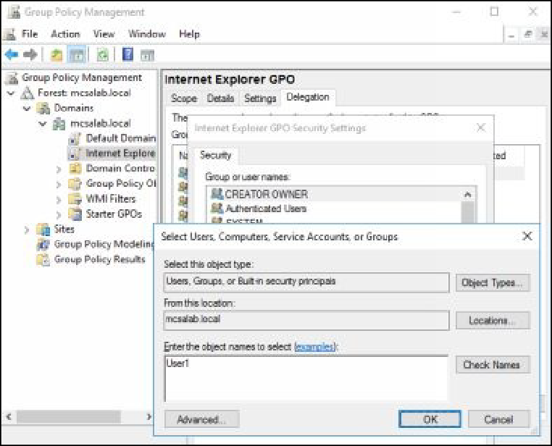

1. On the **Internet Explorer GPO Security Settings** dialog box, in the **Security** section, select **User1**.
2. In the **Permissions for User1** section, select the **Deny** check box, as shown in the following figure, and then click **OK**.

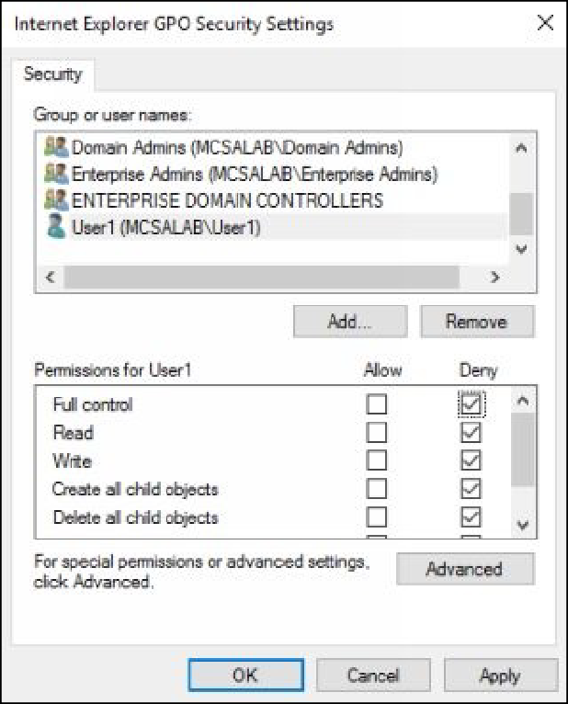

1. On the **Windows Security** dialog box, click **Yes**.
2. Close the **Group Policy Management** console.

# Task 6: Testing the Internet Explorer GPO

1. Switch and Sign in to **CLIENT1** as MCSALAB\User1 with the

password as Password@123.

1. Open the **Run** dialog box, type **control** in the **Open** text box, and

then press **Enter**.

1. On the **Control Panel** window, click **Network and Internet**.
2. On the **Network and Internet** dialog box, click **Change your homepage**. Notice that the **General** tab is available on the **Internet**

**Properties** dialog box.

1. Close all open windows, and sign out.

***Results****: After completing this exercise, you should have configured and tested a GPO.*

Shut down and revert the DC1 and CLIENT1 virtual machines.

# Exercise 18: Implementing AppLocker and Firewall Using Group Policy

AppLocker is a security feature that allows you to restrict specific applications for specific groups or users.

In the exercise, you will learn how to control an application using the AppLocker feature. Further, you will also learn how to manage Windows Firewall using the Group Policy Management console.

Start the DC1 virtual machine to perform this exercise.

# Task 1: Restricting an Application Using AppLocker

1. Sign in to **DC1** as MCSALAB\Administrator with the password as

Password@123.

1. Open the **Group Policy Management** console.
2. Navigate to **Forest: mcsalab.local\Domains\mcsalab.local**.
3. Select and right-click **Group Policy Objects**, and then select **New**.
4. On the **New GPO** dialog box, in the **Name** text box, type **Software**

**Policy**, and then click **OK**.

1. Right-click **Software Policy**, and then select **Edit**.
2. On the **Group Policy Management Editor** console, navigate to **Computer Configuration\Policies\Windows Settings\Security Settings\Application Control Policies\AppLocker**, as shown in

the following figure.

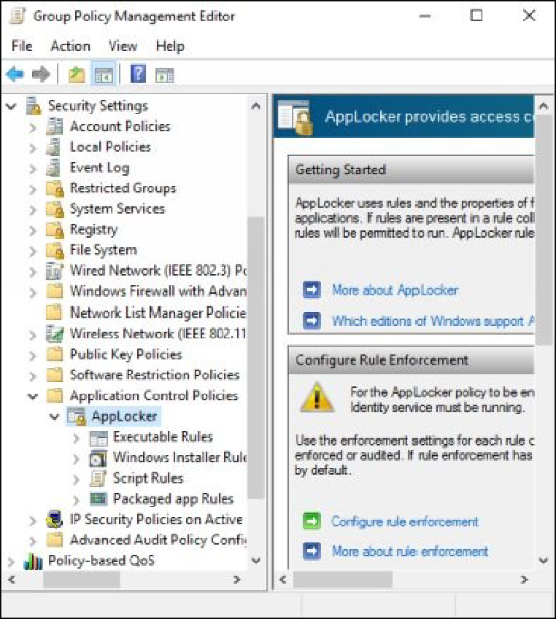

1. Expand **AppLocker**, right-click **Executable Rules**, and then select

## Create New Rule.

1. On the **Before You Begin** page, select **Next**.
2. On the **Permissions** page, under the **Users or Groups** box, select

**Deny**, and then select **Next**.

1. On the **Conditions** page, select the **Path** radio button, as shown in the following figure, and then click **Next**.

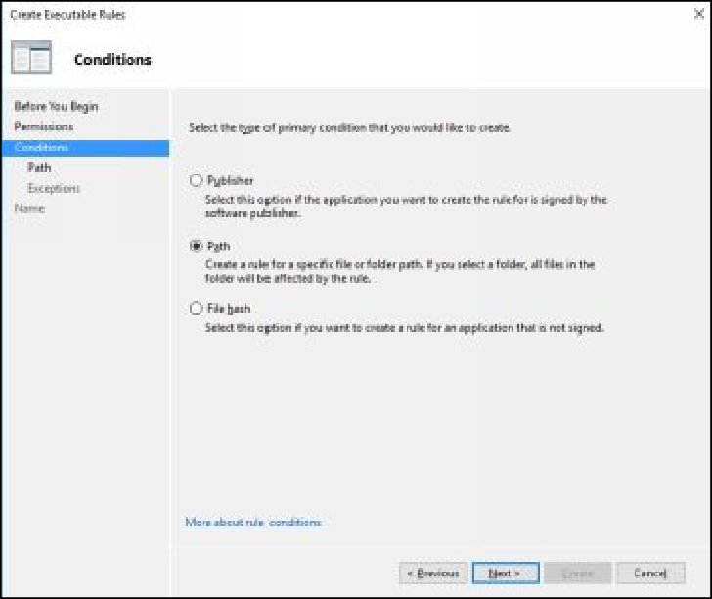

1. On the **Path** page, click **Browse Files**, browse to

**C:\Windows\System32\calc.exe**, click **Open**, as shown in the following figure, and then select **Next**.

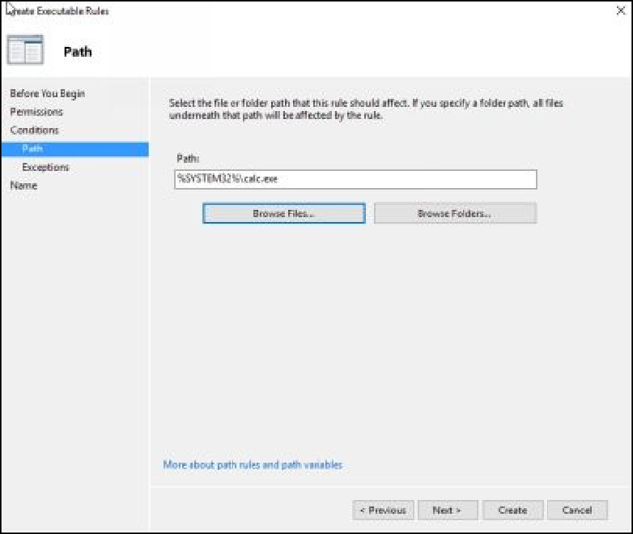

1. On the **Exceptions** page, select **Next**.
2. On the **Name and Description** page, in the **Name** text box, type

**Block Calculator**, and then click **Create**.

1. If the **AppLocker** dialog box appears and prompts to create default

rules, click **Yes**.

1. On the **Group Policy Management Editor** console, as shown in the following figure, notice the default executables rules.

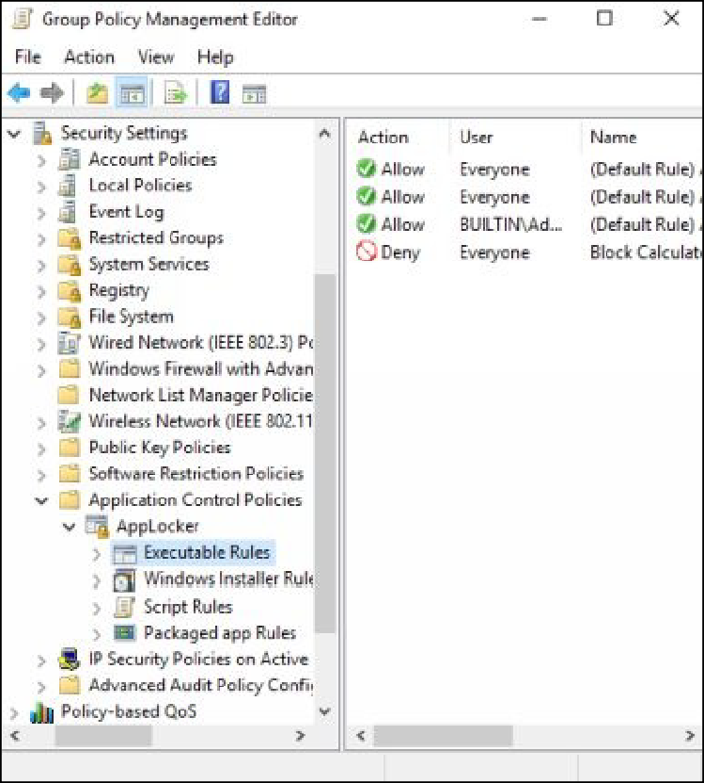

1. Select the **AppLocker** node in the left pane, and then click the

**Configure rule enforcement** link, as shown in the following figure.

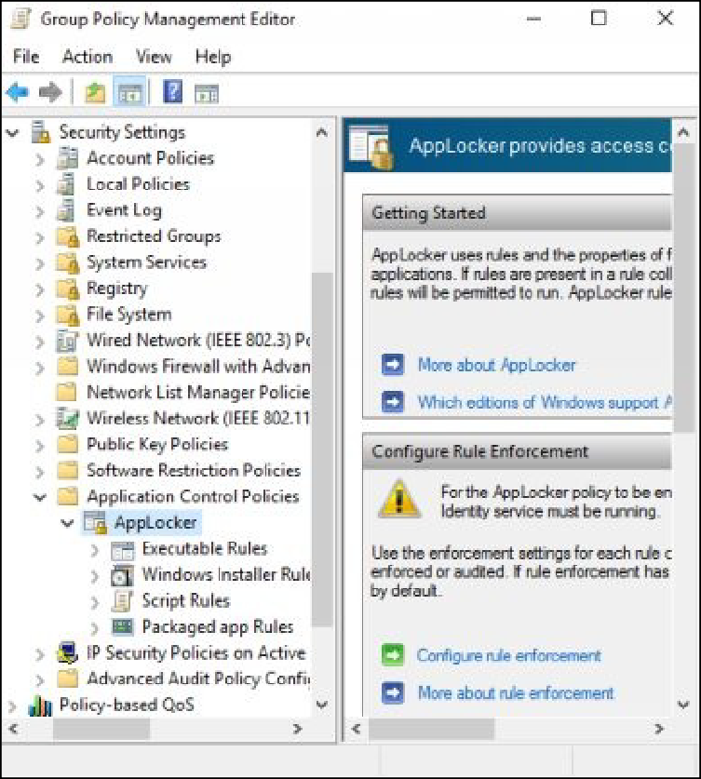

1. On the **Enforcement** tab of the **AppLocker Properties** dialog box, under **Executable** rules, select the **Configured** check box.
2. Make sure that the **Enforce rules** option is selected in the drop- down list, as shown in the following figure, and then click **OK**.

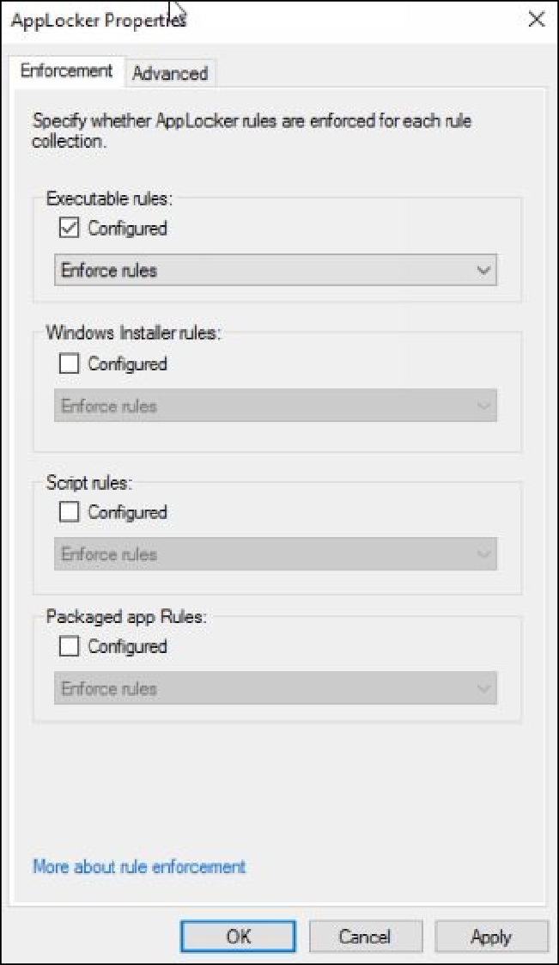

1. Close the **Group Policy Management Editor** console.
2. On the **Group Policy Management** console, select and right-click

**Domain Controllers,** and then select **Link an Existing GPO**.

1. On the **Select GPO** dialog box, select **Software Policy**, and then

click **OK**.

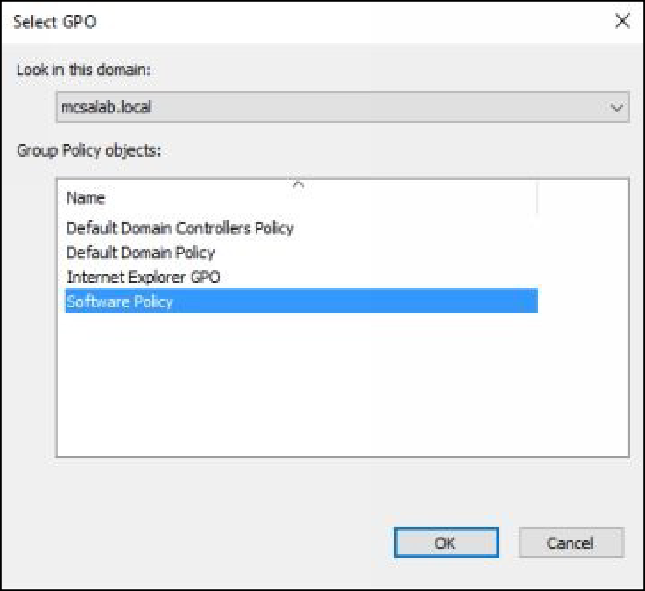

1. Under the **Link Group Policy Objects** tab, select **Software Policy**, and then click **Link Order** to move this policy to top.

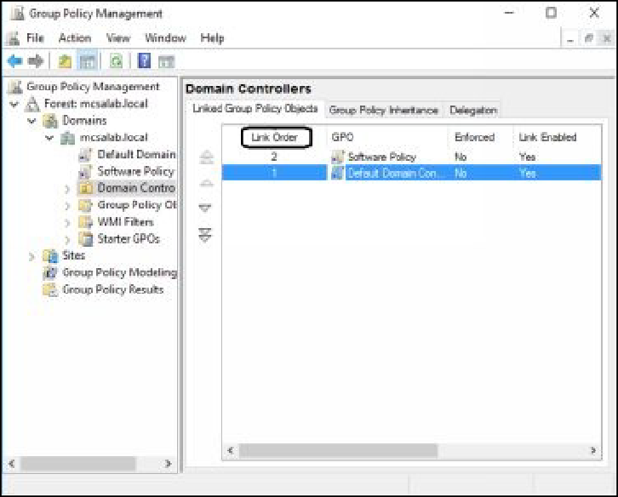

1. Open the **Run** dialog box, type **services.msc**, and then press **Enter**.
2. On the **Services** console, select and right-click **Application Identity**, and then select **Properties**.
3. On the **Application Identity Properties (Local Computer)** dialog box, set the **Startup type** as **Automatic**, click **Start**, as shown in

the following figure, and then click **OK**.

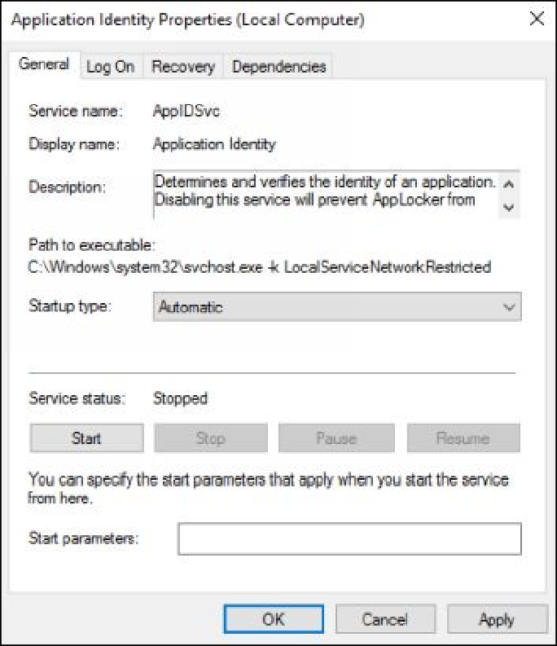

***Note:*** *If you get an error, just close the Service Manager window.*

1. Open the **Command Prompt** window, type **gpupdate /force**, and

then press **Enter**.

1. Sign out from to **DC1** and Sign in back to **DC1** as

MCSALAB\Administrator.

1. Open the **Run** dialog box, type **calc.exe** in the Open text box, and

then press **Enter**.

1. You should get an error as shown in the following figure.

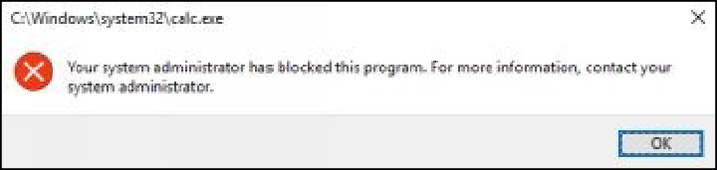

***Note****: If you are still able to open the Calculator application, restart the DC1 server, and then try again.*

# Task 2: Configuring Windows Firewall Rules Using Group Policy

1. Sign in to **DC1** and open the Group Policy Management console, if

required.

## Navigate to Forest: mcsalab.local\Domains\mcsalab.local\Group

**Policy Objects**.

1. Right-click the **Group Policy Objects** node, and then select **New**,

as shown in the following figure.

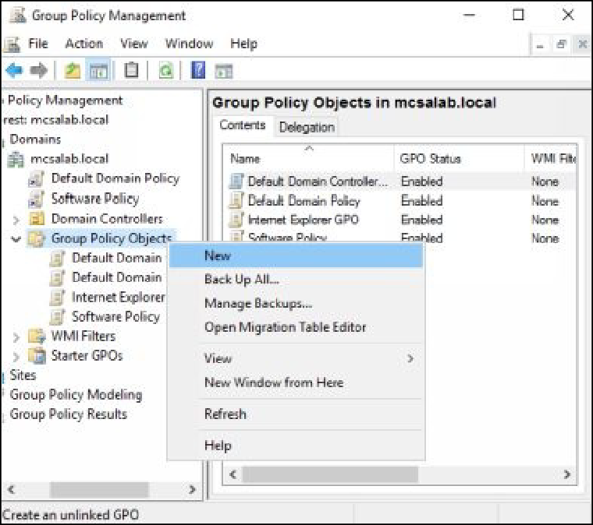

1. In the **Name** text box type **Firewall GPO**, and then click **OK**.
2. Expand **Group Policy Objects**, right-click **Firewall GPO**, and then

select **Edit**.

1. On the **Group Policy Management Editor** console, navigate to

## Computer Configuration\Policies\Windows Settings\Security Settings.

1. Under the **Security Settings** node, expand **Windows Firewall with Advanced Security**, and then expand the **Windows Firewall with**

**Advanced Security – LDAP** node, as shown in the following figure.

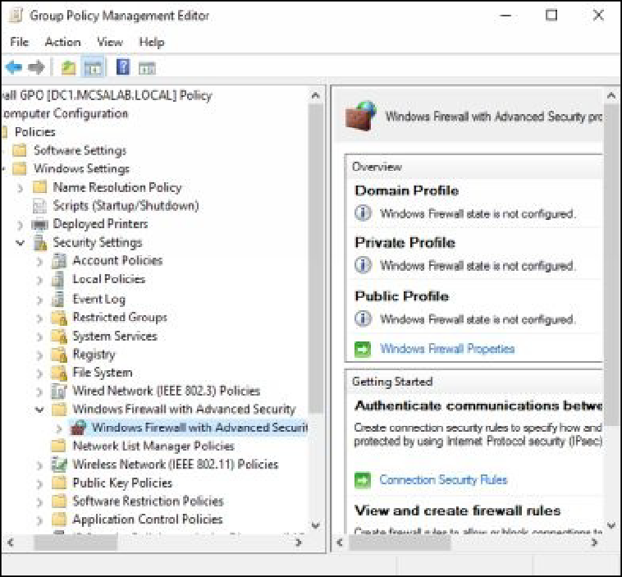

1. Select and right-click **Inbound Rules**, and then select **New Rule**, as

shown in the following figure.

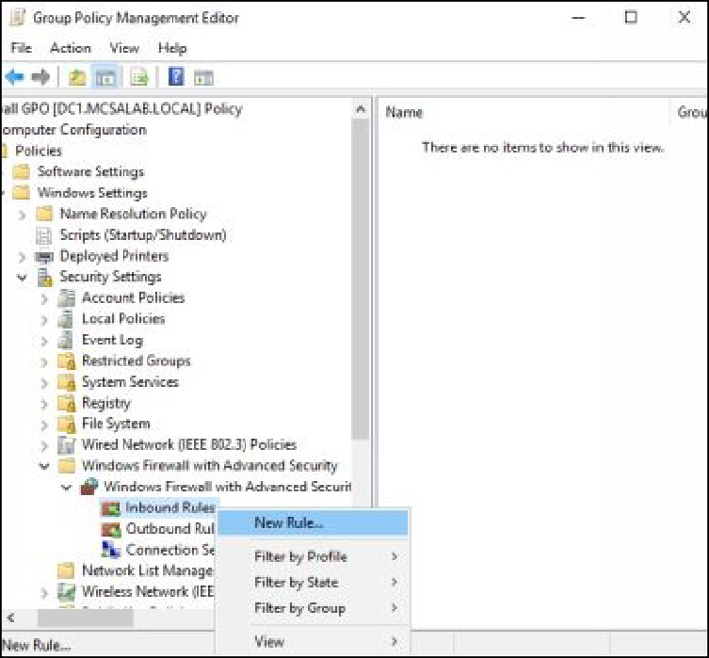

1. On the **New Inbound Rule Wizard**, on the **Rule Type** page, the

select **Predefined** radio button.

1. In the drop-down list, select **Remote Desktop**, as shown in the following figure, and then click **Next**.

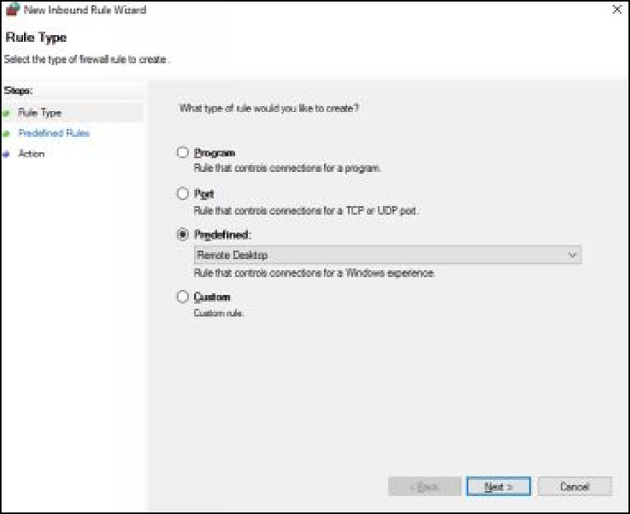

1. On the **Predefined Rules** page, click **Next**.
2. On the **Action** page, select the **Block the connection** radio button, as shown in the following figure, and then click **Finish** to close

## New Inbound Rule Wizard.

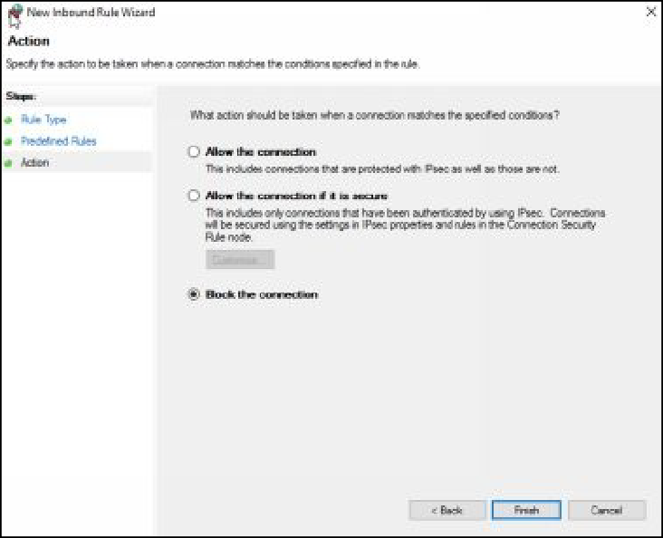

1. Close the **Group Policy Management Editor** console.
2. Open the **Command Prompt** window and type **gpupdate /force**,

and then press **Enter**.

1. Close the **Command Prompt** window.
2. On the **Group Policy Management** console, select **Firewall GPO**

in the left pane.

1. If displayed, on the **Internet Explorer** dialog box click **Close**
2. In the right pane, select the **Settings** tab and verify that the

**Inbound Rules** are configured, as shown in the following figure.

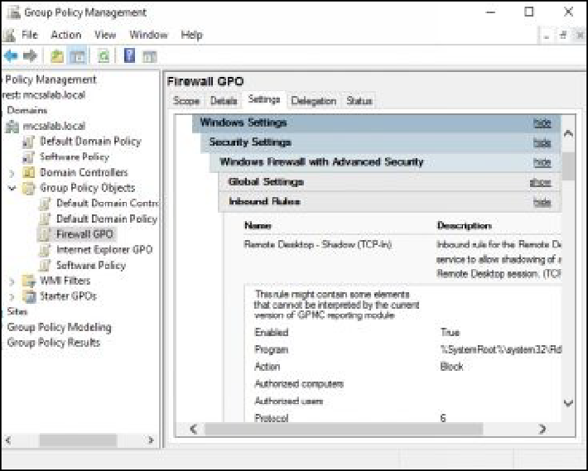

1. Close the **Group Policy Management** console.

***Results****: After completing this exercise, you should have configured AppLocker and Windows Firewall rules using the Group Policy Management console.*

*Shut down and revert the DC1 virtual machine.*

Hope, you have enjoyed a great learning experience with this learning guide and hope you will provide great rating to this lab guide.